**Included Analyses**

* Pearson Correlation Analysis for extentcapitalism and extentspiritual
* Pearson Correlation Analysis for extentcapitalism and extentprocrastinator
* Pearson Correlation Analysis for extentcapitalism and extentpc
* Pearson Correlation Analysis for extentteamwork and extentcapitalism
* Spearman Correlation Analysis for extentteamwork and extentcapitalism
* Pearson Correlation Analysis for extentcapitalism and extentreligious
* Pearson Correlation Analysis for extentconservative, extentspiritual, extentdedicated, extentprocrastinator, extentpc, extentreligious, extentliar, and extentarticulator
* Spearman Correlation Analysis for extentconservative, extentspiritual, extentdedicated, extentprocrastinator, extentpc, extentreligious, extentliar, and extentarticulator
* Pearson Correlation Analysis for extentteamwork, extentspiritual, extentdedicated, extentconservative, extentpc, extentreligious, and extentarticulator
* Spearman Correlation Analysis for extentteamwork, extentspiritual, extentdedicated, extentconservative, extentpc, extentreligious, and extentarticulator
* Pearson Correlation Analysis for extentfeminine and extentleader
* Pearson Correlation Analysis for extentcapitalism and extentleader
* Pearson Correlation Analysis for extentspiritual and extentleader
* Pearson Correlation Analysis for extentleader and extentdedicated
* Pearson Correlation Analysis for extentleader and extentconservative
* Pearson Correlation Analysis for extentleader and extentprocrastinator
* Pearson Correlation Analysis for extentleader and extentpc
* Pearson Correlation Analysis for extentleader and extentpc
* Pearson Correlation Analysis for extentleader and extentteamwork
* Spearman Correlation Analysis for extentleader and extentteamwork
* Pearson Correlation Analysis for extentleader and extentreligious
* Pearson Correlation Analysis for extentleader and extentliar
* Spearman Correlation Analysis for extentleader and extentliar
* Pearson Correlation Analysis for extentleader and extentarticulator
* Pearson Correlation Analysis for extentfeminine and extentconservative
* Pearson Correlation Analysis for extentcapitalism and extentarticulator
* Two-Tailed One Sample z-Test between extentfeminine and a test value of 50
* Two-Tailed One Sample z-Test between extentconservative and a test value of 50
* Two-Tailed One Sample z-Test between extentteamwork and a test value of 50
* Two-Tailed One Sample z-Test between extentcapitalism and a test value of 50
* Two-Tailed One Sample z-Test between extentleader and a test value of 50
* Two-Tailed One Sample z-Test between extentreligious and a test value of 50
* Two-Tailed One Sample z-Test between extentspiritual and a test value of 50
* Two-Tailed One Sample z-Test between extentprocrastinator and a test value of 50
* Two-Tailed One Sample z-Test between extentliar and a test value of 50
* Two-Tailed One Sample z-Test between extentdedicated and a test value of 50
* Two-Tailed One Sample z-Test between extentpc and a test value of 50
* Two-Tailed One Sample z-Test between extentarticulator and a test value of 50
* Two-Tailed Paired Samples t-Test between extentconservative and extentcapitalism
* Two-Tailed Wilcoxon Signed Rank Test between extentconservative and extentcapitalism
* Two-Tailed Paired Samples t-Test between extentconservative and extentreligious
* Two-Tailed Wilcoxon Signed Rank Test between extentconservative and extentreligious
* Two-Tailed Paired Samples t-Test between extentteamwork and extentleader
* Two-Tailed Wilcoxon Signed Rank Test between extentteamwork and extentleader
* Two-Tailed Paired Samples t-Test between extentreligious and extentspiritual
* Two-Tailed Wilcoxon Signed Rank Test between extentreligious and extentspiritual
* Two-Tailed Paired Samples t-Test between age and extentconservative
* Two-Tailed Wilcoxon Signed Rank Test between age and extentconservative
* Two-Tailed Paired Samples t-Test between age and extentcapitalism
* Two-Tailed Wilcoxon Signed Rank Test between age and extentcapitalism

**Results**

**Pearson Correlation Analysis**

***Introduction***

A Pearson correlation analysis was conducted between extentcapitalism and extentspiritual. Cohen's standard was used to evaluate the strength of the relationship, where coefficients between .10 and .29 represent a small effect size, coefficients between .30 and .49 represent a moderate effect size, and coefficients above .50 indicate a large effect size (Cohen, 1988).

***Assumptions***

**Linearity.** A Pearson correlation requires that the relationship between each pair of variables is linear (Conover & Iman, 1981). This assumption is violated if there is curvature among the points on the scatterplot between any pair of variables. Figure 1 presents the scatterplot of the correlation. A regression line has been added to assist the interpretation.

**Figure 1**

*Scatterplots between each variable with the regression line added*

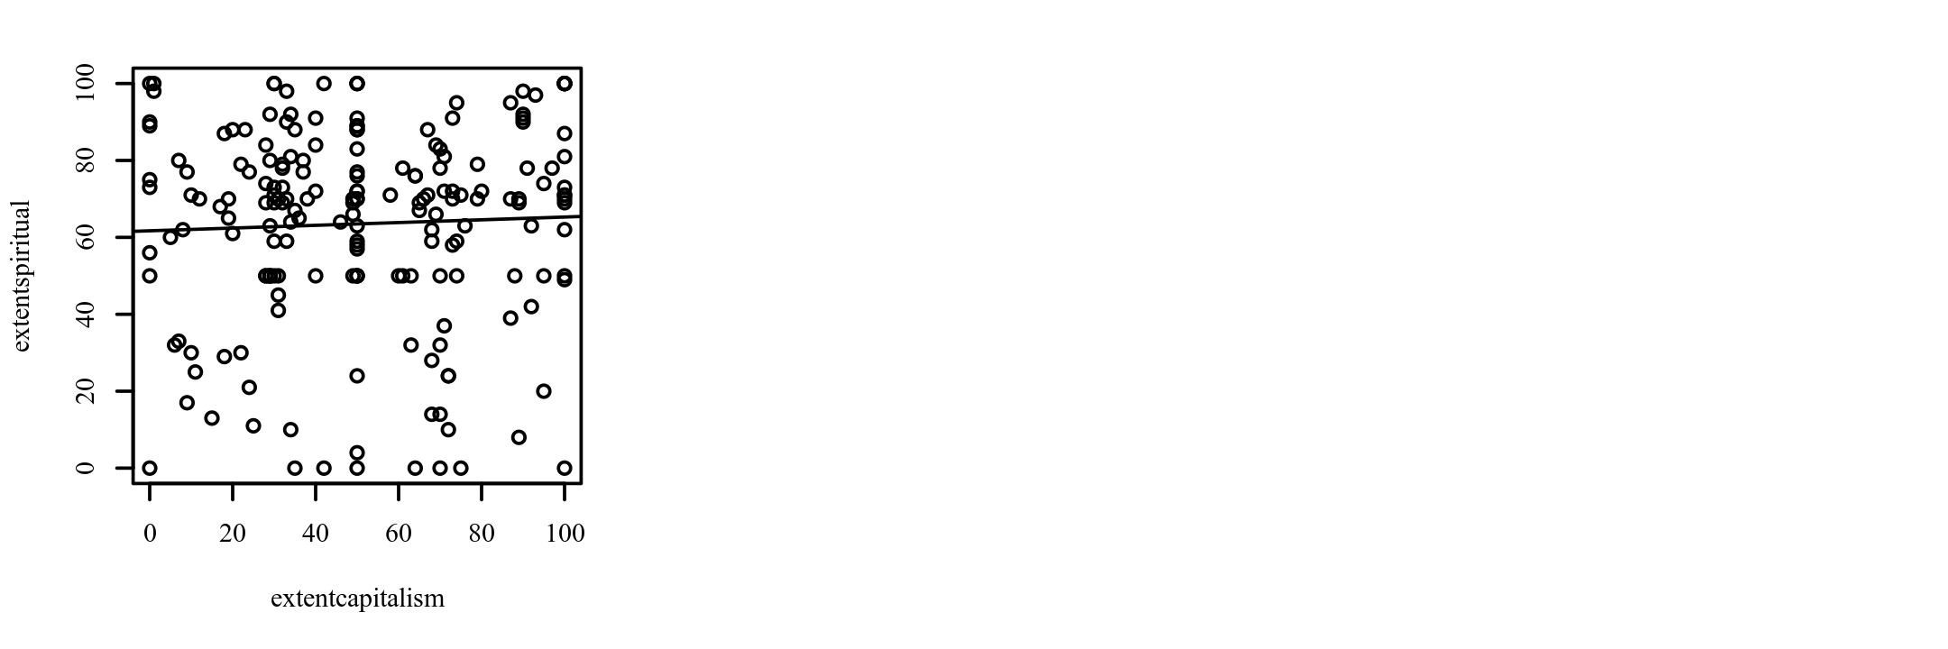

***Results***

The result of the correlation was examined based on an alpha value of 0.05. There were no significant correlations between any pairs of variables. Table 1 presents the results of the correlation.

**Table 1**

*Pearson Correlation Results Between extentcapitalism and extentspiritual*

|  |  |  |  |
| --- | --- | --- | --- |
| Combination | *r*p | 95% CI | *p* |
| extentcapitalism-extentspiritual | 0.04 | [-0.10, 0.18] | .582 |

*Note.* *n* = 193.

**Pearson Correlation Analysis**

***Introduction***

A Pearson correlation analysis was conducted between extentcapitalism and extentprocrastinator. Cohen's standard was used to evaluate the strength of the relationship, where coefficients between .10 and .29 represent a small effect size, coefficients between .30 and .49 represent a moderate effect size, and coefficients above .50 indicate a large effect size (Cohen, 1988).

***Assumptions***

**Linearity.** A Pearson correlation requires that the relationship between each pair of variables is linear (Conover & Iman, 1981). This assumption is violated if there is curvature among the points on the scatterplot between any pair of variables. Figure 2 presents the scatterplot of the correlation. A regression line has been added to assist the interpretation.

**Figure 2**

*Scatterplots between each variable with the regression line added*

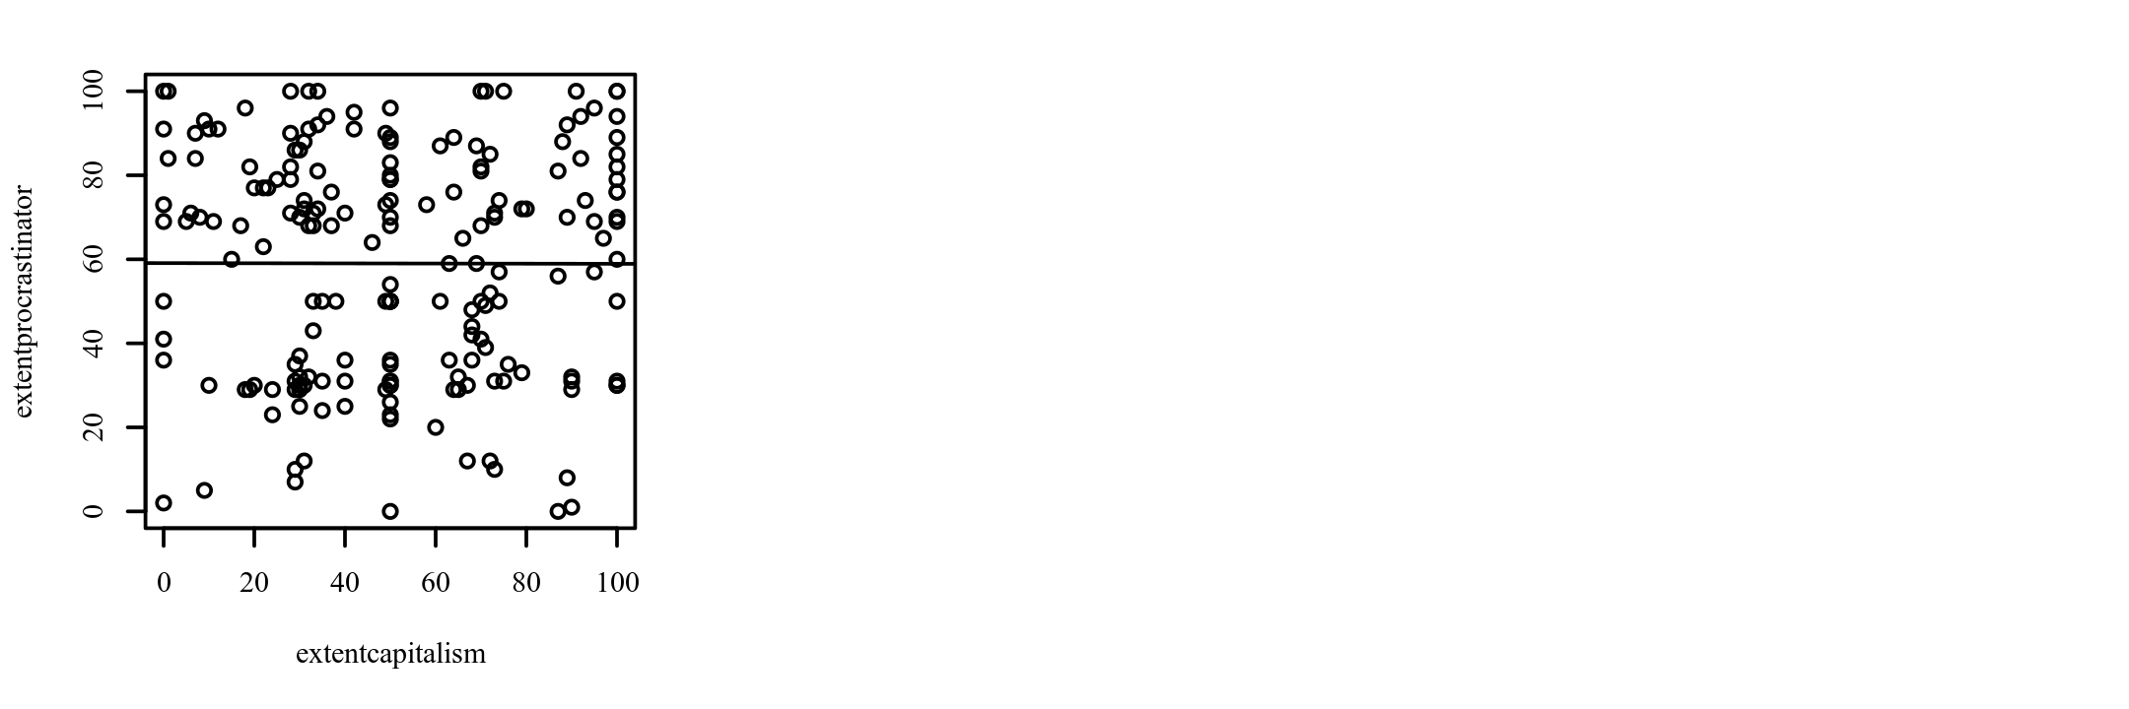

***Results***

The result of the correlation was examined based on an alpha value of 0.05. There were no significant correlations between any pairs of variables. Table 2 presents the results of the correlation.

**Table 2**

*Pearson Correlation Results Between extentcapitalism and extentprocrastinator*

|  |  |  |  |
| --- | --- | --- | --- |
| Combination | *r*p | 95% CI | *p* |
| extentcapitalism-extentprocrastinator | -0.00 | [-0.14, 0.14] | .980 |

*Note.* *n* = 193.

**Pearson Correlation Analysis**

***Introduction***

A Pearson correlation analysis was conducted between extentcapitalism and extentpc. Cohen's standard was used to evaluate the strength of the relationship, where coefficients between .10 and .29 represent a small effect size, coefficients between .30 and .49 represent a moderate effect size, and coefficients above .50 indicate a large effect size (Cohen, 1988).

***Assumptions***

**Linearity.** A Pearson correlation requires that the relationship between each pair of variables is linear (Conover & Iman, 1981). This assumption is violated if there is curvature among the points on the scatterplot between any pair of variables. Figure 3 presents the scatterplot of the correlation. A regression line has been added to assist the interpretation.

**Figure 3**

*Scatterplots between each variable with the regression line added*

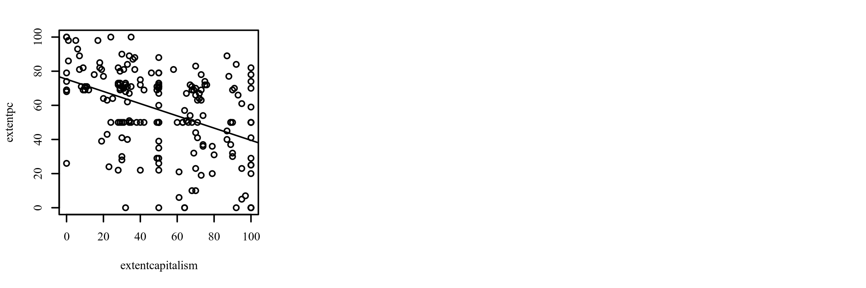

***Results***

The result of the correlation was examined based on an alpha value of 0.05. A significant negative correlation was observed between extentcapitalism and extentpc (*r*p = -0.43, *p* < .001, 95% CI [-0.54, -0.31]). The correlation coefficient between extentcapitalism and extentpc was -0.43, indicating a moderate effect size. This correlation indicates that as extentcapitalism increases, extentpc tends to decrease. Table 3 presents the results of the correlation.

**Table 3**

*Pearson Correlation Results Between extentcapitalism and extentpc*

|  |  |  |  |
| --- | --- | --- | --- |
| Combination | *r*p | 95% CI | *p* |
| extentcapitalism-extentpc | -0.43 | [-0.54, -0.31] | < .001 |

*Note.* *n* = 193.

**Pearson Correlation Analysis**

***Introduction***

A Pearson correlation analysis was conducted between extentteamwork and extentcapitalism. Cohen's standard was used to evaluate the strength of the relationship, where coefficients between .10 and .29 represent a small effect size, coefficients between .30 and .49 represent a moderate effect size, and coefficients above .50 indicate a large effect size (Cohen, 1988).

***Assumptions***

**Linearity.** A Pearson correlation requires that the relationship between each pair of variables is linear (Conover & Iman, 1981). This assumption is violated if there is curvature among the points on the scatterplot between any pair of variables. Figure 4 presents the scatterplot of the correlation. A regression line has been added to assist the interpretation.

**Figure 4**

*Scatterplots between each variable with the regression line added*

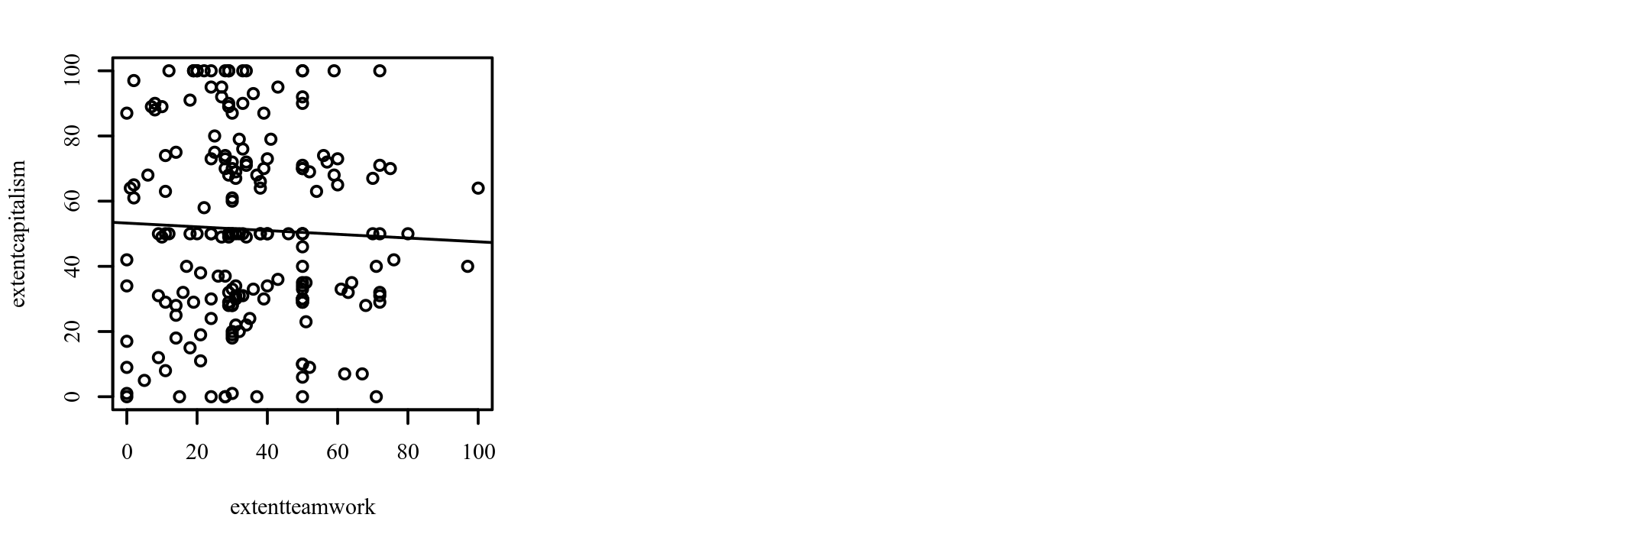

***Results***

The result of the correlation was examined based on an alpha value of 0.05. There were no significant correlations between any pairs of variables. Table 4 presents the results of the correlation.

**Table 4**

*Pearson Correlation Results Between extentteamwork and extentcapitalism*

|  |  |  |  |
| --- | --- | --- | --- |
| Combination | *r*p | 95% CI | *p* |
| extentteamwork-extentcapitalism | -0.04 | [-0.18, 0.10] | .587 |

*Note.* *n* = 193.

**Spearman Correlation Analysis**

***Introduction***

A Spearman correlation analysis was conducted between extentteamwork and extentcapitalism. Cohen's standard was used to evaluate the strength of the relationship, where coefficients between .10 and .29 represent a small effect size, coefficients between .30 and .49 represent a moderate effect size, and coefficients above .50 indicate a large effect size (Cohen, 1988).

***Results***

The result of the correlation was examined based on an alpha value of 0.05. There were no significant correlations between any pairs of variables. Table 5 presents the results of the correlation.

**Table 5**

*Spearman Correlation Results Between extentteamwork and extentcapitalism*

|  |  |  |  |
| --- | --- | --- | --- |
| Combination | *r*s | 95% CI | *p* |
| extentteamwork-extentcapitalism | -0.03 | [-0.17, 0.11] | .650 |

*Note.* *n* = 193.

**Pearson Correlation Analysis**

***Introduction***

A Pearson correlation analysis was conducted between extentcapitalism and extentreligious. Cohen's standard was used to evaluate the strength of the relationship, where coefficients between .10 and .29 represent a small effect size, coefficients between .30 and .49 represent a moderate effect size, and coefficients above .50 indicate a large effect size (Cohen, 1988).

***Assumptions***

**Linearity.** A Pearson correlation requires that the relationship between each pair of variables is linear (Conover & Iman, 1981). This assumption is violated if there is curvature among the points on the scatterplot between any pair of variables. Figure 5 presents the scatterplot of the correlation. A regression line has been added to assist the interpretation.

**Figure 5**

*Scatterplots between each variable with the regression line added*

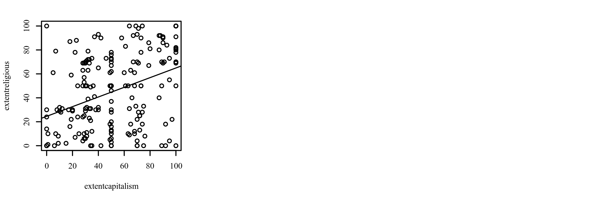

***Results***

The result of the correlation was examined based on an alpha value of 0.05. A significant positive correlation was observed between extentcapitalism and extentreligious (*r*p = 0.37, *p* < .001, 95% CI [0.24, 0.48]). The correlation coefficient between extentcapitalism and extentreligious was 0.37, indicating a moderate effect size. This correlation indicates that as extentcapitalism increases, extentreligious tends to increase. Table 6 presents the results of the correlation.

**Table 6**

*Pearson Correlation Results Between extentcapitalism and extentreligious*

|  |  |  |  |
| --- | --- | --- | --- |
| Combination | *r*p | 95% CI | *p* |
| extentcapitalism-extentreligious | 0.37 | [0.24, 0.48] | < .001 |

*Note.* *n* = 193.

**Pearson Correlation Analysis**

***Introduction***

A Pearson correlation analysis was conducted among extentconservative, extentspiritual, extentdedicated, extentprocrastinator, extentpc, extentreligious, extentliar, and extentarticulator. Cohen's standard was used to evaluate the strength of the relationships, where coefficients between .10 and .29 represent a small effect size, coefficients between .30 and .49 represent a moderate effect size, and coefficients above .50 indicate a large effect size (Cohen, 1988).

***Assumptions***

**Linearity.** A Pearson correlation requires that the relationship between each pair of variables is linear (Conover & Iman, 1981). This assumption is violated if there is curvature among the points on the scatterplot between any pair of variables. Figure 6-Figure 15 presents the scatterplots of the correlations. A regression line has been added to assist the interpretation.

**Figure 6**

*Scatterplots between each variable with the regression line added*

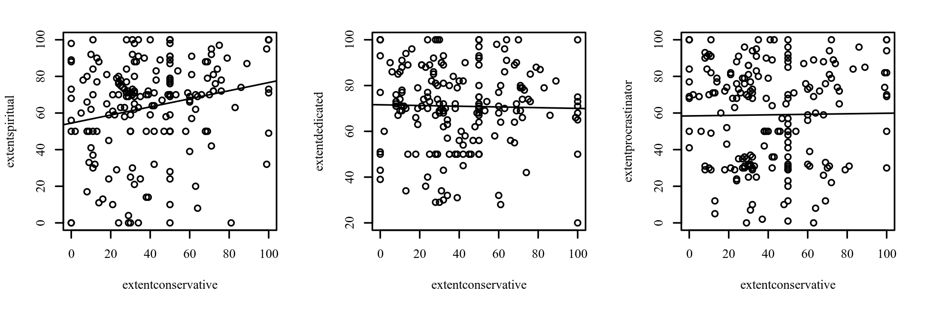

**Figure 7**

*Scatterplots between each variable with the regression line added*

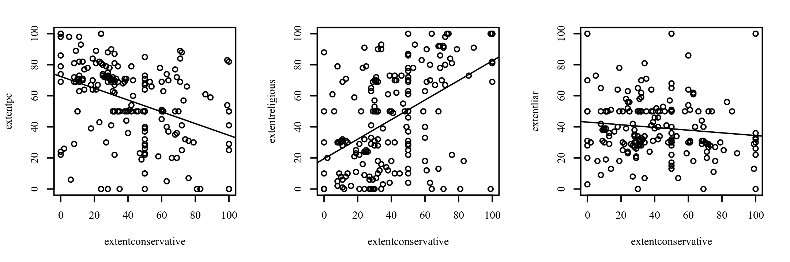

**Figure 8**

*Scatterplots between each variable with the regression line added*

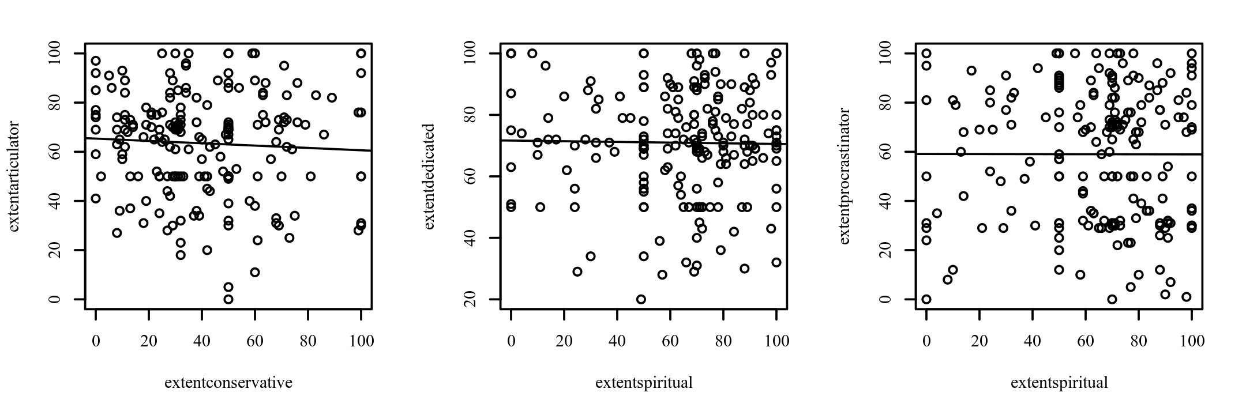

**Figure 9**

*Scatterplots between each variable with the regression line added*

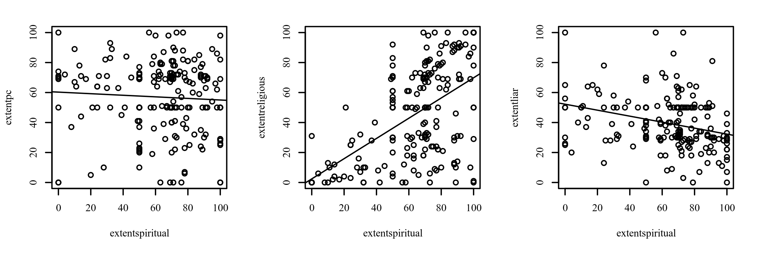

**Figure 10**

*Scatterplots between each variable with the regression line added*

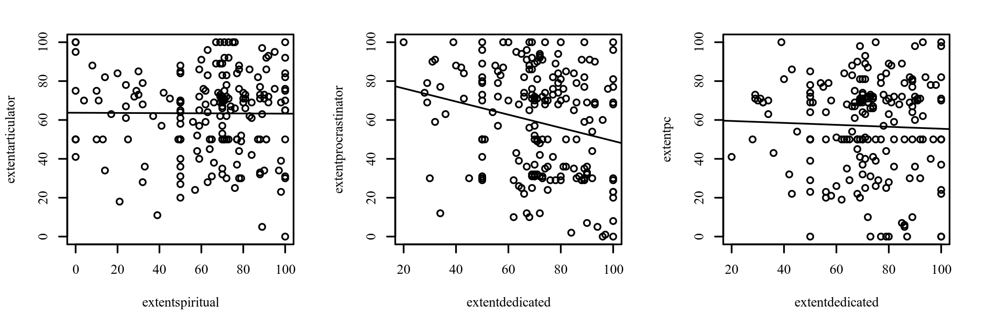

**Figure 11**

*Scatterplots between each variable with the regression line added*

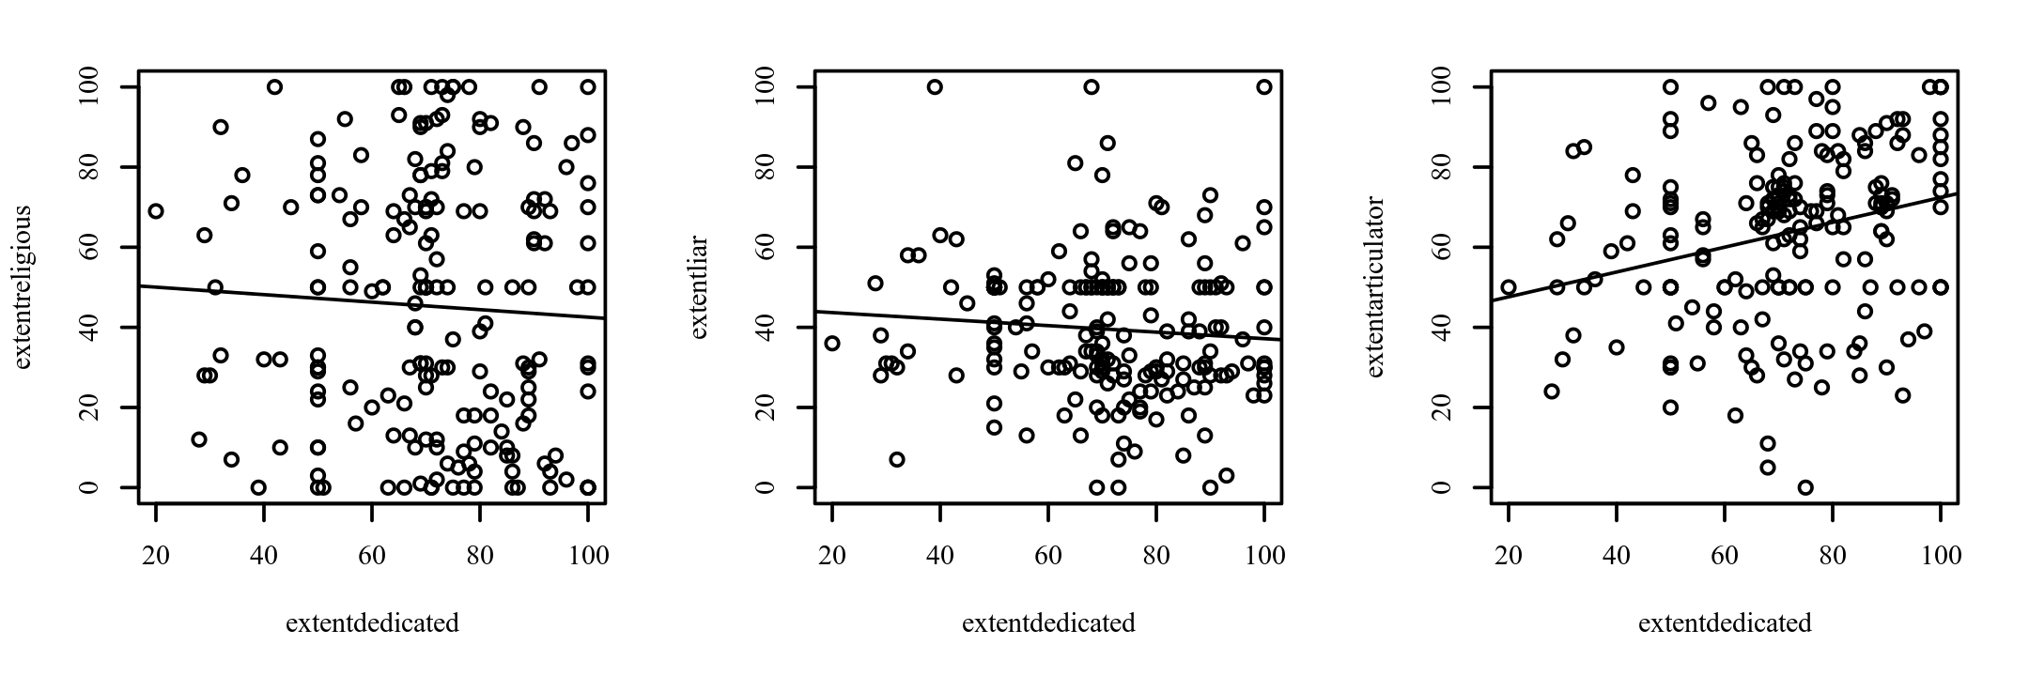

**Figure 12**

*Scatterplots between each variable with the regression line added*

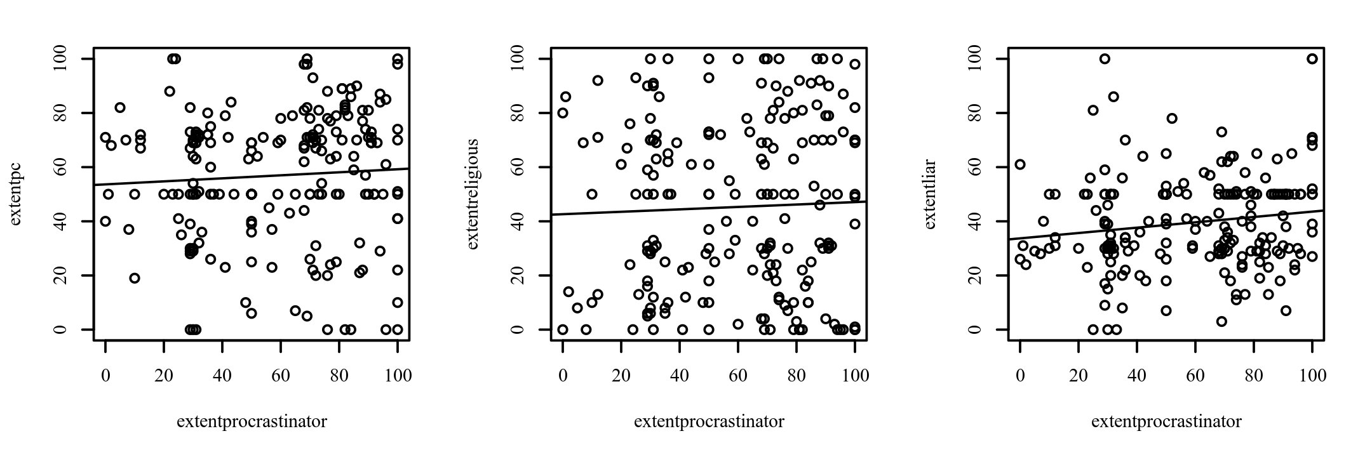

**Figure 13**

*Scatterplots between each variable with the regression line added*

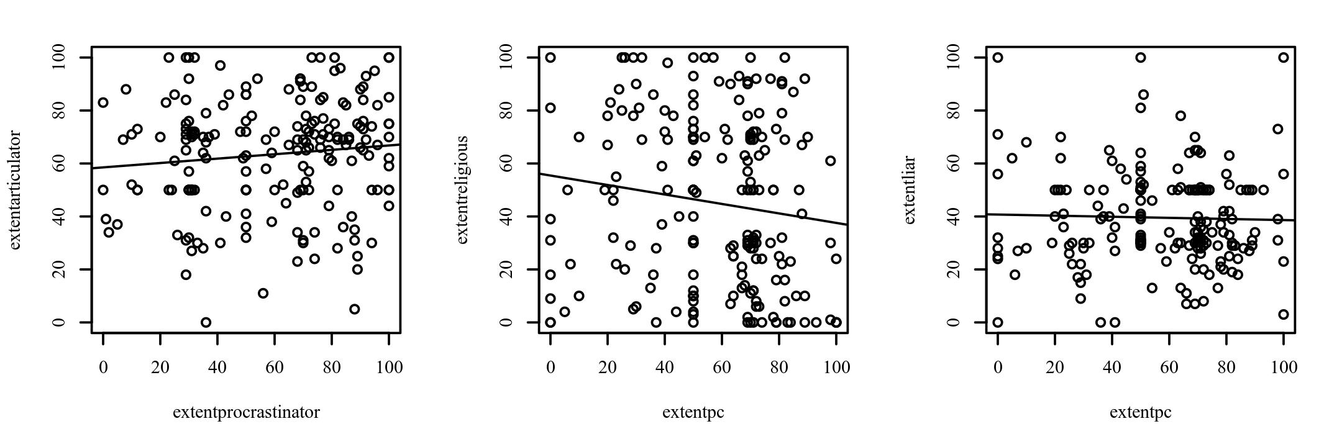

**Figure 14**

*Scatterplots between each variable with the regression line added*

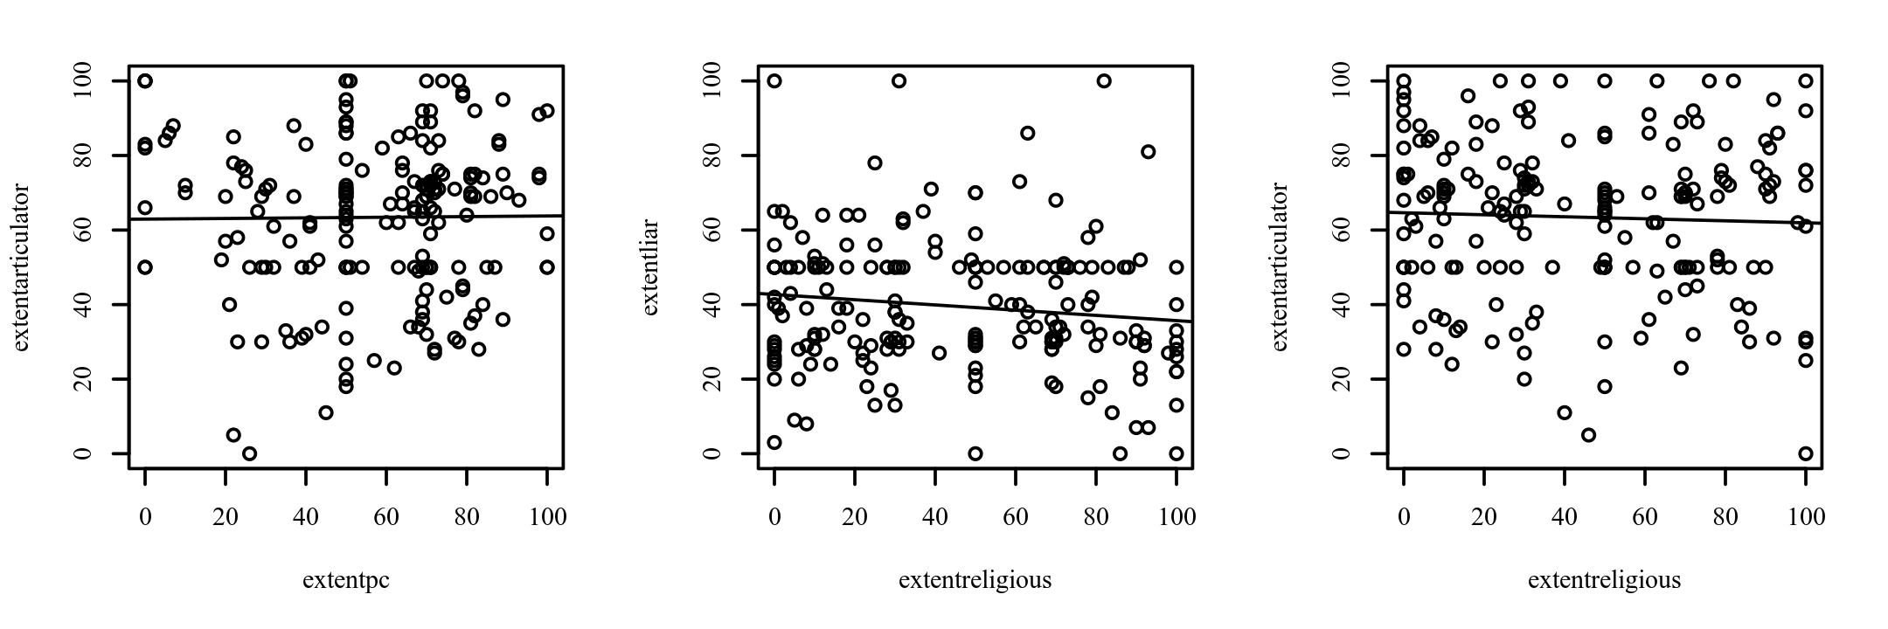

**Figure 15**

*Scatterplots between each variable with the regression line added*

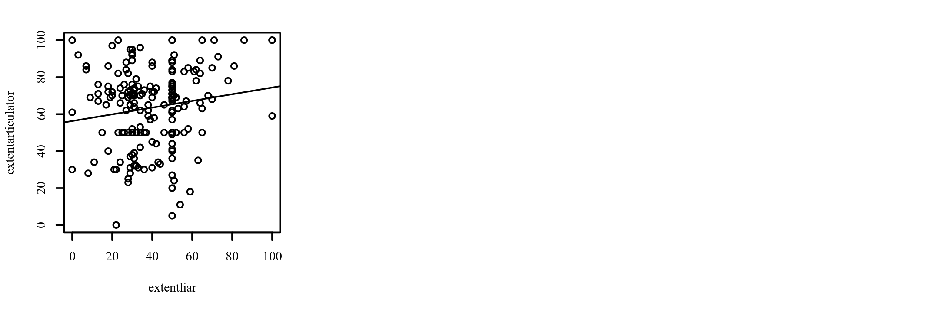

***Results***

The result of the correlations was examined using Holm corrections to adjust for multiple comparisons based on an alpha value of 0.05. A significant positive correlation was observed between extentconservative and extentspiritual (*r*p = 0.21, *p* = .003, 95% CI [0.07, 0.34]). The correlation coefficient between extentconservative and extentspiritual was 0.21, indicating a small effect size. This correlation indicates that as extentconservative increases, extentspiritual tends to increase. A significant negative correlation was observed between extentconservative and extentpc (*r*p = -0.39, *p* < .001, 95% CI [-0.51, -0.27]). The correlation coefficient between extentconservative and extentpc was -0.39, indicating a moderate effect size. This correlation indicates that as extentconservative increases, extentpc tends to decrease. A significant positive correlation was observed between extentconservative and extentreligious (*r*p = 0.50, *p* < .001, 95% CI [0.38, 0.60]). The correlation coefficient between extentconservative and extentreligious was 0.50, indicating a moderate effect size. This correlation indicates that as extentconservative increases, extentreligious tends to increase. A significant positive correlation was observed between extentspiritual and extentreligious (*r*p = 0.55, *p* < .001, 95% CI [0.44, 0.64]). The correlation coefficient between extentspiritual and extentreligious was 0.55, indicating a large effect size. This correlation indicates that as extentspiritual increases, extentreligious tends to increase. A significant negative correlation was observed between extentspiritual and extentliar (*r*p = -0.29, *p* < .001, 95% CI [-0.42, -0.16]). The correlation coefficient between extentspiritual and extentliar was -0.29, indicating a small effect size. This correlation indicates that as extentspiritual increases, extentliar tends to decrease. A significant negative correlation was observed between extentdedicated and extentprocrastinator (*r*p = -0.22, *p* = .002, 95% CI [-0.35, -0.08]). The correlation coefficient between extentdedicated and extentprocrastinator was -0.22, indicating a small effect size. This correlation indicates that as extentdedicated increases, extentprocrastinator tends to decrease. A significant positive correlation was observed between extentdedicated and extentarticulator (*r*p = 0.26, *p* < .001, 95% CI [0.12, 0.39]). The correlation coefficient between extentdedicated and extentarticulator was 0.26, indicating a small effect size. This correlation indicates that as extentdedicated increases, extentarticulator tends to increase. A significant positive correlation was observed between extentprocrastinator and extentliar (*r*p = 0.15, *p* = .036, 95% CI [0.01, 0.29]). The correlation coefficient between extentprocrastinator and extentliar was 0.15, indicating a small effect size. This correlation indicates that as extentprocrastinator increases, extentliar tends to increase. A significant positive correlation was observed between extentliar and extentarticulator (*r*p = 0.15, *p* = .035, 95% CI [0.01, 0.29]). The correlation coefficient between extentliar and extentarticulator was 0.15, indicating a small effect size. This correlation indicates that as extentliar increases, extentarticulator tends to increase. No other significant correlations were found. Table 7 presents the results of the correlations.

**Table 7**

*Pearson Correlation Results Among extentconservative, extentspiritual, extentdedicated, extentprocrastinator, extentpc, extentreligious, extentliar, and extentarticulator*

|  |  |  |  |
| --- | --- | --- | --- |
| Combination | *r*p | 95% CI | *p* |
| extentconservative-extentspiritual | 0.21 | [0.07, 0.34] | .003 |
| extentconservative-extentdedicated | -0.02 | [-0.16, 0.12] | .759 |
| extentconservative-extentprocrastinator | 0.01 | [-0.13, 0.15] | .853 |
| extentconservative-extentpc | -0.39 | [-0.51, -0.27] | < .001 |
| extentconservative-extentreligious | 0.50 | [0.38, 0.60] | < .001 |
| extentconservative-extentliar | -0.12 | [-0.26, 0.02] | .091 |
| extentconservative-extentarticulator | -0.06 | [-0.20, 0.09] | .438 |
| extentspiritual-extentdedicated | -0.02 | [-0.16, 0.13] | .823 |
| extentspiritual-extentprocrastinator | -0.00 | [-0.14, 0.14] | .984 |
| extentspiritual-extentpc | -0.06 | [-0.20, 0.09] | .436 |
| extentspiritual-extentreligious | 0.55 | [0.44, 0.64] | < .001 |
| extentspiritual-extentliar | -0.29 | [-0.42, -0.16] | < .001 |
| extentspiritual-extentarticulator | -0.01 | [-0.15, 0.14] | .938 |
| extentdedicated-extentprocrastinator | -0.22 | [-0.35, -0.08] | .002 |
| extentdedicated-extentpc | -0.04 | [-0.18, 0.10] | .610 |
| extentdedicated-extentreligious | -0.05 | [-0.19, 0.09] | .468 |
| extentdedicated-extentliar | -0.08 | [-0.22, 0.06] | .259 |
| extentdedicated-extentarticulator | 0.26 | [0.12, 0.39] | < .001 |
| extentprocrastinator-extentpc | 0.06 | [-0.08, 0.20] | .387 |
| extentprocrastinator-extentreligious | 0.04 | [-0.10, 0.18] | .598 |
| extentprocrastinator-extentliar | 0.15 | [0.01, 0.29] | .036 |
| extentprocrastinator-extentarticulator | 0.11 | [-0.04, 0.24] | .141 |
| extentpc-extentreligious | -0.14 | [-0.27, 0.01] | .059 |
| extentpc-extentliar | -0.03 | [-0.17, 0.11] | .695 |
| extentpc-extentarticulator | 0.01 | [-0.13, 0.15] | .894 |
| extentreligious-extentliar | -0.13 | [-0.26, 0.02] | .082 |
| extentreligious-extentarticulator | -0.04 | [-0.18, 0.10] | .574 |
| extentliar-extentarticulator | 0.15 | [0.01, 0.29] | .035 |

*Note.* *n* = 193. Holm corrections used to adjust *p*-values.

**Spearman Correlation Analysis**

***Introduction***

A Spearman correlation analysis was conducted among extentconservative, extentspiritual, extentdedicated, extentprocrastinator, extentpc, extentreligious, extentliar, and extentarticulator. Cohen's standard was used to evaluate the strength of the relationships, where coefficients between .10 and .29 represent a small effect size, coefficients between .30 and .49 represent a moderate effect size, and coefficients above .50 indicate a large effect size (Cohen, 1988).

***Results***

The result of the correlations was examined using Holm corrections to adjust for multiple comparisons based on an alpha value of 0.05. A significant positive correlation was observed between extentconservative and extentspiritual (*r*s = 0.21, *p* = .004, 95% CI [0.07, 0.34]). The correlation coefficient between extentconservative and extentspiritual was 0.21, indicating a small effect size. This correlation indicates that as extentconservative increases, extentspiritual tends to increase. A significant negative correlation was observed between extentconservative and extentpc (*r*s = -0.43, *p* < .001, 95% CI [-0.54, -0.31]). The correlation coefficient between extentconservative and extentpc was -0.43, indicating a moderate effect size. This correlation indicates that as extentconservative increases, extentpc tends to decrease. A significant positive correlation was observed between extentconservative and extentreligious (*r*s = 0.48, *p* < .001, 95% CI [0.37, 0.58]). The correlation coefficient between extentconservative and extentreligious was 0.48, indicating a moderate effect size. This correlation indicates that as extentconservative increases, extentreligious tends to increase. A significant positive correlation was observed between extentspiritual and extentreligious (*r*s = 0.52, *p* < .001, 95% CI [0.41, 0.61]). The correlation coefficient between extentspiritual and extentreligious was 0.52, indicating a large effect size. This correlation indicates that as extentspiritual increases, extentreligious tends to increase. A significant negative correlation was observed between extentspiritual and extentliar (*r*s = -0.33, *p* < .001, 95% CI [-0.45, -0.20]). The correlation coefficient between extentspiritual and extentliar was -0.33, indicating a moderate effect size. This correlation indicates that as extentspiritual increases, extentliar tends to decrease. A significant negative correlation was observed between extentdedicated and extentprocrastinator (*r*s = -0.21, *p* = .004, 95% CI [-0.34, -0.07]). The correlation coefficient between extentdedicated and extentprocrastinator was -0.21, indicating a small effect size. This correlation indicates that as extentdedicated increases, extentprocrastinator tends to decrease. A significant negative correlation was observed between extentdedicated and extentliar (*r*s = -0.15, *p* = .040, 95% CI [-0.28, -0.01]). The correlation coefficient between extentdedicated and extentliar was -0.15, indicating a small effect size. This correlation indicates that as extentdedicated increases, extentliar tends to decrease. A significant positive correlation was observed between extentdedicated and extentarticulator (*r*s = 0.29, *p* < .001, 95% CI [0.15, 0.41]). The correlation coefficient between extentdedicated and extentarticulator was 0.29, indicating a small effect size. This correlation indicates that as extentdedicated increases, extentarticulator tends to increase. A significant negative correlation was observed between extentpc and extentreligious (*r*s = -0.17, *p* = .018, 95% CI [-0.30, -0.03]). The correlation coefficient between extentpc and extentreligious was -0.17, indicating a small effect size. This correlation indicates that as extentpc increases, extentreligious tends to decrease. No other significant correlations were found. Table 8 presents the results of the correlations.

**Table 8**

*Spearman Correlation Results Among extentconservative, extentspiritual, extentdedicated, extentprocrastinator, extentpc, extentreligious, extentliar, and extentarticulator*

|  |  |  |  |
| --- | --- | --- | --- |
| Combination | *r*s | 95% CI | *p* |
| extentconservative-extentspiritual | 0.21 | [0.07, 0.34] | .004 |
| extentconservative-extentdedicated | -0.04 | [-0.18, 0.10] | .564 |
| extentconservative-extentprocrastinator | -0.02 | [-0.16, 0.12] | .816 |
| extentconservative-extentpc | -0.43 | [-0.54, -0.31] | < .001 |
| extentconservative-extentreligious | 0.48 | [0.37, 0.58] | < .001 |
| extentconservative-extentliar | -0.11 | [-0.25, 0.03] | .123 |
| extentconservative-extentarticulator | -0.05 | [-0.19, 0.09] | .499 |
| extentspiritual-extentdedicated | 0.01 | [-0.14, 0.15] | .941 |
| extentspiritual-extentprocrastinator | -0.03 | [-0.17, 0.11] | .669 |
| extentspiritual-extentpc | -0.06 | [-0.20, 0.08] | .371 |
| extentspiritual-extentreligious | 0.52 | [0.41, 0.61] | < .001 |
| extentspiritual-extentliar | -0.33 | [-0.45, -0.20] | < .001 |
| extentspiritual-extentarticulator | 0.04 | [-0.10, 0.18] | .598 |
| extentdedicated-extentprocrastinator | -0.21 | [-0.34, -0.07] | .004 |
| extentdedicated-extentpc | 0.01 | [-0.13, 0.15] | .897 |
| extentdedicated-extentreligious | -0.08 | [-0.22, 0.06] | .278 |
| extentdedicated-extentliar | -0.15 | [-0.28, -0.01] | .040 |
| extentdedicated-extentarticulator | 0.29 | [0.15, 0.41] | < .001 |
| extentprocrastinator-extentpc | 0.11 | [-0.04, 0.24] | .140 |
| extentprocrastinator-extentreligious | 0.04 | [-0.11, 0.18] | .616 |
| extentprocrastinator-extentliar | 0.14 | [-0.00, 0.27] | .055 |
| extentprocrastinator-extentarticulator | 0.11 | [-0.04, 0.24] | .143 |
| extentpc-extentreligious | -0.17 | [-0.30, -0.03] | .018 |
| extentpc-extentliar | -0.05 | [-0.19, 0.09] | .509 |
| extentpc-extentarticulator | 0.04 | [-0.10, 0.18] | .544 |
| extentreligious-extentliar | -0.11 | [-0.25, 0.03] | .117 |
| extentreligious-extentarticulator | -0.02 | [-0.16, 0.12] | .791 |
| extentliar-extentarticulator | 0.09 | [-0.05, 0.23] | .204 |

*Note.* *n* = 193. Holm corrections used to adjust *p*-values.

**Pearson Correlation Analysis**

***Introduction***

A Pearson correlation analysis was conducted among extentteamwork, extentspiritual, extentdedicated, extentconservative, extentpc, extentreligious, and extentarticulator. Cohen's standard was used to evaluate the strength of the relationships, where coefficients between .10 and .29 represent a small effect size, coefficients between .30 and .49 represent a moderate effect size, and coefficients above .50 indicate a large effect size (Cohen, 1988).

***Assumptions***

**Linearity.** A Pearson correlation requires that the relationship between each pair of variables is linear (Conover & Iman, 1981). This assumption is violated if there is curvature among the points on the scatterplot between any pair of variables. Figure 16-Figure 22 presents the scatterplots of the correlations. A regression line has been added to assist the interpretation.

**Figure 16**

*Scatterplots between each variable with the regression line added*

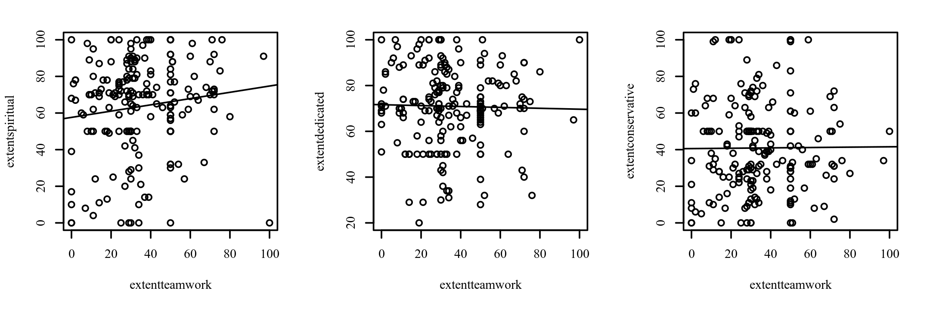

**Figure 17**

*Scatterplots between each variable with the regression line added*

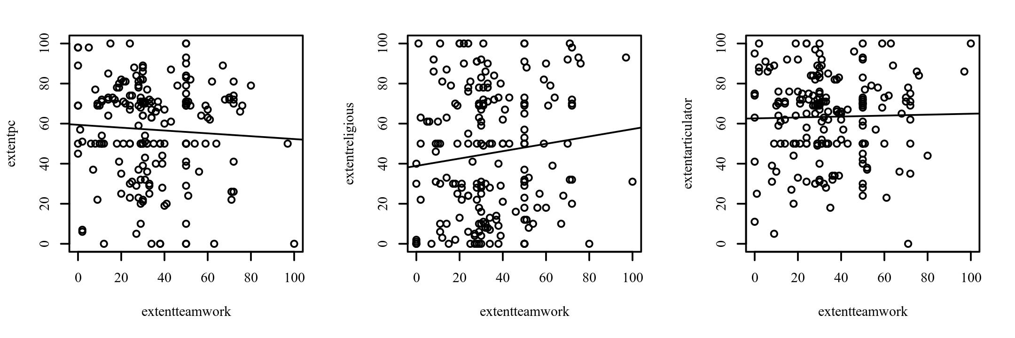

**Figure 18**

*Scatterplots between each variable with the regression line added*

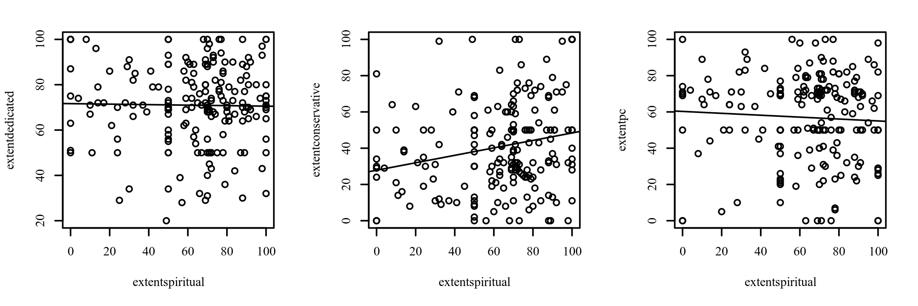

**Figure 19**

*Scatterplots between each variable with the regression line added*

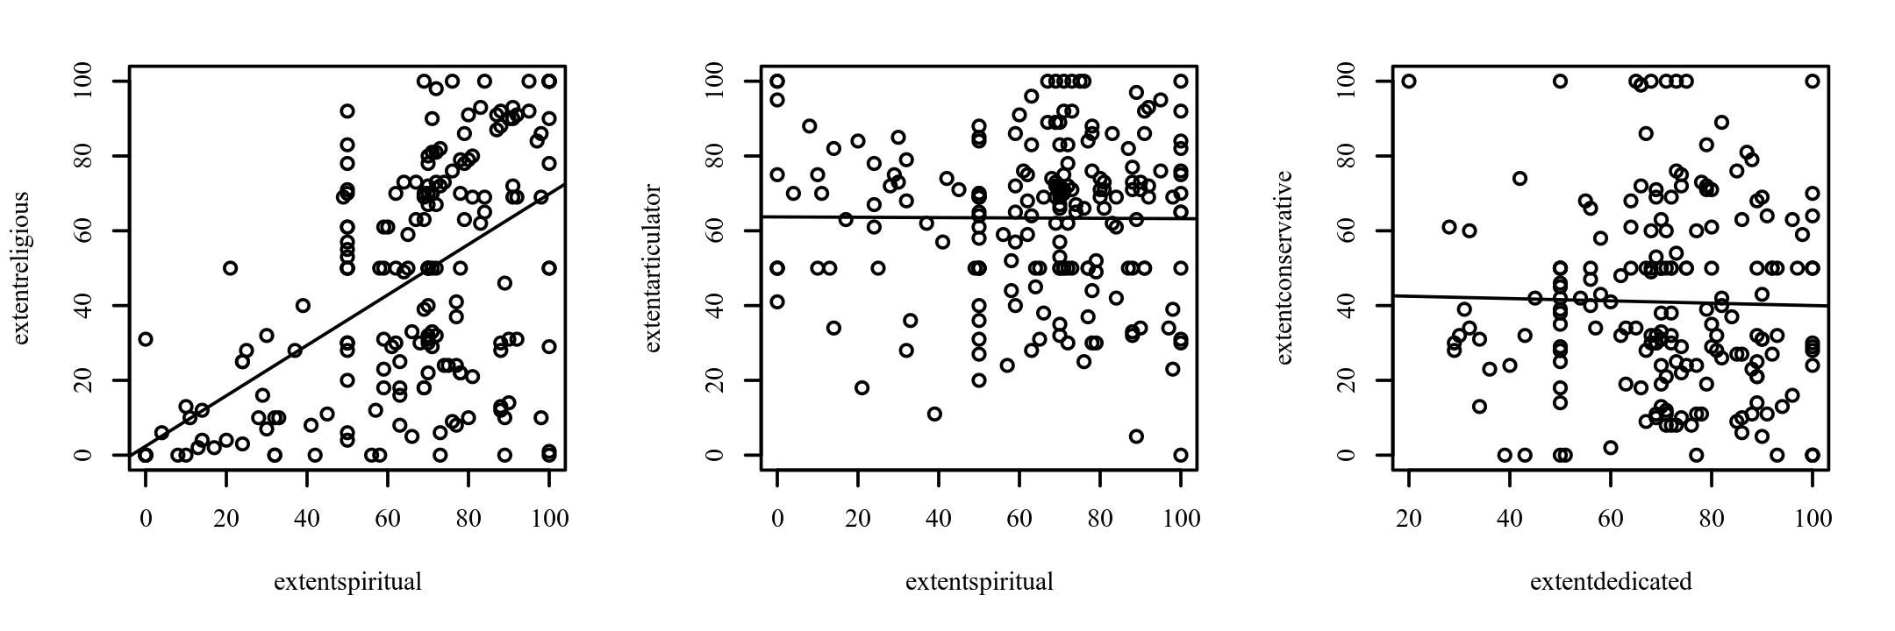

**Figure 20**

*Scatterplots between each variable with the regression line added*

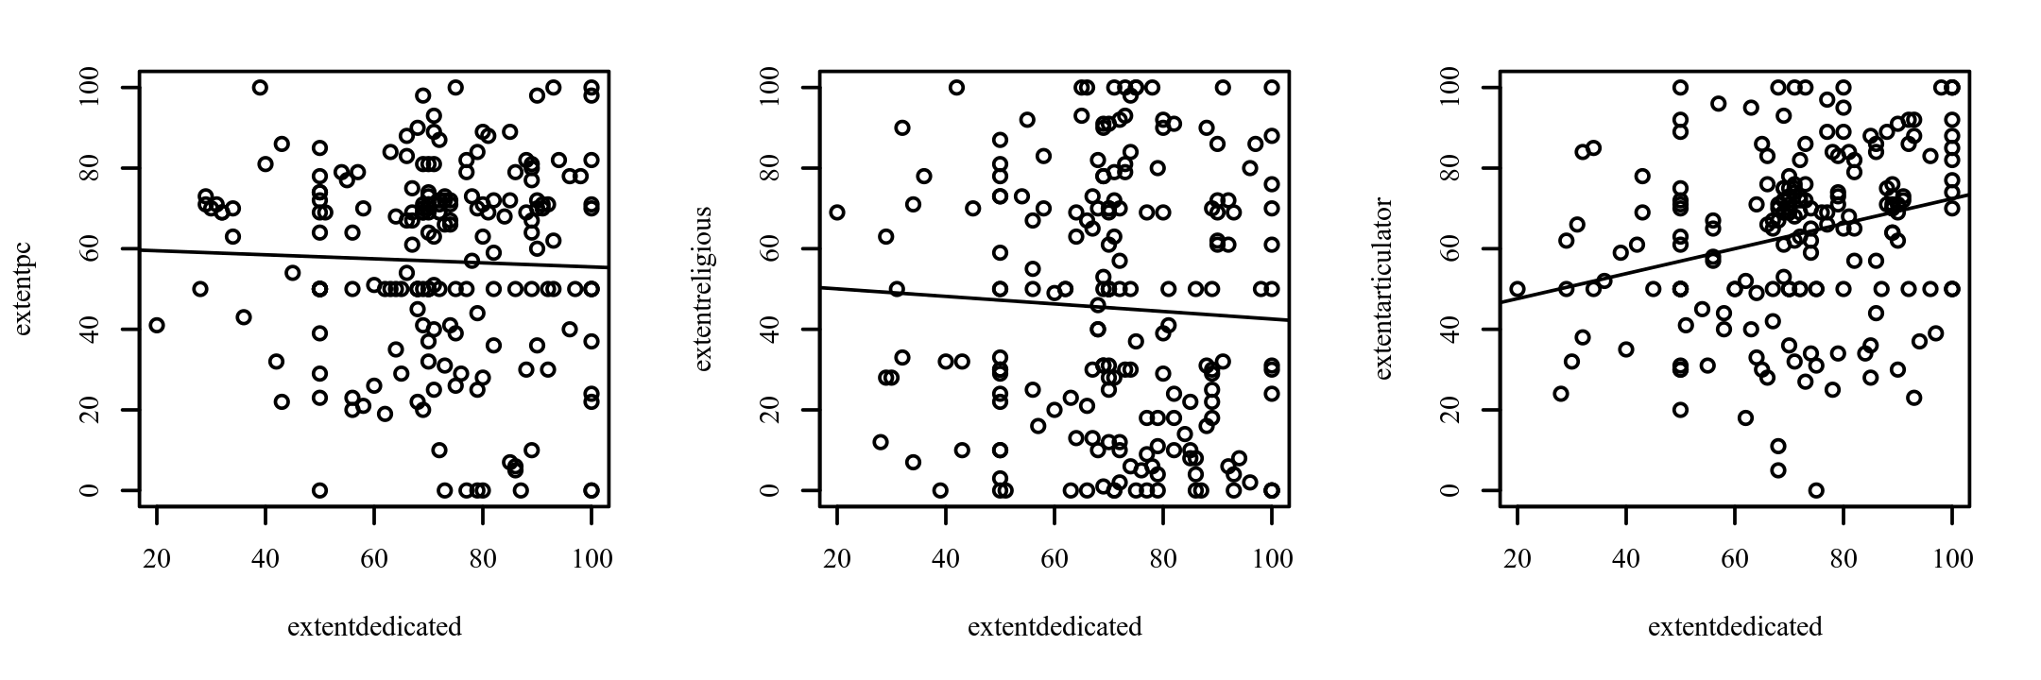

**Figure 21**

*Scatterplots between each variable with the regression line added*

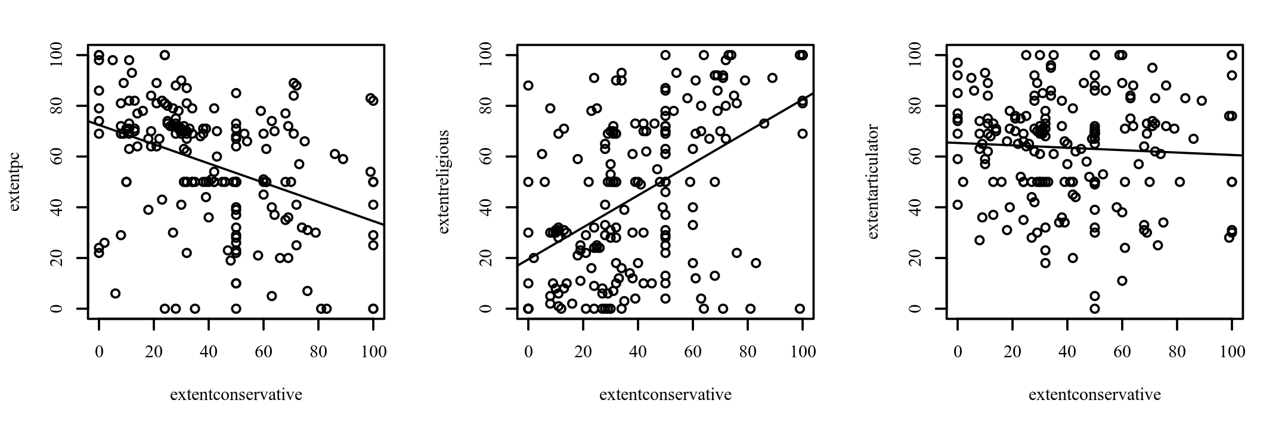

**Figure 22**

*Scatterplots between each variable with the regression line added*

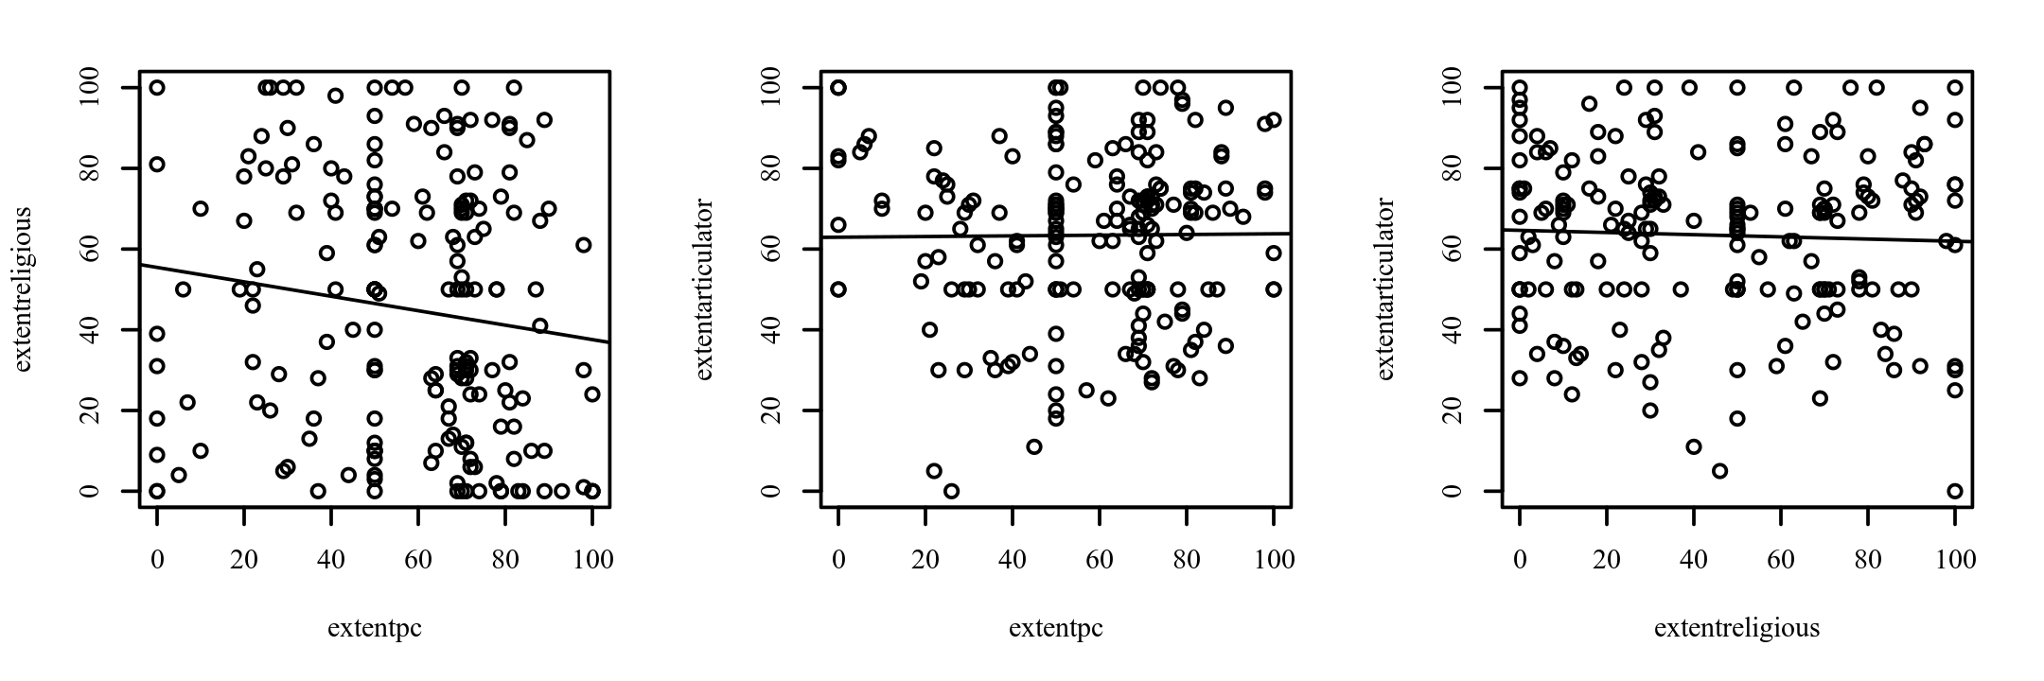

***Results***

The result of the correlations was examined using Holm corrections to adjust for multiple comparisons based on an alpha value of 0.05. A significant positive correlation was observed between extentspiritual and extentconservative (*r*p = 0.21, *p* = .003, 95% CI [0.07, 0.34]). The correlation coefficient between extentspiritual and extentconservative was 0.21, indicating a small effect size. This correlation indicates that as extentspiritual increases, extentconservative tends to increase. A significant positive correlation was observed between extentspiritual and extentreligious (*r*p = 0.55, *p* < .001, 95% CI [0.44, 0.64]). The correlation coefficient between extentspiritual and extentreligious was 0.55, indicating a large effect size. This correlation indicates that as extentspiritual increases, extentreligious tends to increase. A significant positive correlation was observed between extentdedicated and extentarticulator (*r*p = 0.26, *p* < .001, 95% CI [0.12, 0.39]). The correlation coefficient between extentdedicated and extentarticulator was 0.26, indicating a small effect size. This correlation indicates that as extentdedicated increases, extentarticulator tends to increase. A significant negative correlation was observed between extentconservative and extentpc (*r*p = -0.39, *p* < .001, 95% CI [-0.51, -0.27]). The correlation coefficient between extentconservative and extentpc was -0.39, indicating a moderate effect size. This correlation indicates that as extentconservative increases, extentpc tends to decrease. A significant positive correlation was observed between extentconservative and extentreligious (*r*p = 0.50, *p* < .001, 95% CI [0.38, 0.60]). The correlation coefficient between extentconservative and extentreligious was 0.50, indicating a moderate effect size. This correlation indicates that as extentconservative increases, extentreligious tends to increase. No other significant correlations were found. Table 9 presents the results of the correlations.

**Table 9**

*Pearson Correlation Results Among extentteamwork, extentspiritual, extentdedicated, extentconservative, extentpc, extentreligious, and extentarticulator*

|  |  |  |  |
| --- | --- | --- | --- |
| Combination | *r*p | 95% CI | *p* |
| extentteamwork-extentspiritual | 0.13 | [-0.01, 0.27] | .070 |
| extentteamwork-extentdedicated | -0.02 | [-0.16, 0.12] | .762 |
| extentteamwork-extentconservative | 0.01 | [-0.13, 0.15] | .914 |
| extentteamwork-extentpc | -0.06 | [-0.20, 0.08] | .421 |
| extentteamwork-extentreligious | 0.11 | [-0.03, 0.25] | .112 |
| extentteamwork-extentarticulator | 0.02 | [-0.12, 0.16] | .763 |
| extentspiritual-extentdedicated | -0.02 | [-0.16, 0.13] | .823 |
| extentspiritual-extentconservative | 0.21 | [0.07, 0.34] | .003 |
| extentspiritual-extentpc | -0.06 | [-0.20, 0.09] | .436 |
| extentspiritual-extentreligious | 0.55 | [0.44, 0.64] | < .001 |
| extentspiritual-extentarticulator | -0.01 | [-0.15, 0.14] | .938 |
| extentdedicated-extentconservative | -0.02 | [-0.16, 0.12] | .759 |
| extentdedicated-extentpc | -0.04 | [-0.18, 0.10] | .610 |
| extentdedicated-extentreligious | -0.05 | [-0.19, 0.09] | .468 |
| extentdedicated-extentarticulator | 0.26 | [0.12, 0.39] | < .001 |
| extentconservative-extentpc | -0.39 | [-0.51, -0.27] | < .001 |
| extentconservative-extentreligious | 0.50 | [0.38, 0.60] | < .001 |
| extentconservative-extentarticulator | -0.06 | [-0.20, 0.09] | .438 |
| extentpc-extentreligious | -0.14 | [-0.27, 0.01] | .059 |
| extentpc-extentarticulator | 0.01 | [-0.13, 0.15] | .894 |
| extentreligious-extentarticulator | -0.04 | [-0.18, 0.10] | .574 |

*Note.* *n* = 193. Holm corrections used to adjust *p*-values.

**Spearman Correlation Analysis**

***Introduction***

A Spearman correlation analysis was conducted among extentteamwork, extentspiritual, extentdedicated, extentconservative, extentpc, extentreligious, and extentarticulator. Cohen's standard was used to evaluate the strength of the relationships, where coefficients between .10 and .29 represent a small effect size, coefficients between .30 and .49 represent a moderate effect size, and coefficients above .50 indicate a large effect size (Cohen, 1988).

***Results***

The result of the correlations was examined using Holm corrections to adjust for multiple comparisons based on an alpha value of 0.05. A significant positive correlation was observed between extentspiritual and extentconservative (*r*s = 0.21, *p* = .004, 95% CI [0.07, 0.34]). The correlation coefficient between extentspiritual and extentconservative was 0.21, indicating a small effect size. This correlation indicates that as extentspiritual increases, extentconservative tends to increase. A significant positive correlation was observed between extentspiritual and extentreligious (*r*s = 0.52, *p* < .001, 95% CI [0.41, 0.61]). The correlation coefficient between extentspiritual and extentreligious was 0.52, indicating a large effect size. This correlation indicates that as extentspiritual increases, extentreligious tends to increase. A significant positive correlation was observed between extentdedicated and extentarticulator (*r*s = 0.29, *p* < .001, 95% CI [0.15, 0.41]). The correlation coefficient between extentdedicated and extentarticulator was 0.29, indicating a small effect size. This correlation indicates that as extentdedicated increases, extentarticulator tends to increase. A significant negative correlation was observed between extentconservative and extentpc (*r*s = -0.43, *p* < .001, 95% CI [-0.54, -0.31]). The correlation coefficient between extentconservative and extentpc was -0.43, indicating a moderate effect size. This correlation indicates that as extentconservative increases, extentpc tends to decrease. A significant positive correlation was observed between extentconservative and extentreligious (*r*s = 0.48, *p* < .001, 95% CI [0.37, 0.58]). The correlation coefficient between extentconservative and extentreligious was 0.48, indicating a moderate effect size. This correlation indicates that as extentconservative increases, extentreligious tends to increase. A significant negative correlation was observed between extentpc and extentreligious (*r*s = -0.17, *p* = .018, 95% CI [-0.30, -0.03]). The correlation coefficient between extentpc and extentreligious was -0.17, indicating a small effect size. This correlation indicates that as extentpc increases, extentreligious tends to decrease. No other significant correlations were found. Table 10 presents the results of the correlations.

**Table 10**

*Spearman Correlation Results Among extentteamwork, extentspiritual, extentdedicated, extentconservative, extentpc, extentreligious, and extentarticulator*

|  |  |  |  |
| --- | --- | --- | --- |
| Combination | *r*s | 95% CI | *p* |
| extentteamwork-extentspiritual | 0.12 | [-0.02, 0.26] | .099 |
| extentteamwork-extentdedicated | -0.03 | [-0.17, 0.11] | .651 |
| extentteamwork-extentconservative | 0.02 | [-0.12, 0.17] | .732 |
| extentteamwork-extentpc | -0.06 | [-0.20, 0.08] | .403 |
| extentteamwork-extentreligious | 0.10 | [-0.04, 0.24] | .162 |
| extentteamwork-extentarticulator | -0.03 | [-0.17, 0.12] | .722 |
| extentspiritual-extentdedicated | 0.01 | [-0.14, 0.15] | .941 |
| extentspiritual-extentconservative | 0.21 | [0.07, 0.34] | .004 |
| extentspiritual-extentpc | -0.06 | [-0.20, 0.08] | .371 |
| extentspiritual-extentreligious | 0.52 | [0.41, 0.61] | < .001 |
| extentspiritual-extentarticulator | 0.04 | [-0.10, 0.18] | .598 |
| extentdedicated-extentconservative | -0.04 | [-0.18, 0.10] | .564 |
| extentdedicated-extentpc | 0.01 | [-0.13, 0.15] | .897 |
| extentdedicated-extentreligious | -0.08 | [-0.22, 0.06] | .278 |
| extentdedicated-extentarticulator | 0.29 | [0.15, 0.41] | < .001 |
| extentconservative-extentpc | -0.43 | [-0.54, -0.31] | < .001 |
| extentconservative-extentreligious | 0.48 | [0.37, 0.58] | < .001 |
| extentconservative-extentarticulator | -0.05 | [-0.19, 0.09] | .499 |
| extentpc-extentreligious | -0.17 | [-0.30, -0.03] | .018 |
| extentpc-extentarticulator | 0.04 | [-0.10, 0.18] | .544 |
| extentreligious-extentarticulator | -0.02 | [-0.16, 0.12] | .791 |

*Note.* *n* = 193. Holm corrections used to adjust *p*-values.

**Pearson Correlation Analysis**

***Introduction***

A Pearson correlation analysis was conducted between extentfeminine and extentleader. Cohen's standard was used to evaluate the strength of the relationship, where coefficients between .10 and .29 represent a small effect size, coefficients between .30 and .49 represent a moderate effect size, and coefficients above .50 indicate a large effect size (Cohen, 1988).

***Assumptions***

**Linearity.** A Pearson correlation requires that the relationship between each pair of variables is linear (Conover & Iman, 1981). This assumption is violated if there is curvature among the points on the scatterplot between any pair of variables. Figure 23 presents the scatterplot of the correlation. A regression line has been added to assist the interpretation.

**Figure 23**

*Scatterplots between each variable with the regression line added*

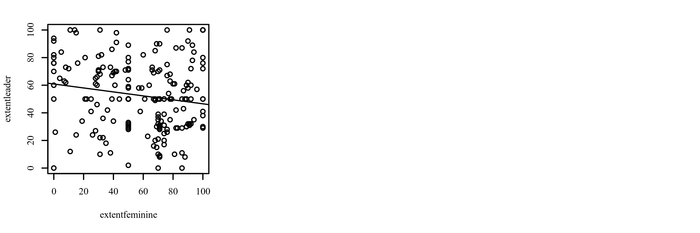

***Results***

The result of the correlation was examined based on an alpha value of 0.05. A significant negative correlation was observed between extentfeminine and extentleader (*r*p = -0.16, *p* = .022, 95% CI [-0.30, -0.02]). The correlation coefficient between extentfeminine and extentleader was -0.16, indicating a small effect size. This correlation indicates that as extentfeminine increases, extentleader tends to decrease. Table 11 presents the results of the correlation.

**Table 11**

*Pearson Correlation Results Between extentfeminine and extentleader*

|  |  |  |  |
| --- | --- | --- | --- |
| Combination | *r*p | 95% CI | *p* |
| extentfeminine-extentleader | -0.16 | [-0.30, -0.02] | .022 |

*Note.* *n* = 193.

**Pearson Correlation Analysis**

***Introduction***

A Pearson correlation analysis was conducted between extentcapitalism and extentleader. Cohen's standard was used to evaluate the strength of the relationship, where coefficients between .10 and .29 represent a small effect size, coefficients between .30 and .49 represent a moderate effect size, and coefficients above .50 indicate a large effect size (Cohen, 1988).

***Assumptions***

**Linearity.** A Pearson correlation requires that the relationship between each pair of variables is linear (Conover & Iman, 1981). This assumption is violated if there is curvature among the points on the scatterplot between any pair of variables. Figure 24 presents the scatterplot of the correlation. A regression line has been added to assist the interpretation.

**Figure 24**

*Scatterplots between each variable with the regression line added*

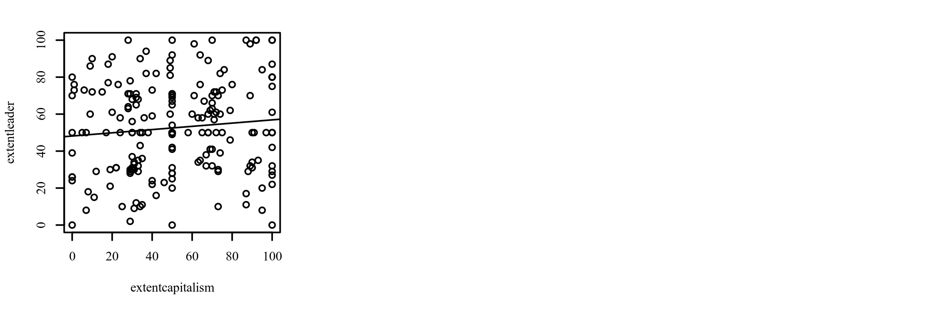

***Results***

The result of the correlation was examined based on an alpha value of 0.05. There were no significant correlations between any pairs of variables. Table 12 presents the results of the correlation.

**Table 12**

*Pearson Correlation Results Between extentcapitalism and extentleader*

|  |  |  |  |
| --- | --- | --- | --- |
| Combination | *r*p | 95% CI | *p* |
| extentcapitalism-extentleader | 0.10 | [-0.04, 0.24] | .164 |

*Note.* *n* = 193.

**Pearson Correlation Analysis**

***Introduction***

A Pearson correlation analysis was conducted between extentspiritual and extentleader. Cohen's standard was used to evaluate the strength of the relationship, where coefficients between .10 and .29 represent a small effect size, coefficients between .30 and .49 represent a moderate effect size, and coefficients above .50 indicate a large effect size (Cohen, 1988).

***Assumptions***

**Linearity.** A Pearson correlation requires that the relationship between each pair of variables is linear (Conover & Iman, 1981). This assumption is violated if there is curvature among the points on the scatterplot between any pair of variables. Figure 25 presents the scatterplot of the correlation. A regression line has been added to assist the interpretation.

**Figure 25**

*Scatterplots between each variable with the regression line added*

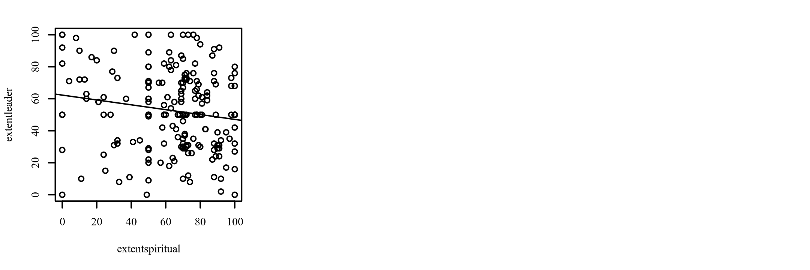

***Results***

The result of the correlation was examined based on an alpha value of 0.05. A significant negative correlation was observed between extentspiritual and extentleader (*r*p = -0.16, *p* = .029, 95% CI [-0.29, -0.02]). The correlation coefficient between extentspiritual and extentleader was -0.16, indicating a small effect size. This correlation indicates that as extentspiritual increases, extentleader tends to decrease. Table 13 presents the results of the correlation.

**Table 13**

*Pearson Correlation Results Between extentspiritual and extentleader*

|  |  |  |  |
| --- | --- | --- | --- |
| Combination | *r*p | 95% CI | *p* |
| extentspiritual-extentleader | -0.16 | [-0.29, -0.02] | .029 |

*Note.* *n* = 193.

**Pearson Correlation Analysis**

***Introduction***

A Pearson correlation analysis was conducted between extentleader and extentdedicated. Cohen's standard was used to evaluate the strength of the relationship, where coefficients between .10 and .29 represent a small effect size, coefficients between .30 and .49 represent a moderate effect size, and coefficients above .50 indicate a large effect size (Cohen, 1988).

***Assumptions***

**Linearity.** A Pearson correlation requires that the relationship between each pair of variables is linear (Conover & Iman, 1981). This assumption is violated if there is curvature among the points on the scatterplot between any pair of variables. Figure 26 presents the scatterplot of the correlation. A regression line has been added to assist the interpretation.

**Figure 26**

*Scatterplots between each variable with the regression line added*

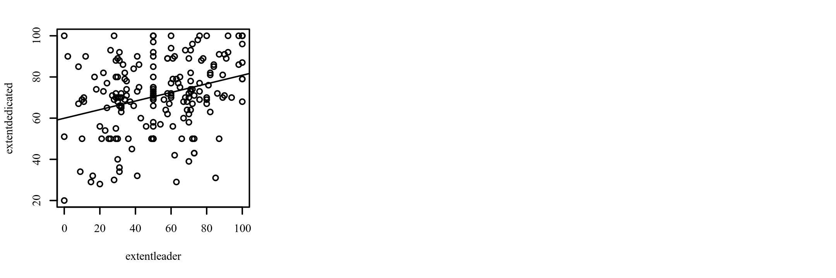

***Results***

The result of the correlation was examined based on an alpha value of 0.05. A significant positive correlation was observed between extentleader and extentdedicated (*r*p = 0.29, *p* < .001, 95% CI [0.16, 0.42]). The correlation coefficient between extentleader and extentdedicated was 0.29, indicating a small effect size. This correlation indicates that as extentleader increases, extentdedicated tends to increase. Table 14 presents the results of the correlation.

**Table 14**

*Pearson Correlation Results Between extentleader and extentdedicated*

|  |  |  |  |
| --- | --- | --- | --- |
| Combination | *r*p | 95% CI | *p* |
| extentleader-extentdedicated | 0.29 | [0.16, 0.42] | < .001 |

*Note.* *n* = 193.

**Pearson Correlation Analysis**

***Introduction***

A Pearson correlation analysis was conducted between extentleader and extentconservative. Cohen's standard was used to evaluate the strength of the relationship, where coefficients between .10 and .29 represent a small effect size, coefficients between .30 and .49 represent a moderate effect size, and coefficients above .50 indicate a large effect size (Cohen, 1988).

***Assumptions***

**Linearity.** A Pearson correlation requires that the relationship between each pair of variables is linear (Conover & Iman, 1981). This assumption is violated if there is curvature among the points on the scatterplot between any pair of variables. Figure 27 presents the scatterplot of the correlation. A regression line has been added to assist the interpretation.

**Figure 27**

*Scatterplots between each variable with the regression line added*

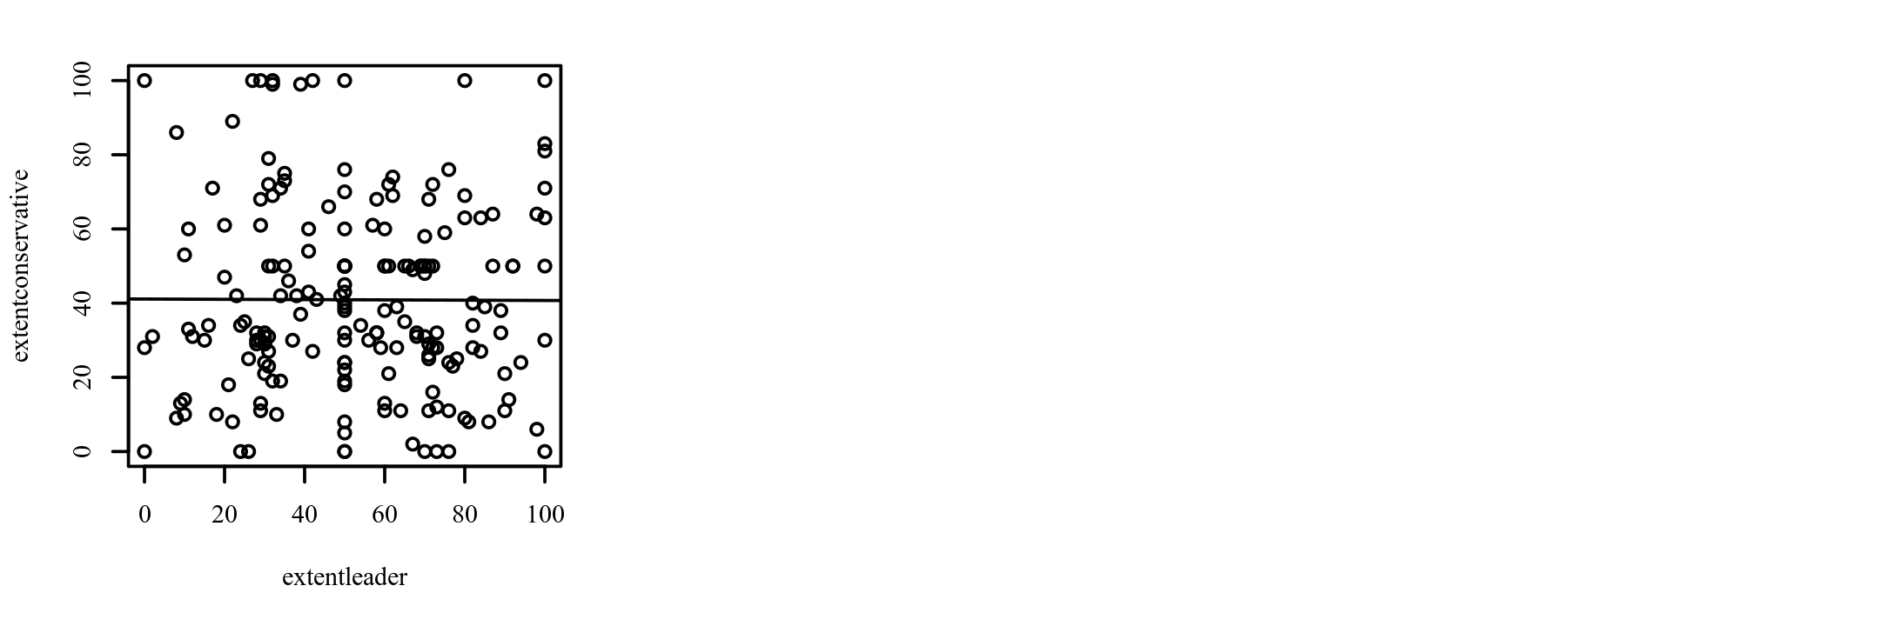

***Results***

The result of the correlation was examined based on an alpha value of 0.05. There were no significant correlations between any pairs of variables. Table 15 presents the results of the correlation.

**Table 15**

*Pearson Correlation Results Between extentleader and extentconservative*

|  |  |  |  |
| --- | --- | --- | --- |
| Combination | *r*p | 95% CI | *p* |
| extentleader-extentconservative | -0.00 | [-0.14, 0.14] | .958 |

*Note.* *n* = 193.

**Pearson Correlation Analysis**

***Introduction***

A Pearson correlation analysis was conducted between extentleader and extentprocrastinator. Cohen's standard was used to evaluate the strength of the relationship, where coefficients between .10 and .29 represent a small effect size, coefficients between .30 and .49 represent a moderate effect size, and coefficients above .50 indicate a large effect size (Cohen, 1988).

***Assumptions***

**Linearity.** A Pearson correlation requires that the relationship between each pair of variables is linear (Conover & Iman, 1981). This assumption is violated if there is curvature among the points on the scatterplot between any pair of variables. Figure 28 presents the scatterplot of the correlation. A regression line has been added to assist the interpretation.

**Figure 28**

*Scatterplots between each variable with the regression line added*

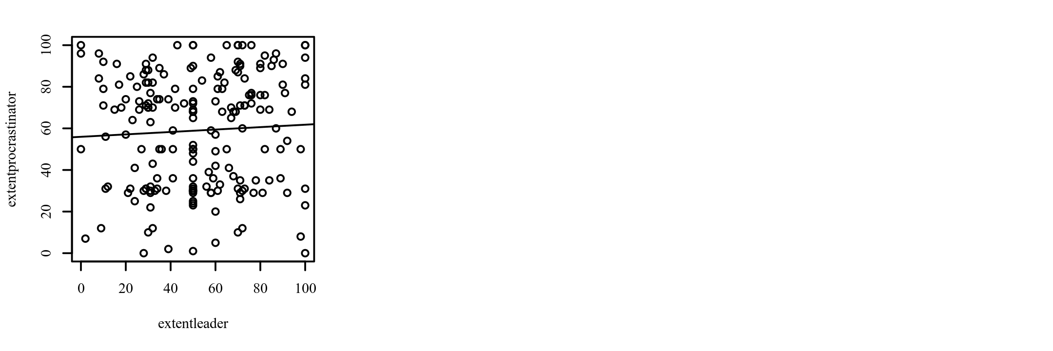

***Results***

The result of the correlation was examined based on an alpha value of 0.05. There were no significant correlations between any pairs of variables. Table 16 presents the results of the correlation.

**Table 16**

*Pearson Correlation Results Between extentleader and extentprocrastinator*

|  |  |  |  |
| --- | --- | --- | --- |
| Combination | *r*p | 95% CI | *p* |
| extentleader-extentprocrastinator | 0.05 | [-0.09, 0.19] | .457 |

*Note.* *n* = 193.

**Pearson Correlation Analysis**

***Introduction***

A Pearson correlation analysis was conducted between extentleader and extentpc. Cohen's standard was used to evaluate the strength of the relationship, where coefficients between .10 and .29 represent a small effect size, coefficients between .30 and .49 represent a moderate effect size, and coefficients above .50 indicate a large effect size (Cohen, 1988).

***Assumptions***

**Linearity.** A Pearson correlation requires that the relationship between each pair of variables is linear (Conover & Iman, 1981). This assumption is violated if there is curvature among the points on the scatterplot between any pair of variables. Figure 29 presents the scatterplot of the correlation. A regression line has been added to assist the interpretation.

**Figure 29**

*Scatterplots between each variable with the regression line added*

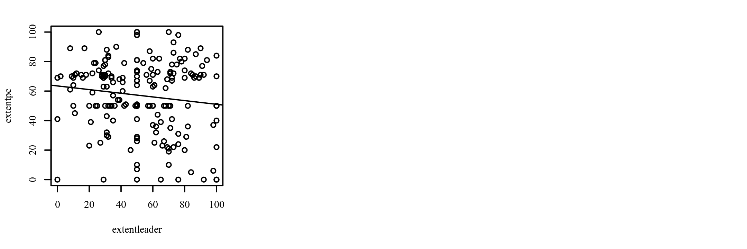

***Results***

The result of the correlation was examined based on an alpha value of 0.05. There were no significant correlations between any pairs of variables. Table 17 presents the results of the correlation.

**Table 17**

*Pearson Correlation Results Between extentleader and extentpc*

|  |  |  |  |
| --- | --- | --- | --- |
| Combination | *r*p | 95% CI | *p* |
| extentleader-extentpc | -0.13 | [-0.27, 0.01] | .073 |

*Note.* *n* = 193.

**Pearson Correlation Analysis**

***Introduction***

A Pearson correlation analysis was conducted between extentleader and extentpc. Cohen's standard was used to evaluate the strength of the relationship, where coefficients between .10 and .29 represent a small effect size, coefficients between .30 and .49 represent a moderate effect size, and coefficients above .50 indicate a large effect size (Cohen, 1988).

***Assumptions***

**Linearity.** A Pearson correlation requires that the relationship between each pair of variables is linear (Conover & Iman, 1981). This assumption is violated if there is curvature among the points on the scatterplot between any pair of variables. Figure 30 presents the scatterplot of the correlation. A regression line has been added to assist the interpretation.

**Figure 30**

*Scatterplots between each variable with the regression line added*



***Results***

The result of the correlation was examined based on an alpha value of 0.05. There were no significant correlations between any pairs of variables. Table 18 presents the results of the correlation.

**Table 18**

*Pearson Correlation Results Between extentleader and extentpc*

|  |  |  |  |
| --- | --- | --- | --- |
| Combination | *r*p | 95% CI | *p* |
| extentleader-extentpc | -0.13 | [-0.27, 0.01] | .073 |

*Note.* *n* = 193.

**Pearson Correlation Analysis**

***Introduction***

A Pearson correlation analysis was conducted between extentleader and extentteamwork. Cohen's standard was used to evaluate the strength of the relationship, where coefficients between .10 and .29 represent a small effect size, coefficients between .30 and .49 represent a moderate effect size, and coefficients above .50 indicate a large effect size (Cohen, 1988).

***Assumptions***

**Linearity.** A Pearson correlation requires that the relationship between each pair of variables is linear (Conover & Iman, 1981). This assumption is violated if there is curvature among the points on the scatterplot between any pair of variables. Figure 31 presents the scatterplot of the correlation. A regression line has been added to assist the interpretation.

**Figure 31**

*Scatterplots between each variable with the regression line added*

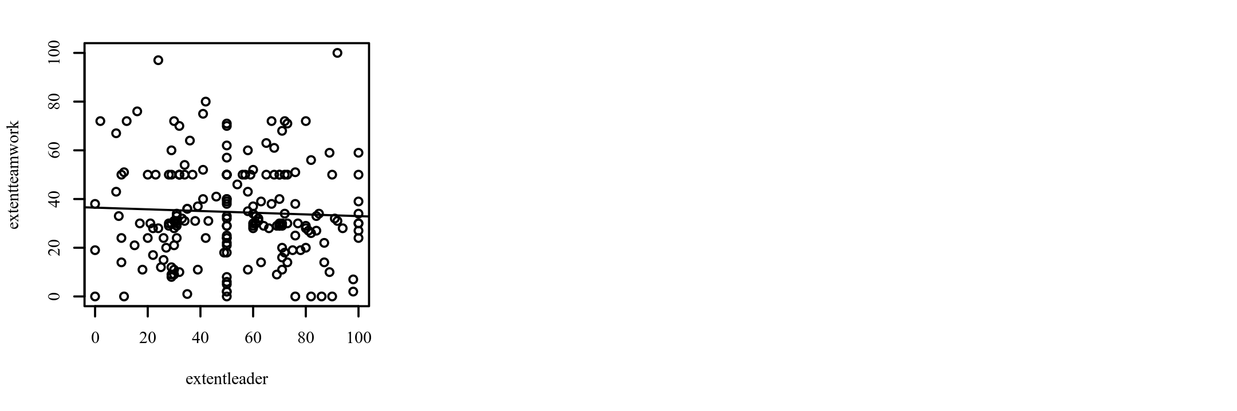

***Results***

The result of the correlation was examined based on an alpha value of 0.05. There were no significant correlations between any pairs of variables. Table 19 presents the results of the correlation.

**Table 19**

*Pearson Correlation Results Between extentleader and extentteamwork*

|  |  |  |  |
| --- | --- | --- | --- |
| Combination | *r*p | 95% CI | *p* |
| extentleader-extentteamwork | -0.04 | [-0.18, 0.10] | .543 |

*Note.* *n* = 193.

**Spearman Correlation Analysis**

***Introduction***

A Spearman correlation analysis was conducted between extentleader and extentteamwork. Cohen's standard was used to evaluate the strength of the relationship, where coefficients between .10 and .29 represent a small effect size, coefficients between .30 and .49 represent a moderate effect size, and coefficients above .50 indicate a large effect size (Cohen, 1988).

***Results***

The result of the correlation was examined based on an alpha value of 0.05. There were no significant correlations between any pairs of variables. Table 20 presents the results of the correlation.

**Table 20**

*Spearman Correlation Results Between extentleader and extentteamwork*

|  |  |  |  |
| --- | --- | --- | --- |
| Combination | *r*s | 95% CI | *p* |
| extentleader-extentteamwork | -0.03 | [-0.17, 0.11] | .676 |

*Note.* *n* = 193.

**Pearson Correlation Analysis**

***Introduction***

A Pearson correlation analysis was conducted between extentleader and extentreligious. Cohen's standard was used to evaluate the strength of the relationship, where coefficients between .10 and .29 represent a small effect size, coefficients between .30 and .49 represent a moderate effect size, and coefficients above .50 indicate a large effect size (Cohen, 1988).

***Assumptions***

**Linearity.** A Pearson correlation requires that the relationship between each pair of variables is linear (Conover & Iman, 1981). This assumption is violated if there is curvature among the points on the scatterplot between any pair of variables. Figure 32 presents the scatterplot of the correlation. A regression line has been added to assist the interpretation.

**Figure 32**

*Scatterplots between each variable with the regression line added*

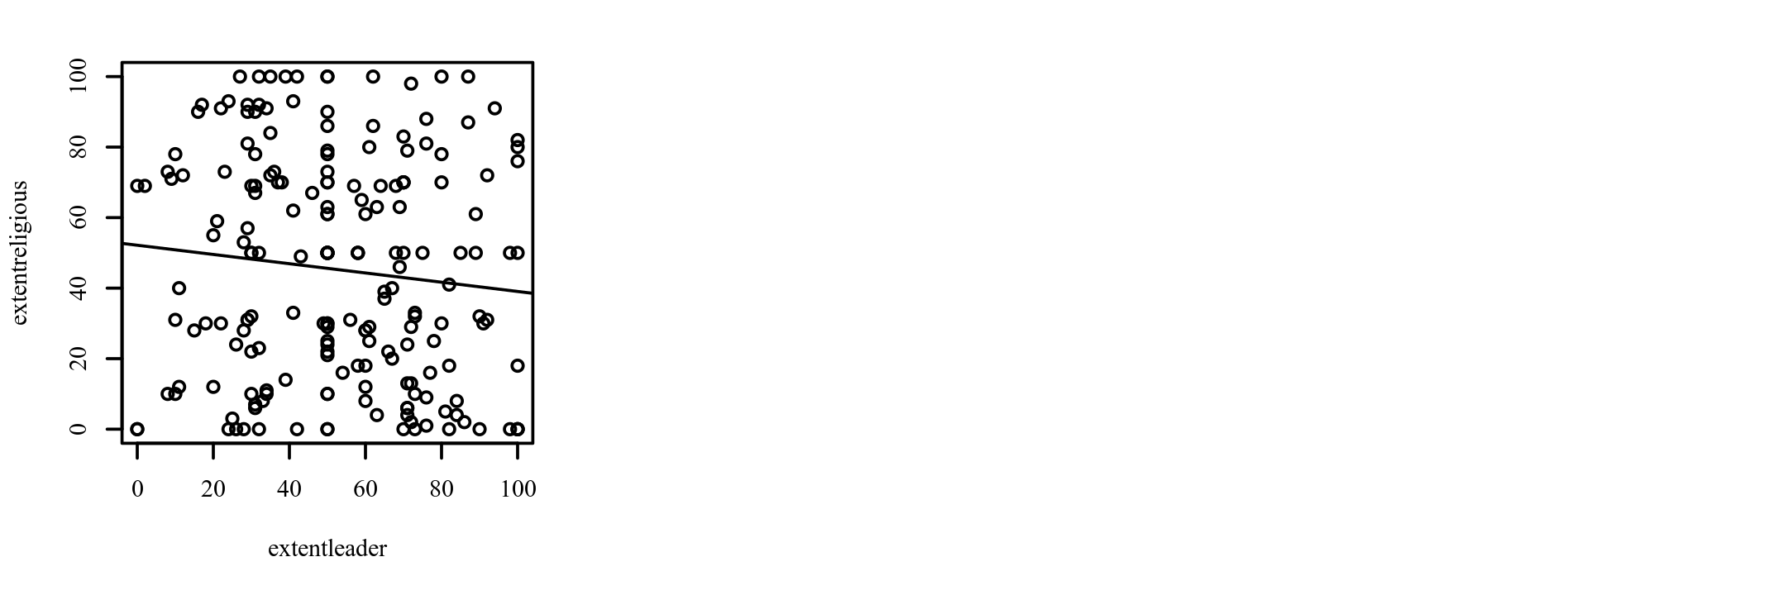

***Results***

The result of the correlation was examined based on an alpha value of 0.05. There were no significant correlations between any pairs of variables. Table 21 presents the results of the correlation.

**Table 21**

*Pearson Correlation Results Between extentleader and extentreligious*

|  |  |  |  |
| --- | --- | --- | --- |
| Combination | *r*p | 95% CI | *p* |
| extentleader-extentreligious | -0.10 | [-0.24, 0.04] | .151 |

*Note.* *n* = 193.

**Pearson Correlation Analysis**

***Introduction***

A Pearson correlation analysis was conducted between extentleader and extentliar. Cohen's standard was used to evaluate the strength of the relationship, where coefficients between .10 and .29 represent a small effect size, coefficients between .30 and .49 represent a moderate effect size, and coefficients above .50 indicate a large effect size (Cohen, 1988).

***Assumptions***

**Linearity.** A Pearson correlation requires that the relationship between each pair of variables is linear (Conover & Iman, 1981). This assumption is violated if there is curvature among the points on the scatterplot between any pair of variables. Figure 33 presents the scatterplot of the correlation. A regression line has been added to assist the interpretation.

**Figure 33**

*Scatterplots between each variable with the regression line added*

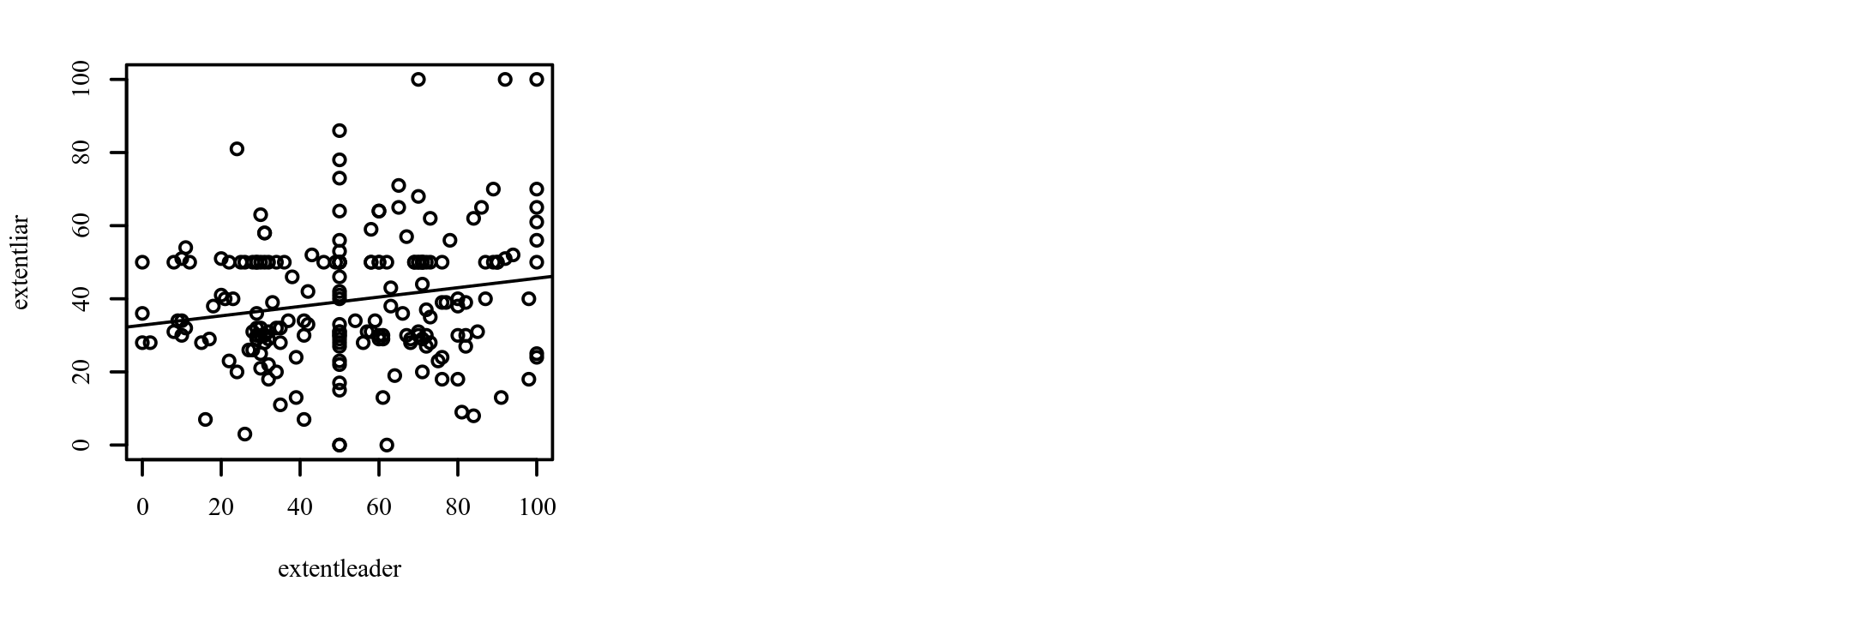

***Results***

The result of the correlation was examined based on an alpha value of 0.05. A significant positive correlation was observed between extentleader and extentliar (*r*p = 0.18, *p* = .012, 95% CI [0.04, 0.31]). The correlation coefficient between extentleader and extentliar was 0.18, indicating a small effect size. This correlation indicates that as extentleader increases, extentliar tends to increase. Table 22 presents the results of the correlation.

**Table 22**

*Pearson Correlation Results Between extentleader and extentliar*

|  |  |  |  |
| --- | --- | --- | --- |
| Combination | *r*p | 95% CI | *p* |
| extentleader-extentliar | 0.18 | [0.04, 0.31] | .012 |

*Note.* *n* = 193.

**Spearman Correlation Analysis**

***Introduction***

A Spearman correlation analysis was conducted between extentleader and extentliar. Cohen's standard was used to evaluate the strength of the relationship, where coefficients between .10 and .29 represent a small effect size, coefficients between .30 and .49 represent a moderate effect size, and coefficients above .50 indicate a large effect size (Cohen, 1988).

***Results***

The result of the correlation was examined based on an alpha value of 0.05. There were no significant correlations between any pairs of variables. Table 23 presents the results of the correlation.

**Table 23**

*Spearman Correlation Results Between extentleader and extentliar*

|  |  |  |  |
| --- | --- | --- | --- |
| Combination | *r*s | 95% CI | *p* |
| extentleader-extentliar | 0.14 | [-0.01, 0.27] | .060 |

*Note.* *n* = 193.

**Pearson Correlation Analysis**

***Introduction***

A Pearson correlation analysis was conducted between extentleader and extentarticulator. Cohen's standard was used to evaluate the strength of the relationship, where coefficients between .10 and .29 represent a small effect size, coefficients between .30 and .49 represent a moderate effect size, and coefficients above .50 indicate a large effect size (Cohen, 1988).

***Assumptions***

**Linearity.** A Pearson correlation requires that the relationship between each pair of variables is linear (Conover & Iman, 1981). This assumption is violated if there is curvature among the points on the scatterplot between any pair of variables. Figure 34 presents the scatterplot of the correlation. A regression line has been added to assist the interpretation.

**Figure 34**

*Scatterplots between each variable with the regression line added*

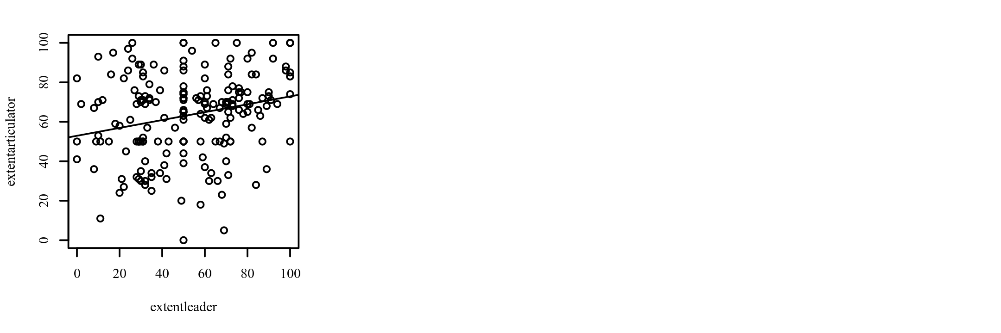

***Results***

The result of the correlation was examined based on an alpha value of 0.05. A significant positive correlation was observed between extentleader and extentarticulator (*r*p = 0.24, *p* < .001, 95% CI [0.10, 0.37]). The correlation coefficient between extentleader and extentarticulator was 0.24, indicating a small effect size. This correlation indicates that as extentleader increases, extentarticulator tends to increase. Table 24 presents the results of the correlation.

**Table 24**

*Pearson Correlation Results Between extentleader and extentarticulator*

|  |  |  |  |
| --- | --- | --- | --- |
| Combination | *r*p | 95% CI | *p* |
| extentleader-extentarticulator | 0.24 | [0.10, 0.37] | < .001 |

*Note.* *n* = 193.

**Pearson Correlation Analysis**

***Introduction***

A Pearson correlation analysis was conducted between extentfeminine and extentconservative. Cohen's standard was used to evaluate the strength of the relationship, where coefficients between .10 and .29 represent a small effect size, coefficients between .30 and .49 represent a moderate effect size, and coefficients above .50 indicate a large effect size (Cohen, 1988).

***Assumptions***

**Linearity.** A Pearson correlation requires that the relationship between each pair of variables is linear (Conover & Iman, 1981). This assumption is violated if there is curvature among the points on the scatterplot between any pair of variables. Figure 35 presents the scatterplot of the correlation. A regression line has been added to assist the interpretation.

**Figure 35**

*Scatterplots between each variable with the regression line added*

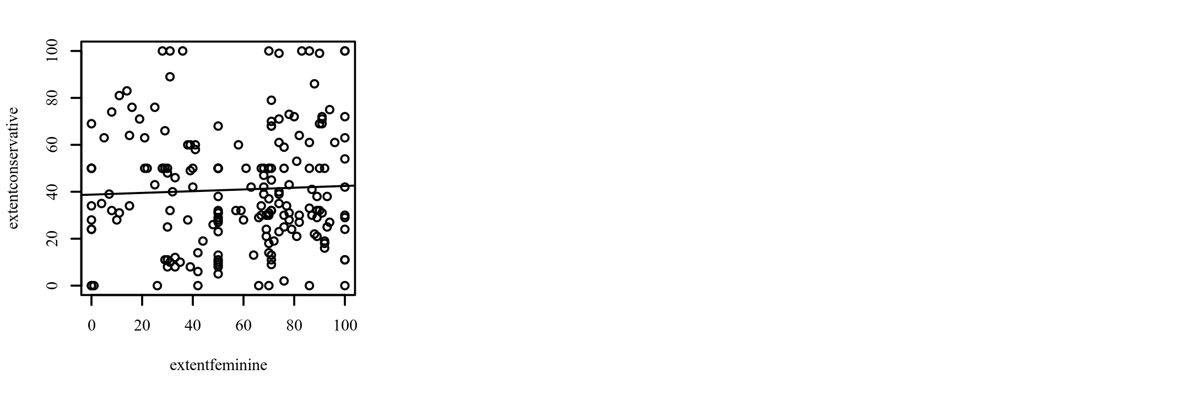

***Results***

The result of the correlation was examined based on an alpha value of 0.05. There were no significant correlations between any pairs of variables. Table 25 presents the results of the correlation.

**Table 25**

*Pearson Correlation Results Between extentfeminine and extentconservative*

|  |  |  |  |
| --- | --- | --- | --- |
| Combination | *r*p | 95% CI | *p* |
| extentfeminine-extentconservative | 0.04 | [-0.10, 0.18] | .556 |

*Note.* *n* = 193.

**Pearson Correlation Analysis**

***Introduction***

A Pearson correlation analysis was conducted between extentcapitalism and extentarticulator. Cohen's standard was used to evaluate the strength of the relationship, where coefficients between .10 and .29 represent a small effect size, coefficients between .30 and .49 represent a moderate effect size, and coefficients above .50 indicate a large effect size (Cohen, 1988).

***Assumptions***

**Linearity.** A Pearson correlation requires that the relationship between each pair of variables is linear (Conover & Iman, 1981). This assumption is violated if there is curvature among the points on the scatterplot between any pair of variables. Figure 36 presents the scatterplot of the correlation. A regression line has been added to assist the interpretation.

**Figure 36**

*Scatterplots between each variable with the regression line added*

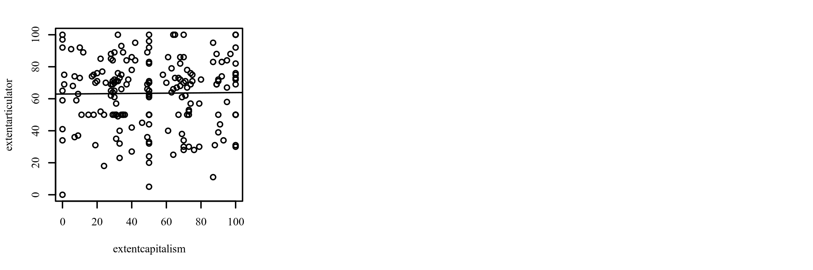

***Results***

The result of the correlation was examined based on an alpha value of 0.05. There were no significant correlations between any pairs of variables. Table 26 presents the results of the correlation.

**Table 26**

*Pearson Correlation Results Between extentcapitalism and extentarticulator*

|  |  |  |  |
| --- | --- | --- | --- |
| Combination | *r*p | 95% CI | *p* |
| extentcapitalism-extentarticulator | 0.01 | [-0.13, 0.15] | .865 |

*Note.* *n* = 193.

**Two-Tailed One Sample *z*-Test**

***Introduction***

A two-tailed one sample *z*-test was conducted to examine whether extentfeminine could have been produced by a probability distribution with a mean of 50.

***Assumptions***

**Normality.** A Shapiro-Wilk test was conducted to determine whether extentfeminine could have been produced by a normal distribution (Razali & Wah, 2011). The results of the Shapiro-Wilk test were significant based on an alpha value of 0.05, *W* = 0.94, *p* < .001. This result suggests extentfeminine is unlikely to have been produced by a normal distribution, indicating the normality assumption is violated.

***Results***

The result of the two-tailed one sample *z*-test was significant based on an alpha value of 0.05, *z* = 3.63, *p* < .001, indicating the null hypothesis can be rejected. This finding suggests extentfeminine was produced by a distribution with a mean that is greater than 50. The results are presented in Table 27.

**Table 27**

*Two-Tailed One Sample z-Test for the Difference between extentfeminine and 50*

|  |  |  |  |  |  |
| --- | --- | --- | --- | --- | --- |
| Variable | *M* | *SD* | μ | *z* | *p* |
| extentfeminine | 57.54 | 28.91 | 50 | 3.63 | < .001 |

*Note.* N = 193.

**Two-Tailed One Sample *z*-Test**

***Introduction***

A two-tailed one sample *z*-test was conducted to examine whether extentconservative could have been produced by a probability distribution with a mean of 50.

***Assumptions***

**Normality.** A Shapiro-Wilk test was conducted to determine whether extentconservative could have been produced by a normal distribution (Razali & Wah, 2011). The results of the Shapiro-Wilk test were significant based on an alpha value of 0.05, *W* = 0.96, *p* < .001. This result suggests extentconservative is unlikely to have been produced by a normal distribution, indicating the normality assumption is violated.

***Results***

The result of the two-tailed one sample *z*-test was significant based on an alpha value of 0.05, *z* = -5.04, *p* < .001, indicating the null hypothesis can be rejected. This finding suggests extentconservative was produced by a distribution with a mean that is less than 50. The results are presented in Table 28.

**Table 28**

*Two-Tailed One Sample z-Test for the Difference between extentconservative and 50*

|  |  |  |  |  |  |
| --- | --- | --- | --- | --- | --- |
| Variable | *M* | *SD* | μ | *z* | *p* |
| extentconservative | 40.91 | 25.05 | 50 | -5.04 | < .001 |

*Note.* N = 193.

**Two-Tailed One Sample *z*-Test**

***Introduction***

A two-tailed one sample *z*-test was conducted to examine whether extentteamwork could have been produced by a probability distribution with a mean of 50.

***Assumptions***

**Normality.** A Shapiro-Wilk test was conducted to determine whether extentteamwork could have been produced by a normal distribution (Razali & Wah, 2011). The results of the Shapiro-Wilk test were significant based on an alpha value of 0.05, *W* = 0.97, *p* < .001. This result suggests extentteamwork is unlikely to have been produced by a normal distribution, indicating the normality assumption is violated.

***Results***

The result of the two-tailed one sample *z*-test was significant based on an alpha value of 0.05, *z* = -10.76, *p* < .001, indicating the null hypothesis can be rejected. This finding suggests extentteamwork was produced by a distribution with a mean that is less than 50. The results are presented in Table 29.

**Table 29**

*Two-Tailed One Sample z-Test for the Difference between extentteamwork and 50*

|  |  |  |  |  |  |
| --- | --- | --- | --- | --- | --- |
| Variable | *M* | *SD* | μ | *z* | *p* |
| extentteamwork | 34.63 | 19.85 | 50 | -10.76 | < .001 |

*Note.* N = 193.

**Two-Tailed One Sample *z*-Test**

***Introduction***

A two-tailed one sample *z*-test was conducted to examine whether extentcapitalism could have been produced by a probability distribution with a mean of 50.

***Assumptions***

**Normality.** A Shapiro-Wilk test was conducted to determine whether extentcapitalism could have been produced by a normal distribution (Razali & Wah, 2011). The results of the Shapiro-Wilk test were significant based on an alpha value of 0.05, *W* = 0.96, *p* < .001. This result suggests extentcapitalism is unlikely to have been produced by a normal distribution, indicating the normality assumption is violated.

***Results***

The result of the two-tailed one sample *z*-test was not significant based on an alpha value of 0.05, *z* = 0.61, *p* = .539, indicating the null hypothesis cannot be rejected. This finding suggests extentcapitalism could have been produced by a distribution with a mean that is equal to 50. The results are presented in Table 30.

**Table 30**

*Two-Tailed One Sample z-Test for the Difference between extentcapitalism and 50*

|  |  |  |  |  |  |
| --- | --- | --- | --- | --- | --- |
| Variable | *M* | *SD* | μ | *z* | *p* |
| extentcapitalism | 51.28 | 28.94 | 50 | 0.61 | .539 |

*Note.* N = 193.

**Two-Tailed One Sample *z*-Test**

***Introduction***

A two-tailed one sample *z*-test was conducted to examine whether extentleader could have been produced by a probability distribution with a mean of 50.

***Assumptions***

**Normality.** A Shapiro-Wilk test was conducted to determine whether extentleader could have been produced by a normal distribution (Razali & Wah, 2011). The results of the Shapiro-Wilk test were significant based on an alpha value of 0.05, *W* = 0.98, *p* = .003. This result suggests extentleader is unlikely to have been produced by a normal distribution, indicating the normality assumption is violated.

***Results***

The result of the two-tailed one sample *z*-test was not significant based on an alpha value of 0.05, *z* = 1.45, *p* = .146, indicating the null hypothesis cannot be rejected. This finding suggests extentleader could have been produced by a distribution with a mean that is equal to 50. The results are presented in Table 31.

**Table 31**

*Two-Tailed One Sample z-Test for the Difference between extentleader and 50*

|  |  |  |  |  |  |
| --- | --- | --- | --- | --- | --- |
| Variable | *M* | *SD* | μ | *z* | *p* |
| extentleader | 52.63 | 25.13 | 50 | 1.45 | .146 |

*Note.* N = 193.

**Two-Tailed One Sample *z*-Test**

***Introduction***

A two-tailed one sample *z*-test was conducted to examine whether extentreligious could have been produced by a probability distribution with a mean of 50.

***Assumptions***

**Normality.** A Shapiro-Wilk test was conducted to determine whether extentreligious could have been produced by a normal distribution (Razali & Wah, 2011). The results of the Shapiro-Wilk test were significant based on an alpha value of 0.05, *W* = 0.93, *p* < .001. This result suggests extentreligious is unlikely to have been produced by a normal distribution, indicating the normality assumption is violated.

***Results***

The result of the two-tailed one sample *z*-test was significant based on an alpha value of 0.05, *z* = -2.07, *p* = .039, indicating the null hypothesis can be rejected. This finding suggests extentreligious was produced by a distribution with a mean that is less than 50. The results are presented in Table 32.

**Table 32**

*Two-Tailed One Sample z-Test for the Difference between extentreligious and 50*

|  |  |  |  |  |  |
| --- | --- | --- | --- | --- | --- |
| Variable | *M* | *SD* | μ | *z* | *p* |
| extentreligious | 45.26 | 31.79 | 50 | -2.07 | .039 |

*Note.* N = 193.

**Two-Tailed One Sample *z*-Test**

***Introduction***

A two-tailed one sample *z*-test was conducted to examine whether extentspiritual could have been produced by a probability distribution with a mean of 50.

***Assumptions***

**Normality.** A Shapiro-Wilk test was conducted to determine whether extentspiritual could have been produced by a normal distribution (Razali & Wah, 2011). The results of the Shapiro-Wilk test were significant based on an alpha value of 0.05, *W* = 0.92, *p* < .001. This result suggests extentspiritual is unlikely to have been produced by a normal distribution, indicating the normality assumption is violated.

***Results***

The result of the two-tailed one sample *z*-test was significant based on an alpha value of 0.05, *z* = 7.24, *p* < .001, indicating the null hypothesis can be rejected. This finding suggests extentspiritual was produced by a distribution with a mean that is greater than 50. The results are presented in Table 33.

**Table 33**

*Two-Tailed One Sample z-Test for the Difference between extentspiritual and 50*

|  |  |  |  |  |  |
| --- | --- | --- | --- | --- | --- |
| Variable | *M* | *SD* | μ | *z* | *p* |
| extentspiritual | 63.54 | 26.00 | 50 | 7.24 | < .001 |

*Note.* N = 193.

**Two-Tailed One Sample *z*-Test**

***Introduction***

A two-tailed one sample *z*-test was conducted to examine whether extentprocrastinator could have been produced by a probability distribution with a mean of 50.

***Assumptions***

**Normality.** A Shapiro-Wilk test was conducted to determine whether extentprocrastinator could have been produced by a normal distribution (Razali & Wah, 2011). The results of the Shapiro-Wilk test were significant based on an alpha value of 0.05, *W* = 0.94, *p* < .001. This result suggests extentprocrastinator is unlikely to have been produced by a normal distribution, indicating the normality assumption is violated.

***Results***

The result of the two-tailed one sample *z*-test was significant based on an alpha value of 0.05, *z* = 4.61, *p* < .001, indicating the null hypothesis can be rejected. This finding suggests extentprocrastinator was produced by a distribution with a mean that is greater than 50. The results are presented in Table 34.

**Table 34**

*Two-Tailed One Sample z-Test for the Difference between extentprocrastinator and 50*

|  |  |  |  |  |  |
| --- | --- | --- | --- | --- | --- |
| Variable | *M* | *SD* | μ | *z* | *p* |
| extentprocrastinator | 59.01 | 27.15 | 50 | 4.61 | < .001 |

*Note.* N = 193.

**Two-Tailed One Sample *z*-Test**

***Introduction***

A two-tailed one sample *z*-test was conducted to examine whether extentliar could have been produced by a probability distribution with a mean of 50.

***Assumptions***

**Normality.** A Shapiro-Wilk test was conducted to determine whether extentliar could have been produced by a normal distribution (Razali & Wah, 2011). The results of the Shapiro-Wilk test were significant based on an alpha value of 0.05, *W* = 0.96, *p* < .001. This result suggests extentliar is unlikely to have been produced by a normal distribution, indicating the normality assumption is violated.

***Results***

The result of the two-tailed one sample *z*-test was significant based on an alpha value of 0.05, *z* = -8.18, *p* < .001, indicating the null hypothesis can be rejected. This finding suggests extentliar was produced by a distribution with a mean that is less than 50. The results are presented in Table 35.

**Table 35**

*Two-Tailed One Sample z-Test for the Difference between extentliar and 50*

|  |  |  |  |  |  |
| --- | --- | --- | --- | --- | --- |
| Variable | *M* | *SD* | μ | *z* | *p* |
| extentliar | 39.53 | 17.78 | 50 | -8.18 | < .001 |

*Note.* N = 193.

**Two-Tailed One Sample *z*-Test**

***Introduction***

A two-tailed one sample *z*-test was conducted to examine whether extentdedicated could have been produced by a probability distribution with a mean of 50.

***Assumptions***

**Normality.** A Shapiro-Wilk test was conducted to determine whether extentdedicated could have been produced by a normal distribution (Razali & Wah, 2011). The results of the Shapiro-Wilk test were significant based on an alpha value of 0.05, *W* = 0.96, *p* < .001. This result suggests extentdedicated is unlikely to have been produced by a normal distribution, indicating the normality assumption is violated.

***Results***

The result of the two-tailed one sample *z*-test was significant based on an alpha value of 0.05, *z* = 16.32, *p* < .001, indicating the null hypothesis can be rejected. This finding suggests extentdedicated was produced by a distribution with a mean that is greater than 50. The results are presented in Table 36.

**Table 36**

*Two-Tailed One Sample z-Test for the Difference between extentdedicated and 50*

|  |  |  |  |  |  |
| --- | --- | --- | --- | --- | --- |
| Variable | *M* | *SD* | μ | *z* | *p* |
| extentdedicated | 70.95 | 17.83 | 50 | 16.32 | < .001 |

*Note.* N = 193.

**Two-Tailed One Sample *z*-Test**

***Introduction***

A two-tailed one sample *z*-test was conducted to examine whether extentpc could have been produced by a probability distribution with a mean of 50.

***Assumptions***

**Normality.** A Shapiro-Wilk test was conducted to determine whether extentpc could have been produced by a normal distribution (Razali & Wah, 2011). The results of the Shapiro-Wilk test were significant based on an alpha value of 0.05, *W* = 0.95, *p* < .001. This result suggests extentpc is unlikely to have been produced by a normal distribution, indicating the normality assumption is violated.

***Results***

The result of the two-tailed one sample *z*-test was significant based on an alpha value of 0.05, *z* = 3.98, *p* < .001, indicating the null hypothesis can be rejected. This finding suggests extentpc was produced by a distribution with a mean that is greater than 50. The results are presented in Table 37.

**Table 37**

*Two-Tailed One Sample z-Test for the Difference between extentpc and 50*

|  |  |  |  |  |  |
| --- | --- | --- | --- | --- | --- |
| Variable | *M* | *SD* | μ | *z* | *p* |
| extentpc | 56.93 | 24.20 | 50 | 3.98 | < .001 |

*Note.* N = 193.

**Two-Tailed One Sample *z*-Test**

***Introduction***

A two-tailed one sample *z*-test was conducted to examine whether extentarticulator could have been produced by a probability distribution with a mean of 50.

***Assumptions***

**Normality.** A Shapiro-Wilk test was conducted to determine whether extentarticulator could have been produced by a normal distribution (Razali & Wah, 2011). The results of the Shapiro-Wilk test were significant based on an alpha value of 0.05, *W* = 0.97, *p* < .001. This result suggests extentarticulator is unlikely to have been produced by a normal distribution, indicating the normality assumption is violated.

***Results***

The result of the two-tailed one sample *z*-test was significant based on an alpha value of 0.05, *z* = 8.82, *p* < .001, indicating the null hypothesis can be rejected. This finding suggests extentarticulator was produced by a distribution with a mean that is greater than 50. The results are presented in Table 38.

**Table 38**

*Two-Tailed One Sample z-Test for the Difference between extentarticulator and 50*

|  |  |  |  |  |  |
| --- | --- | --- | --- | --- | --- |
| Variable | *M* | *SD* | μ | *z* | *p* |
| extentarticulator | 63.41 | 21.14 | 50 | 8.82 | < .001 |

*Note.* N = 193.

**Two-Tailed Paired Samples *t*-Test**

***Introduction***

A two-tailed paired samples *t*-test was conducted to examine whether the mean difference of extentconservative and extentcapitalism was significantly different from zero.

***Assumptions***

**Normality.** A Shapiro-Wilk test was conducted to determine whether the differences in extentconservative and extentcapitalism could have been produced by a normal distribution (Razali & Wah, 2011). The results of the Shapiro-Wilk test were significant based on an alpha value of 0.05, *W* = 0.97, *p* = .001. This result suggests the differences in extentconservative and extentcapitalism are unlikely to have been produced by a normal distribution, indicating the normality assumption is violated.

**Homogeneity of Variance.** Levene's test was conducted to assess whether the variances of extentconservative and extentcapitalism were significantly different. The result of Levene's test for was significant based on an alpha value of 0.05, *F*(1, 384) = 6.28, *p* = .013. This result suggests it is unlikely that extentconservative and extentcapitalism were produced by distributions with equal variances, indicating the assumption of homogeneity of variance was violated.

***Results***

The result of the two-tailed paired samples *t*-test was significant based on an alpha value of 0.05, *t*(192) = -7.73, *p* < .001, indicating the null hypothesis can be rejected. This finding suggests the difference in the mean of extentconservative and the mean of extentcapitalism was significantly different from zero. The mean of extentconservative was significantly lower than the mean of extentcapitalism. The results are presented in Table 39. A bar plot of the means is presented in Figure 37.

**Table 39**

*Two-Tailed Paired Samples t-Test for the Difference Between extentconservative and extentcapitalism*

|  |  |  |  |  |  |  |
| --- | --- | --- | --- | --- | --- | --- |
| extentconservative | | extentcapitalism | |  |  |  |
| *M* | *SD* | *M* | *SD* | *t* | *p* | *d* |
| 40.91 | 25.05 | 51.28 | 28.94 | -7.73 | < .001 | 0.56 |

*Note.* N = 193. Degrees of Freedom for the *t*-statistic = 192. *d* represents Cohen's *d.*

**Figure 37**

*The means of extentconservative and extentcapitalism*

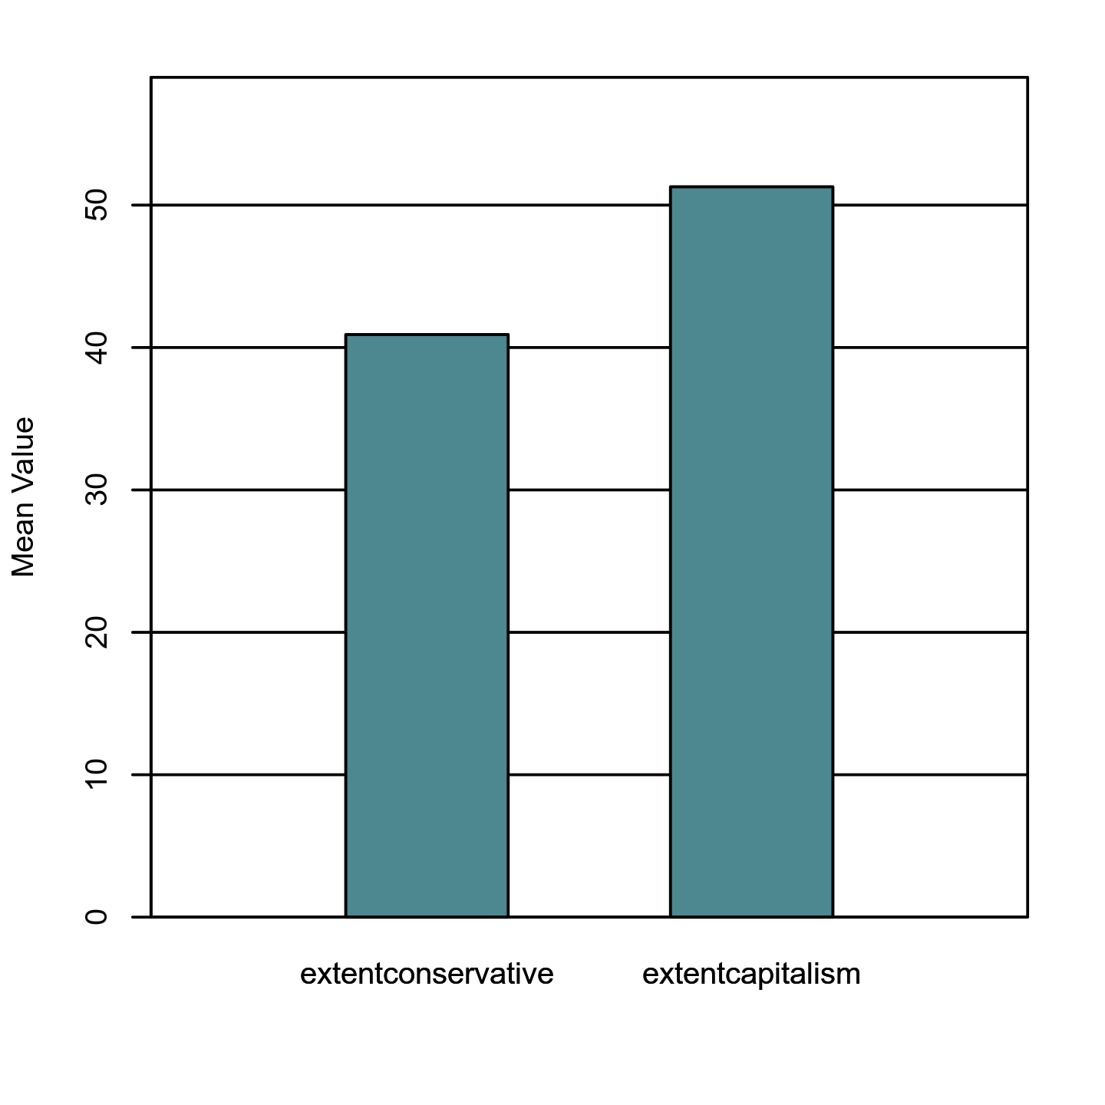

**Two-Tailed Wilcoxon Signed Rank Test**

***Introduction***

A two-tailed Wilcoxon signed rank test was conducted to examine whether there was a significant difference between extentconservative and extentcapitalism. The two-tailed Wilcoxon signed rank test is a non-parametric alternative to the paired samples *t*-test and does not share its distributional assumptions (Conover & Iman, 1981).

***Results***

The results of the two-tailed Wilcoxon signed rank test were significant based on an alpha value of 0.05, *V* = 2546.50, *z* = -7.07, *p* < .001. This indicates that the differences between extentconservative and extentcapitalism are not likely due to random variation. The median of extentconservative (*Mdn* = 37.00) was significantly lower than the median of extentcapitalism (*Mdn* = 50.00). Figure 38 presents a boxplot of the ranked values of extentconservative and extentcapitalism.

**Figure 38**

*Ranked values of extentconservative and extentcapitalism*

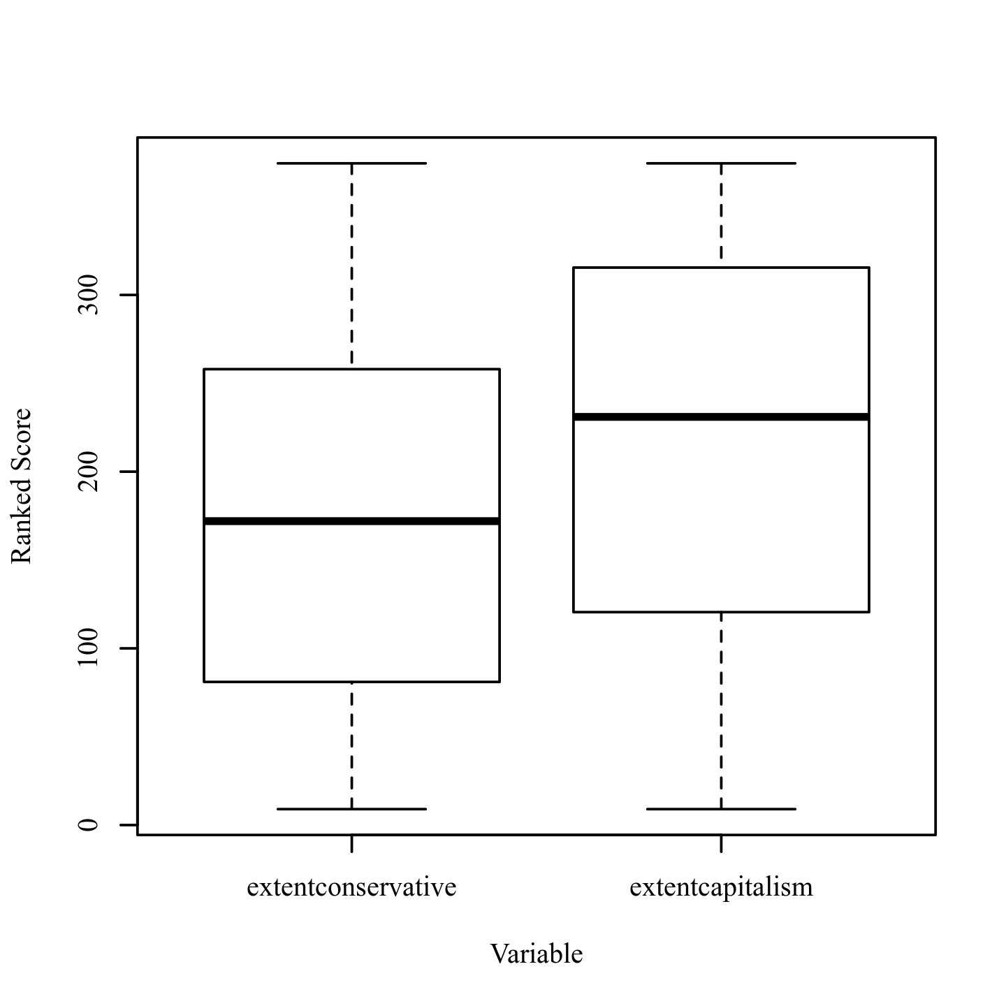

**Two-Tailed Paired Samples *t*-Test**

***Introduction***

A two-tailed paired samples *t*-test was conducted to examine whether the mean difference of extentconservative and extentreligious was significantly different from zero.

***Assumptions***

**Normality.** A Shapiro-Wilk test was conducted to determine whether the differences in extentconservative and extentreligious could have been produced by a normal distribution (Razali & Wah, 2011). The results of the Shapiro-Wilk test were not significant based on an alpha value of 0.05, *W* = 0.99, *p* = .057. This result suggests the possibility that the differences in extentconservative and extentreligious were produced by a normal distribution cannot be ruled out, indicating the normality assumption is met.

**Homogeneity of Variance.** Levene's test was conducted to assess whether the variances of extentconservative and extentreligious were significantly different. The result of Levene's test for was significant based on an alpha value of 0.05, *F*(1, 384) = 25.09, *p* < .001. This result suggests it is unlikely that extentconservative and extentreligious were produced by distributions with equal variances, indicating the assumption of homogeneity of variance was violated.

***Results***

The result of the two-tailed paired samples *t*-test was significant based on an alpha value of 0.05, *t*(192) = -2.08, *p* = .039, indicating the null hypothesis can be rejected. This finding suggests the difference in the mean of extentconservative and the mean of extentreligious was significantly different from zero. The mean of extentconservative was significantly lower than the mean of extentreligious. The results are presented in Table 40. A bar plot of the means is presented in Figure 39.

**Table 40**

*Two-Tailed Paired Samples t-Test for the Difference Between extentconservative and extentreligious*

|  |  |  |  |  |  |  |
| --- | --- | --- | --- | --- | --- | --- |
| extentconservative | | extentreligious | |  |  |  |
| *M* | *SD* | *M* | *SD* | *t* | *p* | *d* |
| 40.91 | 25.05 | 45.26 | 31.79 | -2.08 | .039 | 0.15 |

*Note.* N = 193. Degrees of Freedom for the *t*-statistic = 192. *d* represents Cohen's *d.*

**Figure 39**

*The means of extentconservative and extentreligious*

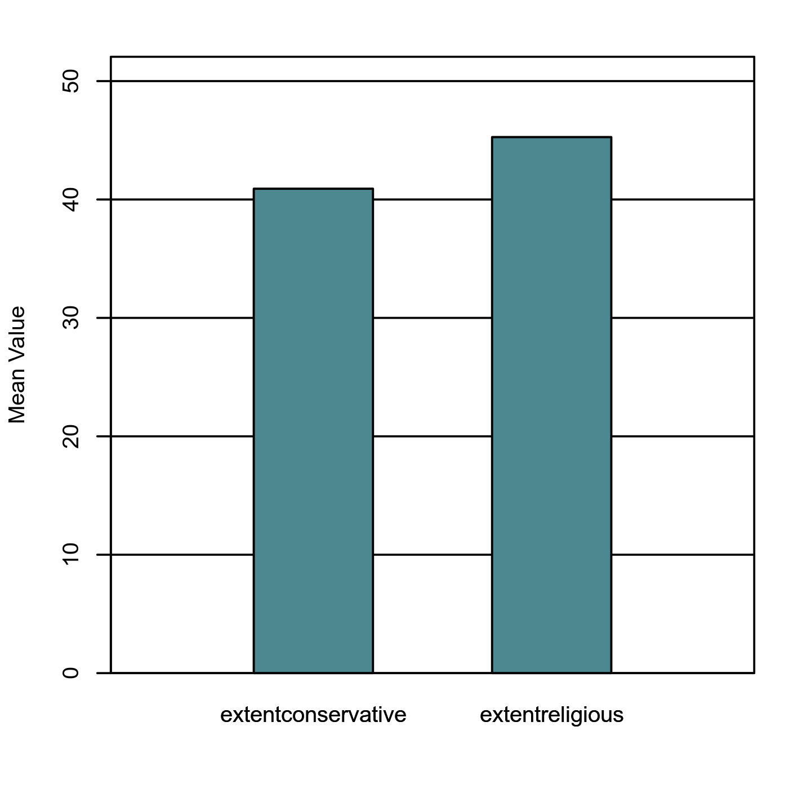

**Two-Tailed Wilcoxon Signed Rank Test**

***Introduction***

A two-tailed Wilcoxon signed rank test was conducted to examine whether there was a significant difference between extentconservative and extentreligious. The two-tailed Wilcoxon signed rank test is a non-parametric alternative to the paired samples *t*-test and does not share its distributional assumptions (Conover & Iman, 1981).

***Results***

The results of the two-tailed Wilcoxon signed rank test were significant based on an alpha value of 0.05, *V* = 6179.00, *z* = -2.38, *p* = .017. This indicates that the differences between extentconservative and extentreligious are not likely due to random variation. The median of extentconservative (*Mdn* = 37.00) was significantly lower than the median of extentreligious (*Mdn* = 50.00). Figure 40 presents a boxplot of the ranked values of extentconservative and extentreligious.

**Figure 40**

*Ranked values of extentconservative and extentreligious*

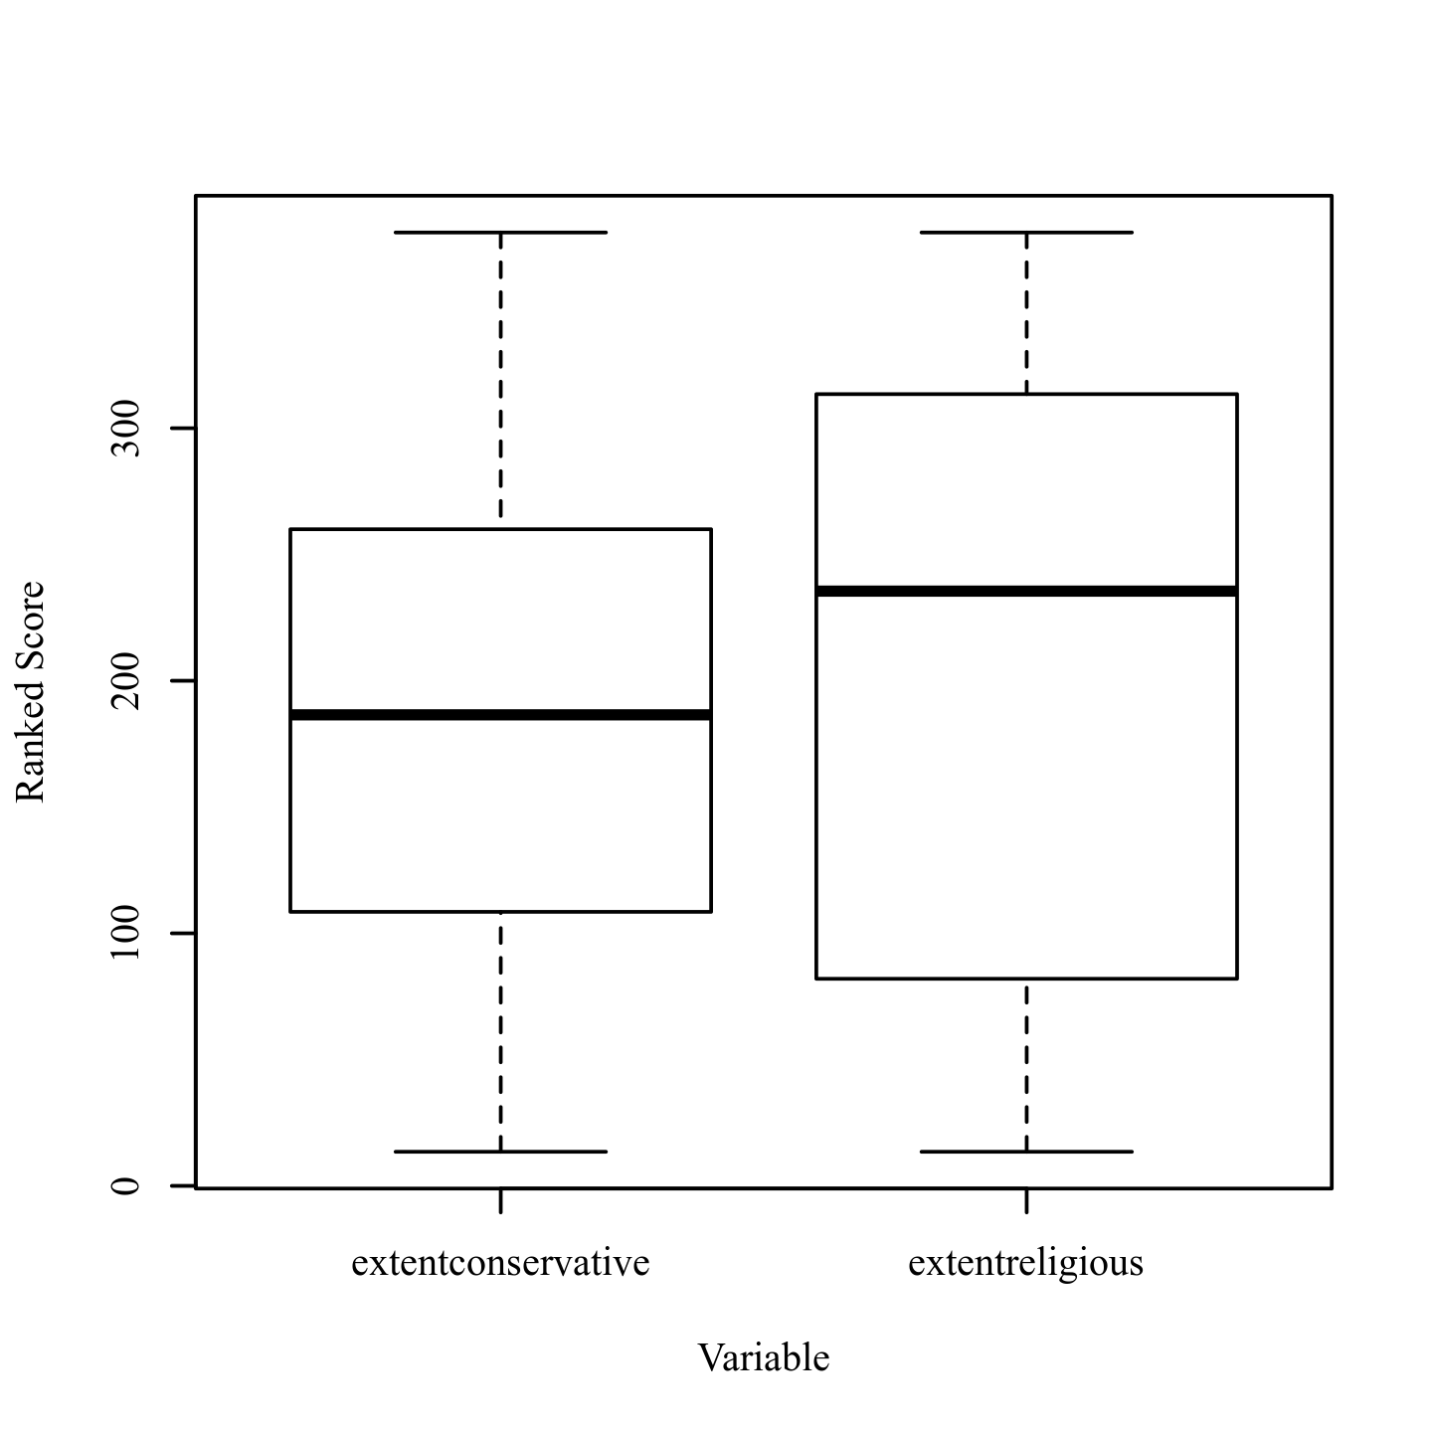

**Two-Tailed Paired Samples *t*-Test**

***Introduction***

A two-tailed paired samples *t*-test was conducted to examine whether the mean difference of extentteamwork and extentleader was significantly different from zero.

***Assumptions***

**Normality.** A Shapiro-Wilk test was conducted to determine whether the differences in extentteamwork and extentleader could have been produced by a normal distribution (Razali & Wah, 2011). The results of the Shapiro-Wilk test were not significant based on an alpha value of 0.05, *W* = 0.99, *p* = .455. This result suggests the possibility that the differences in extentteamwork and extentleader were produced by a normal distribution cannot be ruled out, indicating the normality assumption is met.

**Homogeneity of Variance.** Levene's test was conducted to assess whether the variances of extentteamwork and extentleader were significantly different. The result of Levene's test for was significant based on an alpha value of 0.05, *F*(1, 384) = 16.29, *p* < .001. This result suggests it is unlikely that extentteamwork and extentleader were produced by distributions with equal variances, indicating the assumption of homogeneity of variance was violated.

***Results***

The result of the two-tailed paired samples *t*-test was significant based on an alpha value of 0.05, *t*(192) = -7.64, *p* < .001, indicating the null hypothesis can be rejected. This finding suggests the difference in the mean of extentteamwork and the mean of extentleader was significantly different from zero. The mean of extentteamwork was significantly lower than the mean of extentleader. The results are presented in Table 41. A bar plot of the means is presented in Figure 41.

**Table 41**

*Two-Tailed Paired Samples t-Test for the Difference Between extentteamwork and extentleader*

|  |  |  |  |  |  |  |
| --- | --- | --- | --- | --- | --- | --- |
| extentteamwork | | extentleader | |  |  |  |
| *M* | *SD* | *M* | *SD* | *t* | *p* | *d* |
| 34.63 | 19.85 | 52.63 | 25.13 | -7.64 | < .001 | 0.55 |

*Note.* N = 193. Degrees of Freedom for the *t*-statistic = 192. *d* represents Cohen's *d.*

**Figure 41**

*The means of extentteamwork and extentleader*

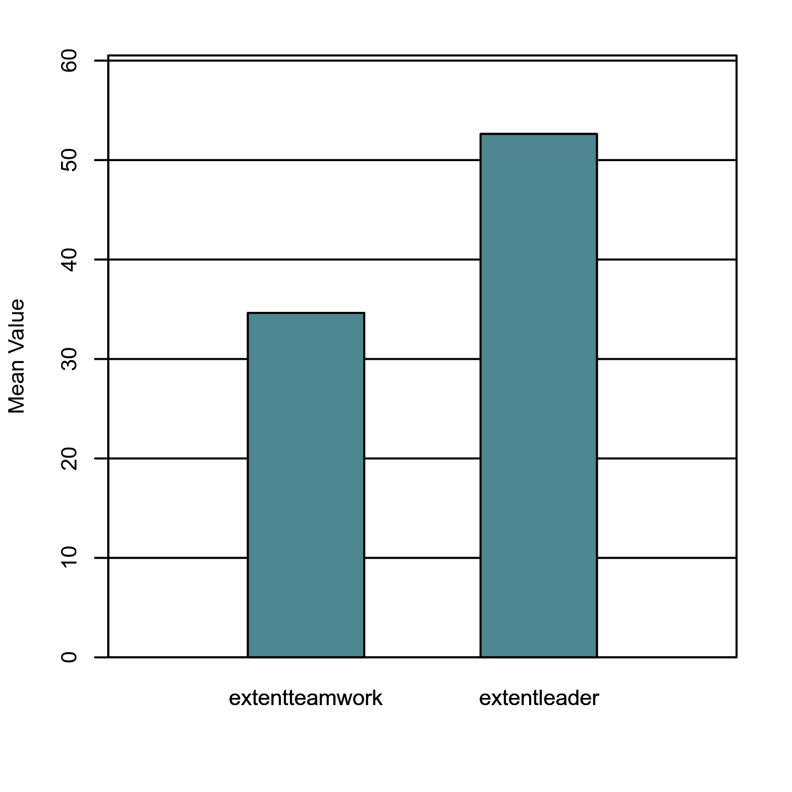

**Two-Tailed Wilcoxon Signed Rank Test**

***Introduction***

A two-tailed Wilcoxon signed rank test was conducted to examine whether there was a significant difference between extentteamwork and extentleader. The two-tailed Wilcoxon signed rank test is a non-parametric alternative to the paired samples *t*-test and does not share its distributional assumptions (Conover & Iman, 1981).

***Results***

The results of the two-tailed Wilcoxon signed rank test were significant based on an alpha value of 0.05, *V* = 3627.00, *z* = -6.89, *p* < .001. This indicates that the differences between extentteamwork and extentleader are not likely due to random variation. The median of extentteamwork (*Mdn* = 31.00) was significantly lower than the median of extentleader (*Mdn* = 50.00). Figure 42 presents a boxplot of the ranked values of extentteamwork and extentleader.

**Figure 42**

*Ranked values of extentteamwork and extentleader*

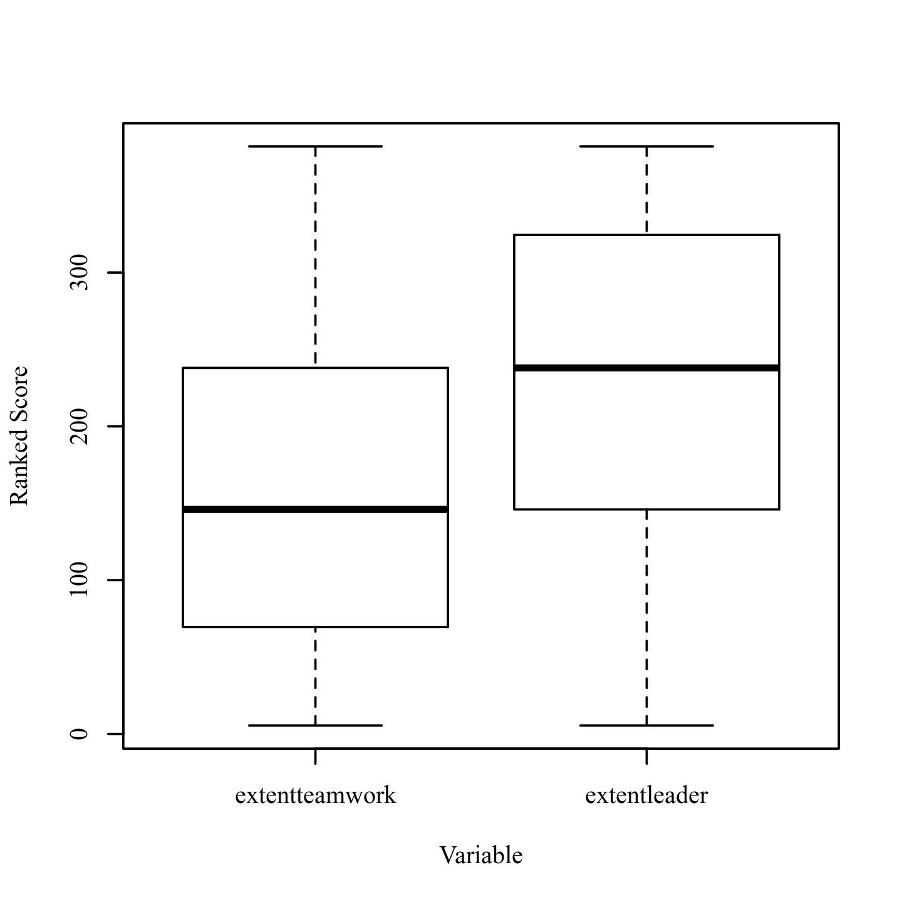

**Two-Tailed Paired Samples *t*-Test**

***Introduction***

A two-tailed paired samples *t*-test was conducted to examine whether the mean difference of extentreligious and extentspiritual was significantly different from zero.

***Assumptions***

**Normality.** A Shapiro-Wilk test was conducted to determine whether the differences in extentreligious and extentspiritual could have been produced by a normal distribution (Razali & Wah, 2011). The results of the Shapiro-Wilk test were significant based on an alpha value of 0.05, *W* = 0.95, *p* < .001. This result suggests the differences in extentreligious and extentspiritual are unlikely to have been produced by a normal distribution, indicating the normality assumption is violated.

**Homogeneity of Variance.** Levene's test was conducted to assess whether the variances of extentreligious and extentspiritual were significantly different. The result of Levene's test for was significant based on an alpha value of 0.05, *F*(1, 384) = 24.62, *p* < .001. This result suggests it is unlikely that extentreligious and extentspiritual were produced by distributions with equal variances, indicating the assumption of homogeneity of variance was violated.

***Results***

The result of the two-tailed paired samples *t*-test was significant based on an alpha value of 0.05, *t*(192) = -9.12, *p* < .001, indicating the null hypothesis can be rejected. This finding suggests the difference in the mean of extentreligious and the mean of extentspiritual was significantly different from zero. The mean of extentreligious was significantly lower than the mean of extentspiritual. The results are presented in Table 42. A bar plot of the means is presented in Figure 43.

**Table 42**

*Two-Tailed Paired Samples t-Test for the Difference Between extentreligious and extentspiritual*

|  |  |  |  |  |  |  |
| --- | --- | --- | --- | --- | --- | --- |
| extentreligious | | extentspiritual | |  |  |  |
| *M* | *SD* | *M* | *SD* | *t* | *p* | *d* |
| 45.26 | 31.79 | 63.54 | 26.00 | -9.12 | < .001 | 0.66 |

*Note.* N = 193. Degrees of Freedom for the *t*-statistic = 192. *d* represents Cohen's *d.*

**Figure 43**

*The means of extentreligious and extentspiritual*

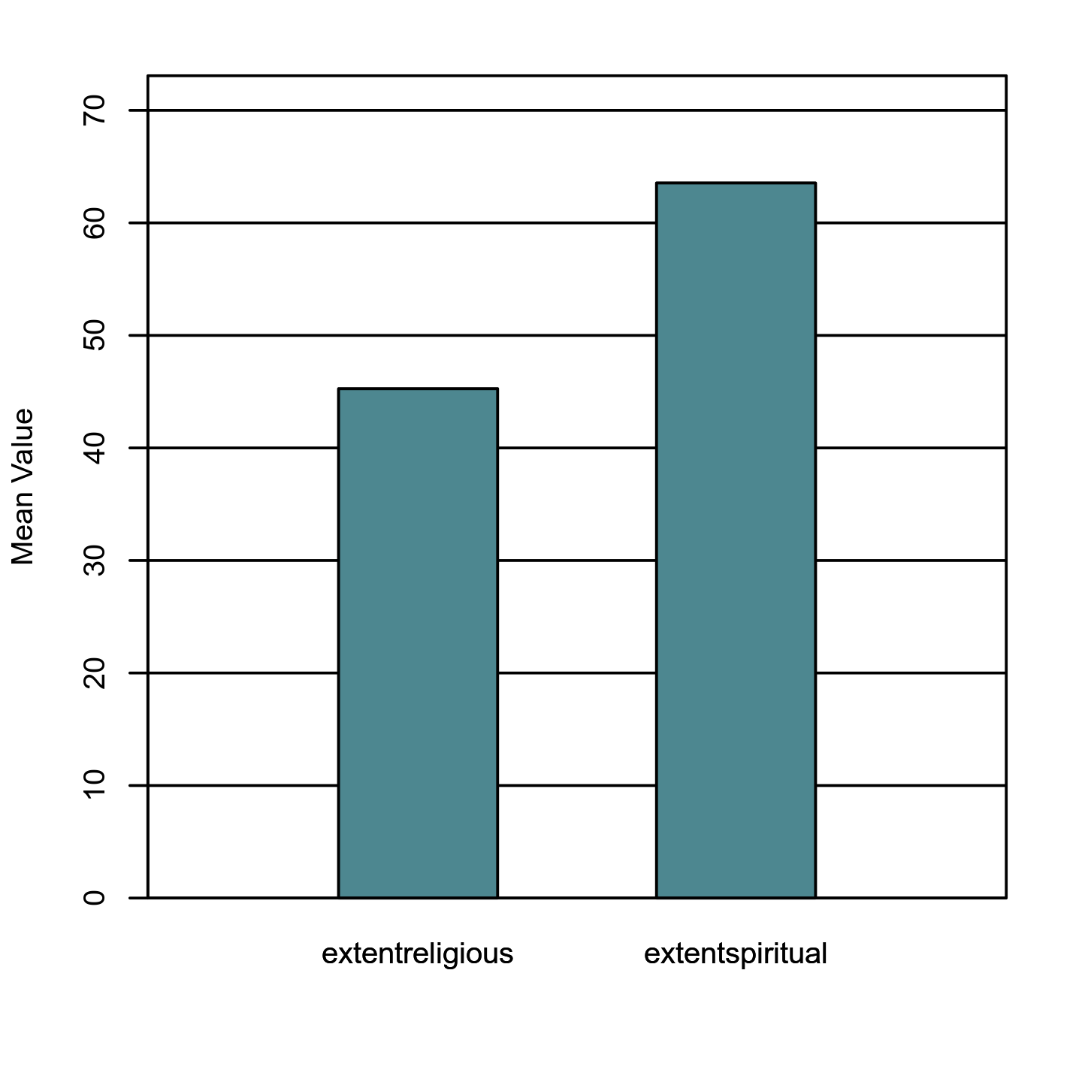

**Two-Tailed Wilcoxon Signed Rank Test**

***Introduction***

A two-tailed Wilcoxon signed rank test was conducted to examine whether there was a significant difference between extentreligious and extentspiritual. The two-tailed Wilcoxon signed rank test is a non-parametric alternative to the paired samples *t*-test and does not share its distributional assumptions (Conover & Iman, 1981).

***Results***

The results of the two-tailed Wilcoxon signed rank test were significant based on an alpha value of 0.05, *V* = 2283.50, *z* = -7.69, *p* < .001. This indicates that the differences between extentreligious and extentspiritual are not likely due to random variation. The median of extentreligious (*Mdn* = 50.00) was significantly lower than the median of extentspiritual (*Mdn* = 70.00). Figure 44 presents a boxplot of the ranked values of extentreligious and extentspiritual.

**Figure 44**

*Ranked values of extentreligious and extentspiritual*

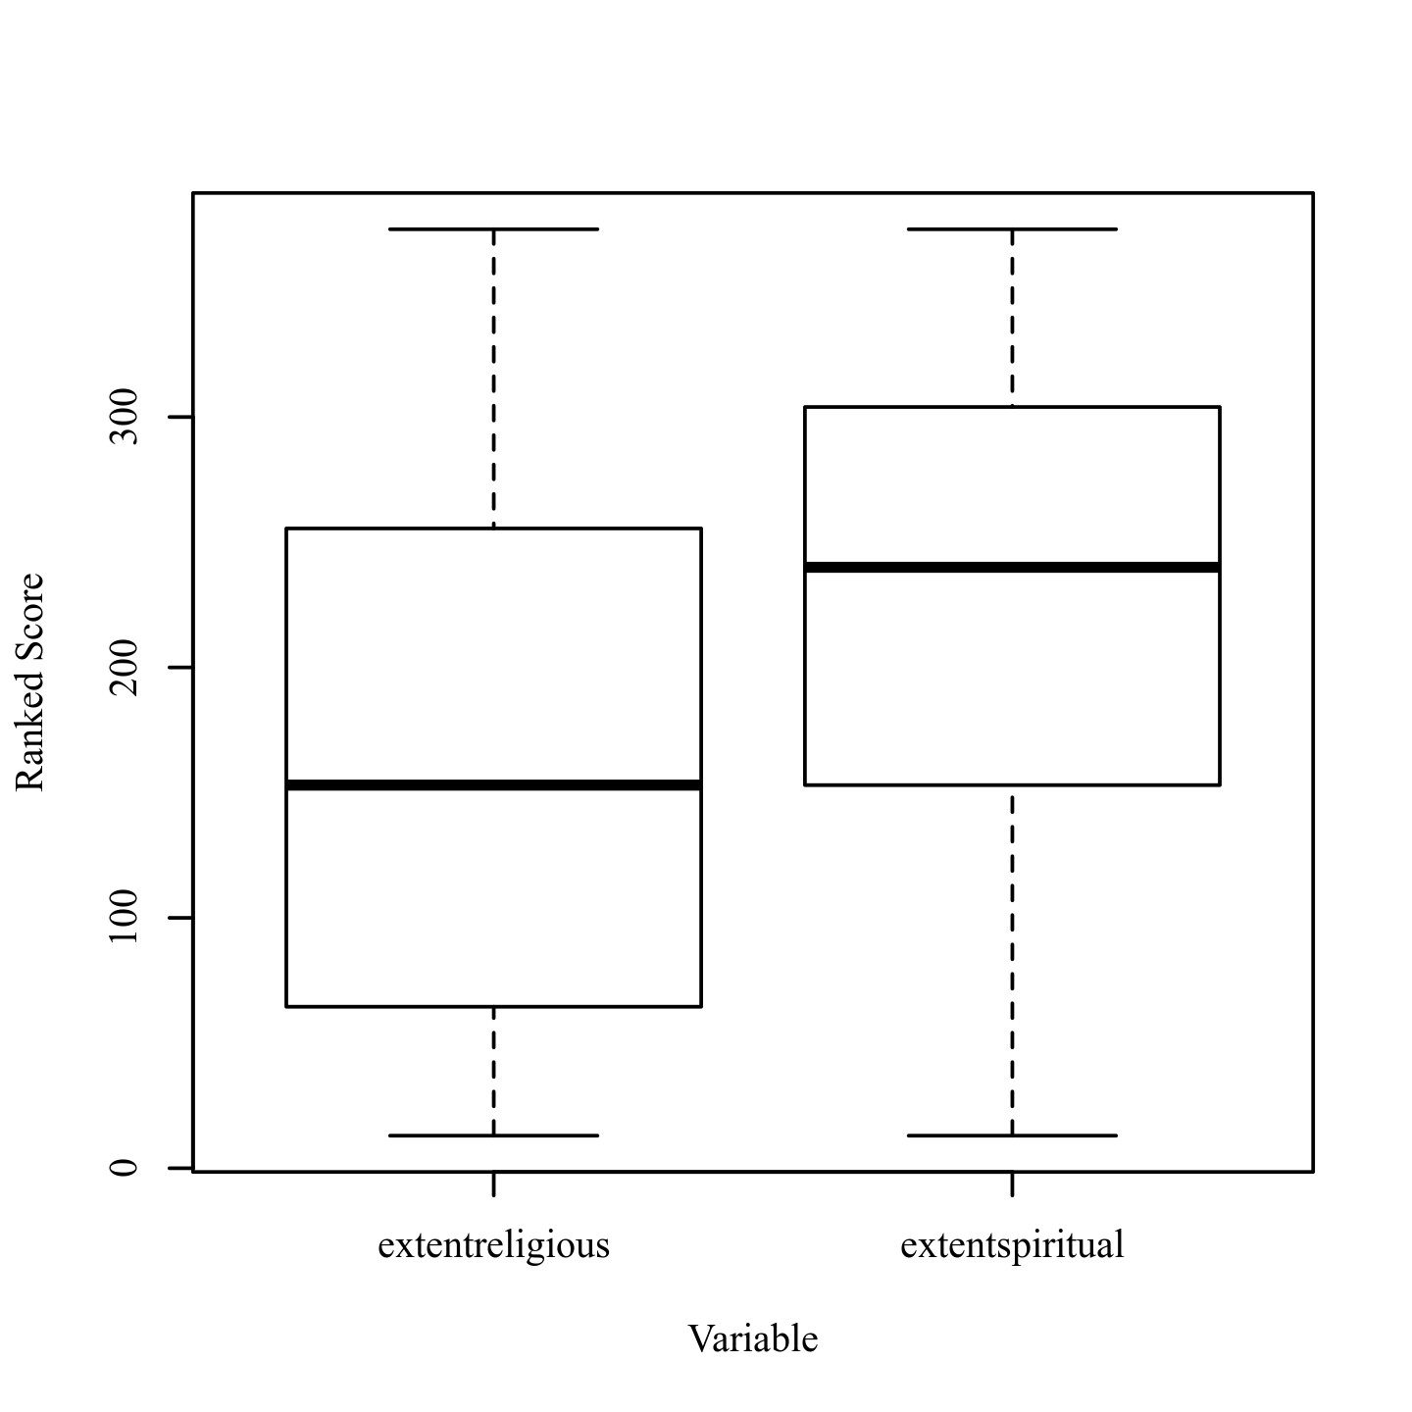

**Two-Tailed Paired Samples *t*-Test**

***Introduction***

A two-tailed paired samples *t*-test was conducted to examine whether the mean difference of age and extentconservative was significantly different from zero.

***Assumptions***

**Normality.** A Shapiro-Wilk test was conducted to determine whether the differences in age and extentconservative could have been produced by a normal distribution (Razali & Wah, 2011). The results of the Shapiro-Wilk test were significant based on an alpha value of 0.05, *W* = 0.98, *p* = .021. This result suggests the differences in age and extentconservative are unlikely to have been produced by a normal distribution, indicating the normality assumption is violated.

**Homogeneity of Variance.** Levene's test was conducted to assess whether the variances of age and extentconservative were significantly different. The result of Levene's test for was significant based on an alpha value of 0.05, *F*(1, 384) = 39.07, *p* < .001. This result suggests it is unlikely that age and extentconservative were produced by distributions with equal variances, indicating the assumption of homogeneity of variance was violated.

***Results***

The result of the two-tailed paired samples *t*-test was significant based on an alpha value of 0.05, *t*(192) = -5.06, *p* < .001, indicating the null hypothesis can be rejected. This finding suggests the difference in the mean of age and the mean of extentconservative was significantly different from zero. The mean of age was significantly lower than the mean of extentconservative. The results are presented in Table 43. A bar plot of the means is presented in Figure 45.

**Table 43**

*Two-Tailed Paired Samples t-Test for the Difference Between age and extentconservative*

|  |  |  |  |  |  |  |
| --- | --- | --- | --- | --- | --- | --- |
| age | | extentconservative | |  |  |  |
| *M* | *SD* | *M* | *SD* | *t* | *p* | *d* |
| 29.68 | 15.83 | 40.91 | 25.05 | -5.06 | < .001 | 0.36 |

*Note.* N = 193. Degrees of Freedom for the *t*-statistic = 192. *d* represents Cohen's *d.*

**Figure 45**

*The means of age and extentconservative*

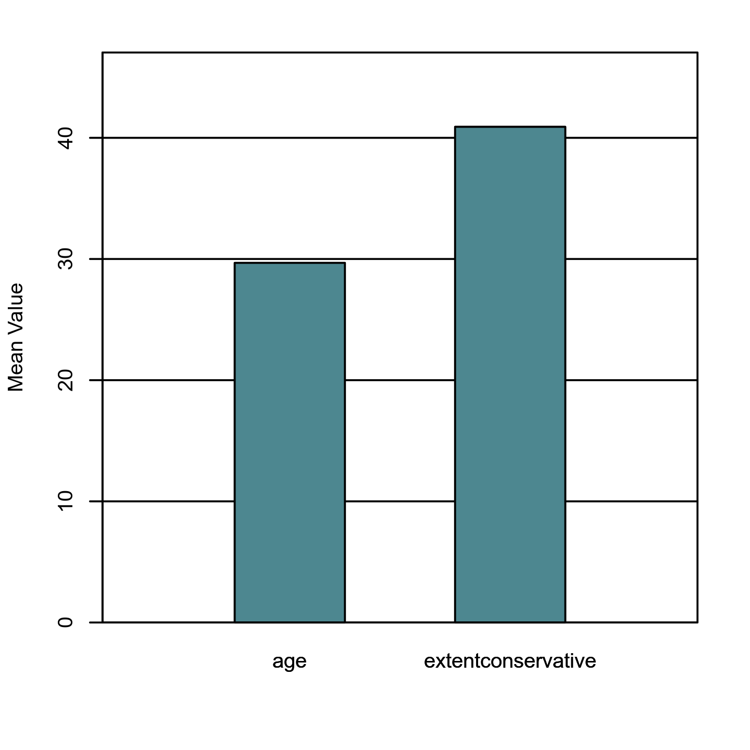

**Two-Tailed Wilcoxon Signed Rank Test**

***Introduction***

A two-tailed Wilcoxon signed rank test was conducted to examine whether there was a significant difference between age and extentconservative. The two-tailed Wilcoxon signed rank test is a non-parametric alternative to the paired samples *t*-test and does not share its distributional assumptions (Conover & Iman, 1981).

***Results***

The results of the two-tailed Wilcoxon signed rank test were significant based on an alpha value of 0.05, *V* = 5897.00, *z* = -4.37, *p* < .001. This indicates that the differences between age and extentconservative are not likely due to random variation. The median of age (*Mdn* = 22.00) was significantly lower than the median of extentconservative (*Mdn* = 37.00). Figure 46 presents a boxplot of the ranked values of age and extentconservative.

**Figure 46**

*Ranked values of age and extentconservative*

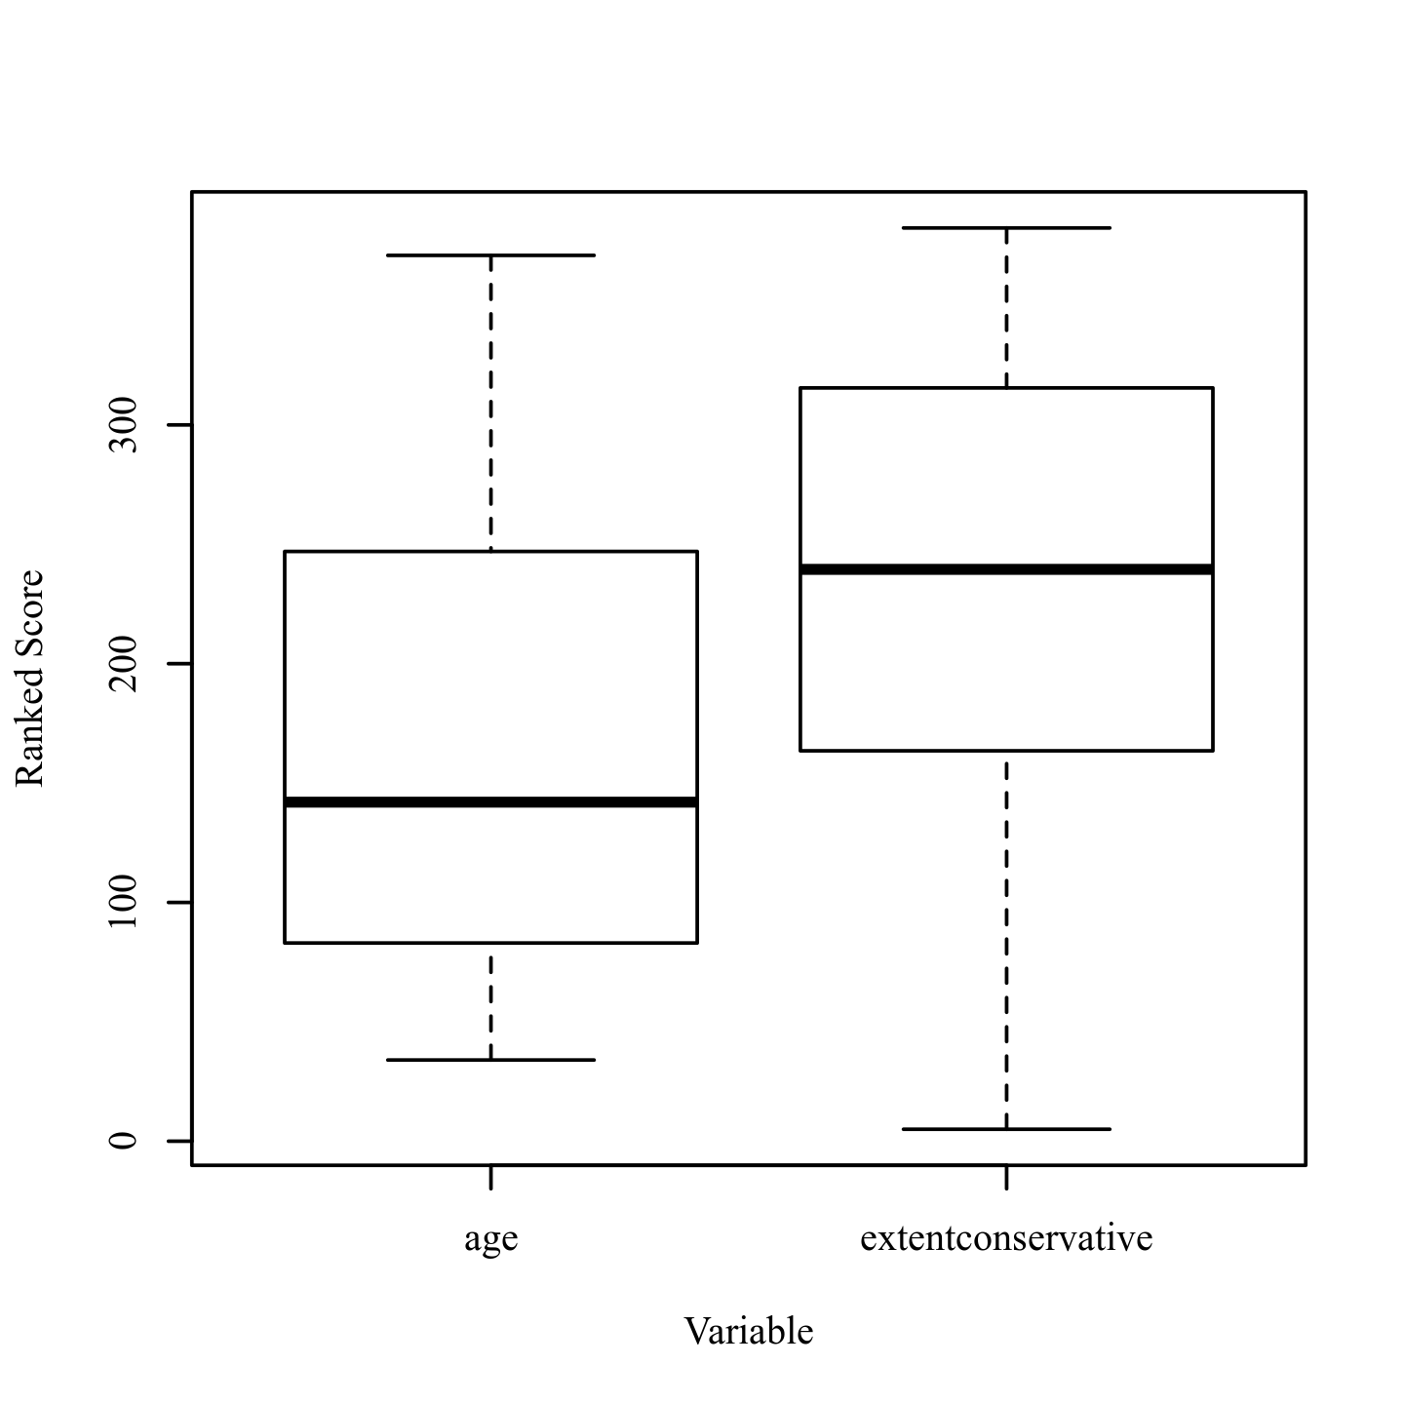

**Two-Tailed Paired Samples *t*-Test**

***Introduction***

A two-tailed paired samples *t*-test was conducted to examine whether the mean difference of age and extentcapitalism was significantly different from zero.

***Assumptions***

**Normality.** A Shapiro-Wilk test was conducted to determine whether the differences in age and extentcapitalism could have been produced by a normal distribution (Razali & Wah, 2011). The results of the Shapiro-Wilk test were significant based on an alpha value of 0.05, *W* = 0.98, *p* = .003. This result suggests the differences in age and extentcapitalism are unlikely to have been produced by a normal distribution, indicating the normality assumption is violated.

**Homogeneity of Variance.** Levene's test was conducted to assess whether the variances of age and extentcapitalism were significantly different. The result of Levene's test for was significant based on an alpha value of 0.05, *F*(1, 384) = 76.40, *p* < .001. This result suggests it is unlikely that age and extentcapitalism were produced by distributions with equal variances, indicating the assumption of homogeneity of variance was violated.

***Results***

The result of the two-tailed paired samples *t*-test was significant based on an alpha value of 0.05, *t*(192) = -8.64, *p* < .001, indicating the null hypothesis can be rejected. This finding suggests the difference in the mean of age and the mean of extentcapitalism was significantly different from zero. The mean of age was significantly lower than the mean of extentcapitalism. The results are presented in Table 44. A bar plot of the means is presented in Figure 47.

**Table 44**

*Two-Tailed Paired Samples t-Test for the Difference Between age and extentcapitalism*

|  |  |  |  |  |  |  |
| --- | --- | --- | --- | --- | --- | --- |
| age | | extentcapitalism | |  |  |  |
| *M* | *SD* | *M* | *SD* | *t* | *p* | *d* |
| 29.68 | 15.83 | 51.28 | 28.94 | -8.64 | < .001 | 0.62 |

*Note.* N = 193. Degrees of Freedom for the *t*-statistic = 192. *d* represents Cohen's *d.*

**Figure 47**

*The means of age and extentcapitalism*

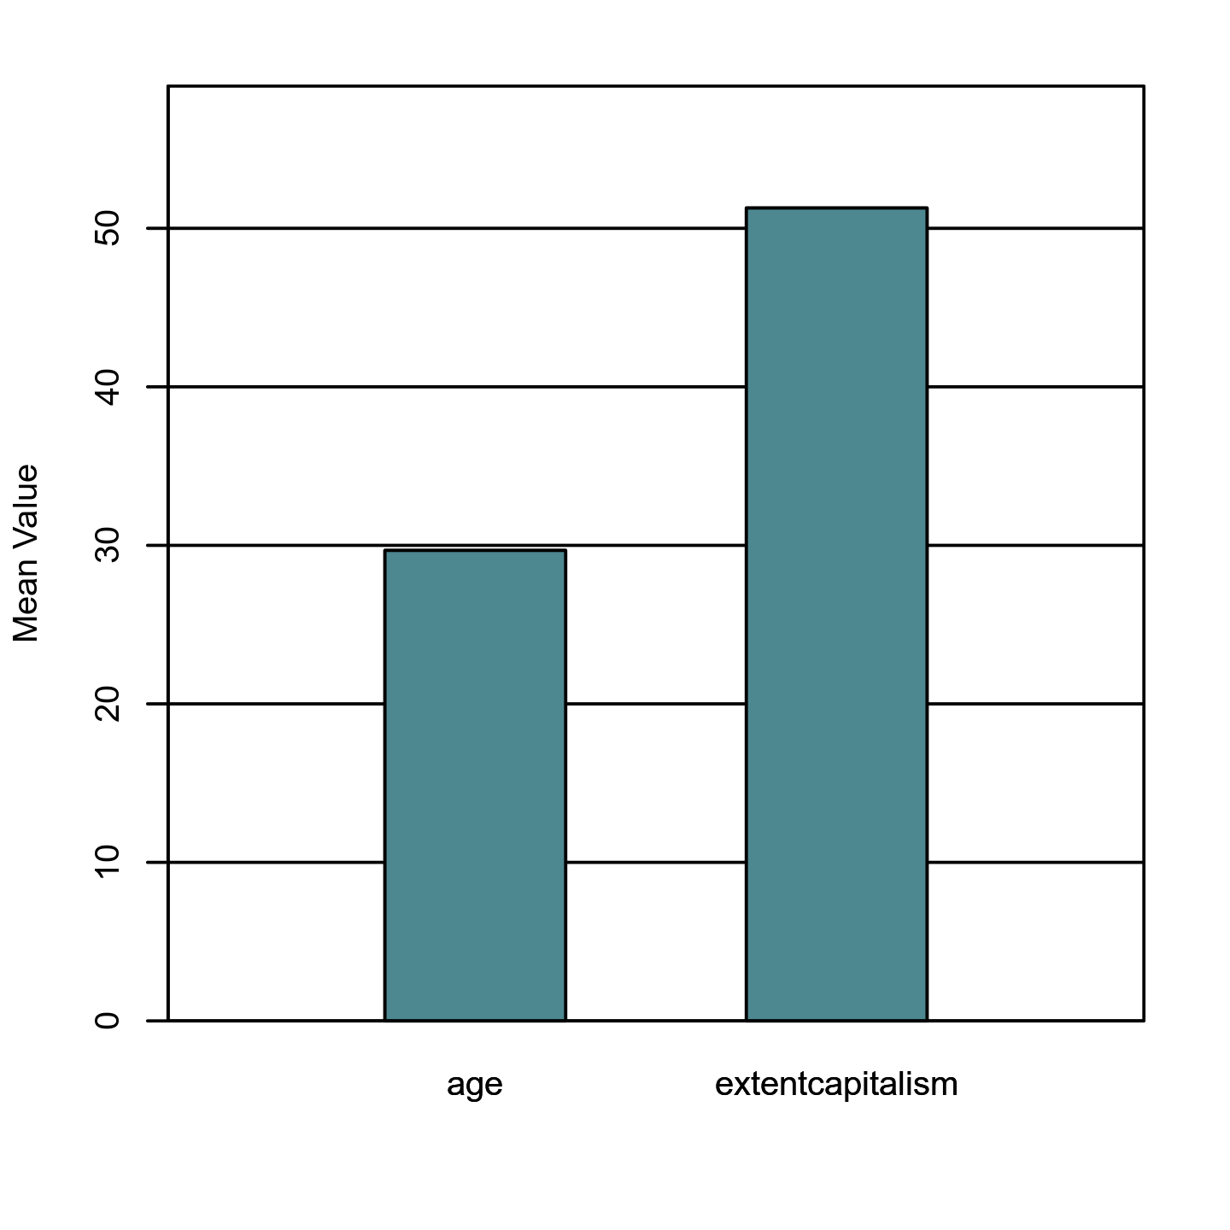

**Two-Tailed Wilcoxon Signed Rank Test**

***Introduction***

A two-tailed Wilcoxon signed rank test was conducted to examine whether there was a significant difference between age and extentcapitalism. The two-tailed Wilcoxon signed rank test is a non-parametric alternative to the paired samples *t*-test and does not share its distributional assumptions (Conover & Iman, 1981).

***Results***

The results of the two-tailed Wilcoxon signed rank test were significant based on an alpha value of 0.05, *V* = 3758.00, *z* = -7.21, *p* < .001. This indicates that the differences between age and extentcapitalism are not likely due to random variation. The median of age (*Mdn* = 22.00) was significantly lower than the median of extentcapitalism (*Mdn* = 50.00). Figure 48 presents a boxplot of the ranked values of age and extentcapitalism.

**Figure 48**

*Ranked values of age and extentcapitalism*

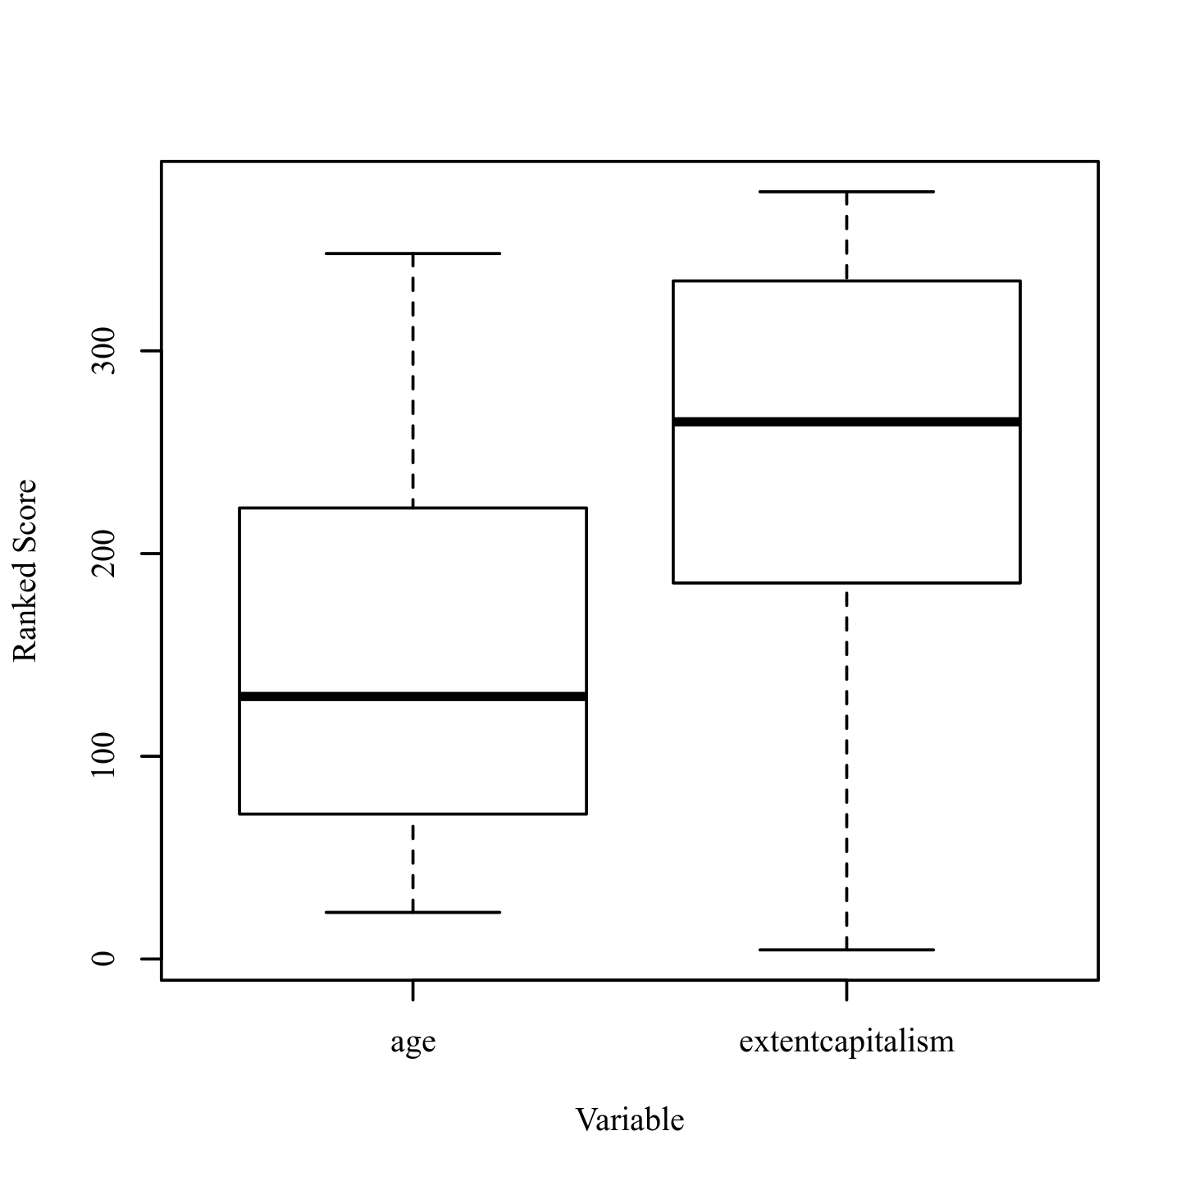

**References**

Cohen, J. (1988). *Statistical power analysis for the behavior sciences* (2nd ed.). West Publishing Company.

Conover, W. J., & Iman, R. L. (1981). Rank transformations as a bridge between parametric and nonparametric statistics. *The American Statistician, 35*(3), 124-129. https://doi.org/10.1080/00031305.1981.10479327

Intellectus Statistics [Online computer software]. (2020). Intellectus Statistics. https://analyze.intellectusstatistics.com/

Razali, N. M., & Wah, Y. B. (2011). Power comparisons of Shapiro-Wilk, Kolmogorov-Smirnov, Lilliefors and Anderson-Darling tests. *Journal of Statistical Modeling and Analytics, 2*(1), 21-33.

**Glossaries**

**Pearson (Product-Moment) Correlation**  
  
A correlation expresses the strength of linkage or co-occurrence between two variables in a single value between -1 and +1. This value that measures the strength of linkage is called *correlation coefficient*, which is represented typically as the letter r. The correlation coefficient between two continuous-level variables is also called Pearson's r or Pearson product-moment correlation coefficient. A positive r value expresses a positive relationship between the two variables (the larger A becomes, the larger B becomes) while a negative r value indicates a negative relationship (the larger A becomes, the smaller B becomes). A correlation coefficient of zero indicates no relationship between the variables. However, correlations are limited to linear relationships between variables. Even if the correlation coefficient is zero, a non-linear relationship might exist. ***Fun Fact!*** *Correlation is a widely used term in statistics. In fact, it entered the English language in 1561, 200 years before most of the modern statistic tests were discovered. It is derived from the [same] Latin word correlation, which means relation.* **Bonferroni Correction:** If one conducts a lot of correlations, some relationships will occur by chance. To mitigate this, Bonferroni correction is applied. It reduces the alpha level for the analysis, thus reducing the likelihood of making a Type I error (false positive); it is based on the number of times each variable is used. **Correlation Coefficient (*r*):** Ranges from -1 to 1; describes to the strength of the relationship between the variables. **Critical Value:** The minimum value at which an observed correlation coefficient is statistically significant. ***p*-value:** The probability of obtaining the observed results if the null hypothesis is true. A result is usually considered statistically significant if the *p*-value is ≤ .05.

**Spearman Correlation**  
  
Spearman rank correlation is a non-parametric test used to measure the degree of association between two variables. It was developed by Spearman; thus it is called the Spearman rank correlation. Spearman rank correlation test does not make any assumptions about the distribution of the data and is the appropriate correlation analysis when the variables are measured on a scale that is at least ordinal level. ***Fun Fact!*** *Correlation is a widely used term in statistics. In fact, it entered the English language in 1561, 200 years before most of the modern statistic tests were discovered. It is derived from the [same] Latin word correlation, which means relation.* **Correlation Coefficient (*r*):** Ranges from -1 to 1; describes to the strength of the relationship between the variables. **Critical Value:** The minimum value at which an observed correlation coefficient is statistically significant. **Effect Size:** The strength of the relationship. **Ordinal Data:** Ordinal scales rank order the items that are being measured to indicate if they possess more, less, or the same amount of the variable being measured. An ordinal scale allows us to determine if X > Y, Y > X, or if X = Y. ***p*-value:** The probability of obtaining the observed results if the null hypothesis is true. A result is usually considered statistically significant if the *p*-value is ≤ .05.

**One Sample *t*-Test**  
  
The one sample *t*-test is used to assess if the values of a single variable are significantly different from a test value. The test value is typically a population average or a baseline value that the researcher wishes to compare against (e.g., the average height of adults in the United States). This test uses the average deviation of the variable from the test value to compute the *t* statistic, which is used with the *df* to compute the p-value (i.e., significance level). A significant result for this test indicates that, on average, the values on the variable of interest are significantly different from the test value. The one sample *t*-test assumes that the observations are independent of each other and that the values of the variable are normally distributed (i.e., normality). ***Fun Fact!*** *A dependent samples t-test is mathematically the same as a one sample t-test that compares the differences in the pairs of scores to a test value of zero.* **Cohen's *d*:** Effect size for the *t*-test; determines the strength of the differences between the matched scores. The larger the effect size, the greater the differences in the matched pairs. **Degrees of Freedom (*df*):** Determined by multiplying the (number of rows - 1) × (number of columns - 1). **Mean (*M*):** The average value of a scale-level variable. **Normality:** Refers to the distribution of the data. The assumption is that the data follows the bell-shaped curve. ***p*-value:** The probability of obtaining the observed results if the null hypothesis is true. A result is usually considered statistically significant if the *p*-value is ≤ .05. **Shapiro-Wilk Test:** A test to assess if the assumption of normality is met. If statistical significance is found in this test, the data is *not* normally distributed. **Standard Deviation (*SD*):** The spread of the data around the mean of a scale-level variable. **Test Value:** The value that the data is tested against. ***t*-Test Statistic (*t*):** Used with the *df* to determine the *p* value.

**Paired Samples *t*-Test**  
  
The paired (dependent) samples *t*-test is used to assess for significant differences between two scale variables that can be matched. Typically, the scale variables are matched by time (e.g. pretest vs. posttest), but the data can also be matched in other ways (e.g. husband vs. wife). The test uses the average difference between each pair of matched scores to compute the t statistic, which is used with the *df* to compute the *p*-value (i.e., significance level). A significant result indicates the observed test statistic would be unlikely under the null hypothesis. The dependent samples *t*-test assumes that the differences between pairs of matched scores are normally distributed (i.e., normality). ***Fun Fact!*** *This test is based on the Student's t distribution. This distribution was named after William Sealy Gosset, who published a paper about the distribution in 1908 under the pseudonym "Student."* **Cohen's *d*:** Effect size for the *t*-test; determines the strength of the differences between the matched scores. The larger the effect size, the greater the differences in the matched scores. **Degrees of Freedom (*df*):** Refers to the number of values used to compute a statistic. The *df* is determined by the number of observations in the sample and equal the number of observations - 1; used with *t* to compute the *p*-value. **Mean (*M*):** The average value of a scale-level variable. **Normality:** Refers to the distribution of the data. The assumption is that the data follows the bell-shaped curve. ***p*-value:** The probability of obtaining the observed results if the null hypothesis is true. A result is usually considered statistically significant if the *p*-value is ≤ .05. **Shapiro-Wilk Test:** A test to assess if the assumption of normality is met. If statistical significance is found in this test, the data is *not* normally distributed. **Standard Deviation (*SD*):** The spread of the data around the mean of a scale-level variable. ***t*-Test Statistic (*t*):** Used with the *df* to determine the *p* value.

**Wilcoxon Signed Rank**  
  
The Wilcoxon Signed Rank test is a non-parametric test used to assess for significant differences between two scale or ordinal variables that can be matched. Typically, the variables are matched by time (such as pretest vs. posttest), but the data can also be matched by other characteristics (such as husband vs. wife). This test ranks the pairs of scores by the magnitude of the differences between each matched pair, then sums the signed ranks to compute the *V* statistic. The *V* statistic is then used to compute *z*, which in turn is used to compute the *p*-value (i.e., significance level). A significant result for this test suggests that the two matched variables are reliably different from each other (e.g., pretest scores are significantly different from posttest scores). The Wilcoxon Signed Rank test assumes that the variables under investigation are scale or ordinal level. ***Fun Fact!*** *The Wilcoxon Signed Rank test is named after Frank Wilcoxon, a chemist who published more than 70 papers over the course of his career.* **Non-Parametric Test:** A type of statistical test that does not require the data to follow a particular distribution; typically used when assumptions of a parametric test are violated or when the data do not fit the level of measurement required by a parametric test. ***p*-value:** The probability of obtaining the observed results if the null hypothesis (no relationship between the independent variable(s) and dependent variable) is true; in most social science research, a result is considered statistically significant if this value is ≤ .05. ***V*-Test Statistic (*V*):** Represents the sum of the signed ranks; used to compute the *z*. ***z*-Test Statistic (*z*):** Used to compute the *p* value.

**Raw Output**

**Pearson Correlation Test**

Included Variables:  
extentcapitalism and extentspiritual

Sample Size (Complete Cases):  
N = 193

Correlation Results:

|  |  |  |  |
| --- | --- | --- | --- |
| Combination | rp | 95% CI | p |
| extentcapitalism-extentspiritual | 0.040 | [-0.102, 0.180] | 0.58 |

Note: n = 193;

**Pearson Correlation Test**

Included Variables:  
extentcapitalism and extentprocrastinator

Sample Size (Complete Cases):  
N = 193

Correlation Results:

|  |  |  |  |
| --- | --- | --- | --- |
| Combination | rp | 95% CI | p |
| extentcapitalism-extentprocrastinator | -0.002 | [-0.143, 0.139] | 0.98 |

Note: n = 193;

**Pearson Correlation Test**

Included Variables:  
extentcapitalism and extentpc

Sample Size (Complete Cases):  
N = 193

Correlation Results:

|  |  |  |  |
| --- | --- | --- | --- |
| Combination | rp | 95% CI | p |
| extentcapitalism-extentpc | -0.428 | [-0.537, -0.305] | 5.377e-10 |

Note: n = 193;

**Pearson Correlation Test**

Included Variables:  
extentteamwork and extentcapitalism

Sample Size (Complete Cases):  
N = 193

Correlation Results:

|  |  |  |  |
| --- | --- | --- | --- |
| Combination | rp | 95% CI | p |
| extentteamwork-extentcapitalism | -0.039 | [-0.180, 0.103] | 0.59 |

Note: n = 193;

**Spearman Correlation Test**

Included Variables:  
extentteamwork and extentcapitalism

Sample Size (Complete Cases):  
N = 193

Correlation Results:

|  |  |  |  |
| --- | --- | --- | --- |
| Combination | rs | 95% CI | p |
| extentteamwork-extentcapitalism | -0.033 | [-0.173, 0.109] | 0.65 |

Note: n = 193;

**Pearson Correlation Test**

Included Variables:  
extentcapitalism and extentreligious

Sample Size (Complete Cases):  
N = 193

Correlation Results:

|  |  |  |  |
| --- | --- | --- | --- |
| Combination | rp | 95% CI | p |
| extentcapitalism-extentreligious | 0.368 | [0.239, 0.484] | 1.425e-07 |

Note: n = 193;

**Pearson Correlation Test**

Included Variables:  
extentconservative, extentspiritual, extentdedicated, extentprocrastinator, extentpc, extentreligious, extentliar, and extentarticulator

Sample Size (Complete Cases):  
N = 193

Correlation Results:

|  |  |  |  |
| --- | --- | --- | --- |
| Combination | rp | 95% CI | p |
| extentconservative-extentspiritual | 0.213 | [0.074, 0.344] | 2.889e-03 |
| extentconservative-extentdedicated | -0.022 | [-0.163, 0.119] | 7.592e-01 |
| extentconservative-extentprocrastinator | 0.013 | [-0.128, 0.154] | 8.527e-01 |
| extentconservative-extentpc | -0.392 | [-0.506, -0.266] | 1.678e-08 |
| extentconservative-extentreligious | 0.496 | [0.382, 0.596] | 2.088e-13 |
| extentconservative-extentliar | -0.122 | [-0.259, 0.020] | 9.110e-02 |
| extentconservative-extentarticulator | -0.056 | [-0.196, 0.086] | 4.380e-01 |
| extentspiritual-extentdedicated | -0.016 | [-0.157, 0.125] | 8.231e-01 |
| extentspiritual-extentprocrastinator | -0.001 | [-0.143, 0.140] | 9.839e-01 |
| extentspiritual-extentpc | -0.056 | [-0.196, 0.085] | 4.355e-01 |
| extentspiritual-extentreligious | 0.552 | [0.445, 0.643] | 9.371e-17 |
| extentspiritual-extentliar | -0.292 | [-0.416, -0.157] | 3.809e-05 |
| extentspiritual-extentarticulator | -0.006 | [-0.147, 0.136] | 9.378e-01 |
| extentdedicated-extentprocrastinator | -0.222 | [-0.352, -0.084] | 1.905e-03 |
| extentdedicated-extentpc | -0.037 | [-0.177, 0.105] | 6.102e-01 |
| extentdedicated-extentreligious | -0.052 | [-0.192, 0.089] | 4.684e-01 |
| extentdedicated-extentliar | -0.082 | [-0.220, 0.060] | 2.589e-01 |
| extentdedicated-extentarticulator | 0.261 | [0.125, 0.388] | 2.395e-04 |
| extentprocrastinator-extentpc | 0.063 | [-0.079, 0.202] | 3.867e-01 |
| extentprocrastinator-extentreligious | 0.038 | [-0.104, 0.178] | 5.982e-01 |
| extentprocrastinator-extentliar | 0.151 | [0.010, 0.286] | 3.642e-02 |
| extentprocrastinator-extentarticulator | 0.106 | [-0.035, 0.244] | 1.411e-01 |
| extentpc-extentreligious | -0.136 | [-0.272, 0.005] | 5.903e-02 |
| extentpc-extentliar | -0.028 | [-0.169, 0.113] | 6.951e-01 |
| extentpc-extentarticulator | 0.010 | [-0.132, 0.151] | 8.944e-01 |
| extentreligious-extentliar | -0.125 | [-0.262, 0.016] | 8.232e-02 |
| extentreligious-extentarticulator | -0.041 | [-0.181, 0.101] | 5.744e-01 |
| extentliar-extentarticulator | 0.152 | [0.011, 0.287] | 3.461e-02 |

Note: n = 193; Holm corrections used to adjust *p*-values.

**Spearman Correlation Test**

Included Variables:  
extentconservative, extentspiritual, extentdedicated, extentprocrastinator, extentpc, extentreligious, extentliar, and extentarticulator

Sample Size (Complete Cases):  
N = 193

Correlation Results:

|  |  |  |  |
| --- | --- | --- | --- |
| Combination | rs | 95% CI | p |
| extentconservative-extentspiritual | 0.207 | [0.067, 0.338] | 3.914e-03 |
| extentconservative-extentdedicated | -0.042 | [-0.182, 0.100] | 5.639e-01 |
| extentconservative-extentprocrastinator | -0.017 | [-0.158, 0.125] | 8.160e-01 |
| extentconservative-extentpc | -0.430 | [-0.539, -0.308] | 4.216e-10 |
| extentconservative-extentreligious | 0.483 | [0.367, 0.584] | 1.161e-12 |
| extentconservative-extentliar | -0.111 | [-0.249, 0.030] | 1.235e-01 |
| extentconservative-extentarticulator | -0.049 | [-0.189, 0.093] | 4.986e-01 |
| extentspiritual-extentdedicated | 0.005 | [-0.136, 0.146] | 9.411e-01 |
| extentspiritual-extentprocrastinator | -0.031 | [-0.171, 0.111] | 6.690e-01 |
| extentspiritual-extentpc | -0.065 | [-0.204, 0.077] | 3.710e-01 |
| extentspiritual-extentreligious | 0.517 | [0.406, 0.614] | 1.317e-14 |
| extentspiritual-extentliar | -0.334 | [-0.453, -0.202] | 2.135e-06 |
| extentspiritual-extentarticulator | 0.038 | [-0.104, 0.179] | 5.975e-01 |
| extentdedicated-extentprocrastinator | -0.208 | [-0.339, -0.068] | 3.781e-03 |
| extentdedicated-extentpc | 0.009 | [-0.132, 0.150] | 8.973e-01 |
| extentdedicated-extentreligious | -0.078 | [-0.217, 0.064] | 2.784e-01 |
| extentdedicated-extentliar | -0.148 | [-0.283, -0.007] | 4.036e-02 |
| extentdedicated-extentarticulator | 0.286 | [0.151, 0.411] | 5.362e-05 |
| extentprocrastinator-extentpc | 0.106 | [-0.035, 0.244] | 1.405e-01 |
| extentprocrastinator-extentreligious | 0.036 | [-0.105, 0.177] | 6.156e-01 |
| extentprocrastinator-extentliar | 0.139 | [-0.003, 0.274] | 5.464e-02 |
| extentprocrastinator-extentarticulator | 0.106 | [-0.036, 0.244] | 1.426e-01 |
| extentpc-extentreligious | -0.171 | [-0.305, -0.030] | 1.750e-02 |
| extentpc-extentliar | -0.048 | [-0.188, 0.094] | 5.091e-01 |
| extentpc-extentarticulator | 0.044 | [-0.098, 0.184] | 5.445e-01 |
| extentreligious-extentliar | -0.113 | [-0.250, 0.029] | 1.172e-01 |
| extentreligious-extentarticulator | -0.019 | [-0.160, 0.122] | 7.911e-01 |
| extentliar-extentarticulator | 0.092 | [-0.050, 0.230] | 2.042e-01 |

Note: n = 193; Holm corrections used to adjust *p*-values.

**Pearson Correlation Test**

Included Variables:  
extentteamwork, extentspiritual, extentdedicated, extentconservative, extentpc, extentreligious, and extentarticulator

Sample Size (Complete Cases):  
N = 193

Correlation Results:

|  |  |  |  |
| --- | --- | --- | --- |
| Combination | rp | 95% CI | p |
| extentteamwork-extentspiritual | 0.131 | [-0.011, 0.267] | 6.990e-02 |
| extentteamwork-extentdedicated | -0.022 | [-0.163, 0.120] | 7.624e-01 |
| extentteamwork-extentconservative | 0.008 | [-0.134, 0.149] | 9.137e-01 |
| extentteamwork-extentpc | -0.058 | [-0.198, 0.084] | 4.211e-01 |
| extentteamwork-extentreligious | 0.115 | [-0.027, 0.252] | 1.122e-01 |
| extentteamwork-extentarticulator | 0.022 | [-0.120, 0.163] | 7.626e-01 |
| extentspiritual-extentdedicated | -0.016 | [-0.157, 0.125] | 8.231e-01 |
| extentspiritual-extentconservative | 0.213 | [0.074, 0.344] | 2.889e-03 |
| extentspiritual-extentpc | -0.056 | [-0.196, 0.085] | 4.355e-01 |
| extentspiritual-extentreligious | 0.552 | [0.445, 0.643] | 9.371e-17 |
| extentspiritual-extentarticulator | -0.006 | [-0.147, 0.136] | 9.378e-01 |
| extentdedicated-extentconservative | -0.022 | [-0.163, 0.119] | 7.592e-01 |
| extentdedicated-extentpc | -0.037 | [-0.177, 0.105] | 6.102e-01 |
| extentdedicated-extentreligious | -0.052 | [-0.192, 0.089] | 4.684e-01 |
| extentdedicated-extentarticulator | 0.261 | [0.125, 0.388] | 2.395e-04 |
| extentconservative-extentpc | -0.392 | [-0.506, -0.266] | 1.678e-08 |
| extentconservative-extentreligious | 0.496 | [0.382, 0.596] | 2.088e-13 |
| extentconservative-extentarticulator | -0.056 | [-0.196, 0.086] | 4.380e-01 |
| extentpc-extentreligious | -0.136 | [-0.272, 0.005] | 5.903e-02 |
| extentpc-extentarticulator | 0.010 | [-0.132, 0.151] | 8.944e-01 |
| extentreligious-extentarticulator | -0.041 | [-0.181, 0.101] | 5.744e-01 |

Note: n = 193; Holm corrections used to adjust *p*-values.

**Spearman Correlation Test**

Included Variables:  
extentteamwork, extentspiritual, extentdedicated, extentconservative, extentpc, extentreligious, and extentarticulator

Sample Size (Complete Cases):  
N = 193

Correlation Results:

|  |  |  |  |
| --- | --- | --- | --- |
| Combination | rs | 95% CI | p |
| extentteamwork-extentspiritual | 0.119 | [-0.023, 0.256] | 9.922e-02 |
| extentteamwork-extentdedicated | -0.033 | [-0.173, 0.109] | 6.514e-01 |
| extentteamwork-extentconservative | 0.025 | [-0.117, 0.165] | 7.318e-01 |
| extentteamwork-extentpc | -0.061 | [-0.200, 0.081] | 4.031e-01 |
| extentteamwork-extentreligious | 0.101 | [-0.041, 0.239] | 1.616e-01 |
| extentteamwork-extentarticulator | -0.026 | [-0.166, 0.116] | 7.220e-01 |
| extentspiritual-extentdedicated | 0.005 | [-0.136, 0.146] | 9.411e-01 |
| extentspiritual-extentconservative | 0.207 | [0.067, 0.338] | 3.914e-03 |
| extentspiritual-extentpc | -0.065 | [-0.204, 0.077] | 3.710e-01 |
| extentspiritual-extentreligious | 0.517 | [0.406, 0.614] | 1.317e-14 |
| extentspiritual-extentarticulator | 0.038 | [-0.104, 0.179] | 5.975e-01 |
| extentdedicated-extentconservative | -0.042 | [-0.182, 0.100] | 5.639e-01 |
| extentdedicated-extentpc | 0.009 | [-0.132, 0.150] | 8.973e-01 |
| extentdedicated-extentreligious | -0.078 | [-0.217, 0.064] | 2.784e-01 |
| extentdedicated-extentarticulator | 0.286 | [0.151, 0.411] | 5.362e-05 |
| extentconservative-extentpc | -0.430 | [-0.539, -0.308] | 4.216e-10 |
| extentconservative-extentreligious | 0.483 | [0.367, 0.584] | 1.161e-12 |
| extentconservative-extentarticulator | -0.049 | [-0.189, 0.093] | 4.986e-01 |
| extentpc-extentreligious | -0.171 | [-0.305, -0.030] | 1.750e-02 |
| extentpc-extentarticulator | 0.044 | [-0.098, 0.184] | 5.445e-01 |
| extentreligious-extentarticulator | -0.019 | [-0.160, 0.122] | 7.911e-01 |

Note: n = 193; Holm corrections used to adjust *p*-values.

**Pearson Correlation Test**

Included Variables:  
extentfeminine and extentleader

Sample Size (Complete Cases):  
N = 193

Correlation Results:

|  |  |  |  |
| --- | --- | --- | --- |
| Combination | rp | 95% CI | p |
| extentfeminine-extentleader | -0.165 | [-0.299, -0.024] | 0.022 |

Note: n = 193;

**Pearson Correlation Test**

Included Variables:  
extentcapitalism and extentleader

Sample Size (Complete Cases):  
N = 193

Correlation Results:

|  |  |  |  |
| --- | --- | --- | --- |
| Combination | rp | 95% CI | p |
| extentcapitalism-extentleader | 0.101 | [-0.041, 0.239] | 0.16 |

Note: n = 193;

**Pearson Correlation Test**

Included Variables:  
extentspiritual and extentleader

Sample Size (Complete Cases):  
N = 193

Correlation Results:

|  |  |  |  |
| --- | --- | --- | --- |
| Combination | rp | 95% CI | p |
| extentspiritual-extentleader | -0.157 | [-0.292, -0.016] | 0.029 |

Note: n = 193;

**Pearson Correlation Test**

Included Variables:  
extentleader and extentdedicated

Sample Size (Complete Cases):  
N = 193

Correlation Results:

|  |  |  |  |
| --- | --- | --- | --- |
| Combination | rp | 95% CI | p |
| extentleader-extentdedicated | 0.294 | [0.160, 0.418] | 3.284e-05 |

Note: n = 193;

**Pearson Correlation Test**

Included Variables:  
extentleader and extentconservative

Sample Size (Complete Cases):  
N = 193

Correlation Results:

|  |  |  |  |
| --- | --- | --- | --- |
| Combination | rp | 95% CI | p |
| extentleader-extentconservative | -0.004 | [-0.145, 0.137] | 0.96 |

Note: n = 193;

**Pearson Correlation Test**

Included Variables:  
extentleader and extentprocrastinator

Sample Size (Complete Cases):  
N = 193

Correlation Results:

|  |  |  |  |
| --- | --- | --- | --- |
| Combination | rp | 95% CI | p |
| extentleader-extentprocrastinator | 0.054 | [-0.088, 0.194] | 0.46 |

Note: n = 193;

**Pearson Correlation Test**

Included Variables:  
extentleader and extentpc

Sample Size (Complete Cases):  
N = 193

Correlation Results:

|  |  |  |  |
| --- | --- | --- | --- |
| Combination | rp | 95% CI | p |
| extentleader-extentpc | -0.129 | [-0.266, 0.012] | 0.073 |

Note: n = 193;

**Pearson Correlation Test**

Included Variables:  
extentleader and extentpc

Sample Size (Complete Cases):  
N = 193

Correlation Results:

|  |  |  |  |
| --- | --- | --- | --- |
| Combination | rp | 95% CI | p |
| extentleader-extentpc | -0.129 | [-0.266, 0.012] | 0.073 |

Note: n = 193;

**Pearson Correlation Test**

Included Variables:  
extentleader and extentteamwork

Sample Size (Complete Cases):  
N = 193

Correlation Results:

|  |  |  |  |
| --- | --- | --- | --- |
| Combination | rp | 95% CI | p |
| extentleader-extentteamwork | -0.044 | [-0.184, 0.098] | 0.54 |

Note: n = 193;

**Spearman Correlation Test**

Included Variables:  
extentleader and extentteamwork

Sample Size (Complete Cases):  
N = 193

Correlation Results:

|  |  |  |  |
| --- | --- | --- | --- |
| Combination | rs | 95% CI | p |
| extentleader-extentteamwork | -0.030 | [-0.171, 0.111] | 0.68 |

Note: n = 193;

**Pearson Correlation Test**

Included Variables:  
extentleader and extentreligious

Sample Size (Complete Cases):  
N = 193

Correlation Results:

|  |  |  |  |
| --- | --- | --- | --- |
| Combination | rp | 95% CI | p |
| extentleader-extentreligious | -0.104 | [-0.241, 0.038] | 0.15 |

Note: n = 193;

**Pearson Correlation Test**

Included Variables:  
extentleader and extentliar

Sample Size (Complete Cases):  
N = 193

Correlation Results:

|  |  |  |  |
| --- | --- | --- | --- |
| Combination | rp | 95% CI | p |
| extentleader-extentliar | 0.182 | [0.041, 0.315] | 0.012 |

Note: n = 193;

**Spearman Correlation Test**

Included Variables:  
extentleader and extentliar

Sample Size (Complete Cases):  
N = 193

Correlation Results:

|  |  |  |  |
| --- | --- | --- | --- |
| Combination | rs | 95% CI | p |
| extentleader-extentliar | 0.136 | [-0.005, 0.272] | 0.06 |

Note: n = 193;

**Pearson Correlation Test**

Included Variables:  
extentleader and extentarticulator

Sample Size (Complete Cases):  
N = 193

Correlation Results:

|  |  |  |  |
| --- | --- | --- | --- |
| Combination | rp | 95% CI | p |
| extentleader-extentarticulator | 0.237 | [0.099, 0.366] | 0.0009 |

Note: n = 193;

**Pearson Correlation Test**

Included Variables:  
extentfeminine and extentconservative

Sample Size (Complete Cases):  
N = 193

Correlation Results:

|  |  |  |  |
| --- | --- | --- | --- |
| Combination | rp | 95% CI | p |
| extentfeminine-extentconservative | 0.043 | [-0.099, 0.183] | 0.56 |

Note: n = 193;

**Pearson Correlation Test**

Included Variables:  
extentcapitalism and extentarticulator

Sample Size (Complete Cases):  
N = 193

Correlation Results:

|  |  |  |  |
| --- | --- | --- | --- |
| Combination | rp | 95% CI | p |
| extentcapitalism-extentarticulator | 0.012 | [-0.129, 0.153] | 0.87 |

Note: n = 193;

**One Sample z-Test for extentfeminine**

Included Variables:  
extentfeminine

Sample Size (Complete Cases):  
N = 193

Shapiro-Wilk Test:  
W = 0.943, p = 6.485e-07

Results:

|  |  |  |  |  |  |
| --- | --- | --- | --- | --- | --- |
| Variable | M | SD | mu | z | p |
| extentfeminine | 57.544 | 28.907 | 50 | 3.626 | 0.00029 |

Note: N = 193.

Confidence Interval Based on α = 0.05:  
Lower Limit = 3.466, Mean = 57.544, Upper Limit = 11.622

**One Sample z-Test for extentconservative**

Included Variables:  
extentconservative

Sample Size (Complete Cases):  
N = 193

Shapiro-Wilk Test:  
W = 0.960, p = 2.984e-05

Results:

|  |  |  |  |  |  |
| --- | --- | --- | --- | --- | --- |
| Variable | M | SD | mu | z | p |
| extentconservative | 40.907 | 25.046 | 50 | -5.044 | 4.562e-07 |

Note: N = 193.

Confidence Interval Based on α = 0.05:  
Lower Limit = -12.627, Mean = 40.907, Upper Limit = -5.560

**One Sample z-Test for extentteamwork**

Included Variables:  
extentteamwork

Sample Size (Complete Cases):  
N = 193

Shapiro-Wilk Test:  
W = 0.966, p = 0.00014

Results:

|  |  |  |  |  |  |
| --- | --- | --- | --- | --- | --- |
| Variable | M | SD | mu | z | p |
| extentteamwork | 34.632 | 19.845 | 50 | -10.758 | 5.422e-27 |

Note: N = 193.

Confidence Interval Based on α = 0.05:  
Lower Limit = -18.168, Mean = 34.632, Upper Limit = -12.568

**One Sample z-Test for extentcapitalism**

Included Variables:  
extentcapitalism

Sample Size (Complete Cases):  
N = 193

Shapiro-Wilk Test:  
W = 0.957, p = 1.290e-05

Results:

|  |  |  |  |  |  |
| --- | --- | --- | --- | --- | --- |
| Variable | M | SD | mu | z | p |
| extentcapitalism | 51.280 | 28.945 | 50 | 0.614 | 0.54 |

Note: N = 193.

Confidence Interval Based on α = 0.05:  
Lower Limit = -2.804, Mean = 51.280, Upper Limit = 5.363

**One Sample z-Test for extentleader**

Included Variables:  
extentleader

Sample Size (Complete Cases):  
N = 193

Shapiro-Wilk Test:  
W = 0.977, p = 0.0029

Results:

|  |  |  |  |  |  |
| --- | --- | --- | --- | --- | --- |
| Variable | M | SD | mu | z | p |
| extentleader | 52.627 | 25.133 | 50 | 1.452 | 0.15 |

Note: N = 193.

Confidence Interval Based on α = 0.05:  
Lower Limit = -0.919, Mean = 52.627, Upper Limit = 6.173

**One Sample z-Test for extentreligious**

Included Variables:  
extentreligious

Sample Size (Complete Cases):  
N = 193

Shapiro-Wilk Test:  
W = 0.933, p = 8.483e-08

Results:

|  |  |  |  |  |  |
| --- | --- | --- | --- | --- | --- |
| Variable | M | SD | mu | z | p |
| extentreligious | 45.264 | 31.794 | 50 | -2.069 | 0.039 |

Note: N = 193.

Confidence Interval Based on α = 0.05:  
Lower Limit = -9.221, Mean = 45.264, Upper Limit = -0.250

**One Sample z-Test for extentspiritual**

Included Variables:  
extentspiritual

Sample Size (Complete Cases):  
N = 193

Shapiro-Wilk Test:  
W = 0.922, p = 1.418e-08

Results:

|  |  |  |  |  |  |
| --- | --- | --- | --- | --- | --- |
| Variable | M | SD | mu | z | p |
| extentspiritual | 63.544 | 25.998 | 50 | 7.238 | 4.569e-13 |

Note: N = 193.

Confidence Interval Based on α = 0.05:  
Lower Limit = 9.876, Mean = 63.544, Upper Limit = 17.212

**One Sample z-Test for extentprocrastinator**

Included Variables:  
extentprocrastinator

Sample Size (Complete Cases):  
N = 193

Shapiro-Wilk Test:  
W = 0.944, p = 8.182e-07

Results:

|  |  |  |  |  |  |
| --- | --- | --- | --- | --- | --- |
| Variable | M | SD | mu | z | p |
| extentprocrastinator | 59.010 | 27.147 | 50 | 4.611 | 4.006e-06 |

Note: N = 193.

Confidence Interval Based on α = 0.05:  
Lower Limit = 5.180, Mean = 59.010, Upper Limit = 12.840

**One Sample z-Test for extentliar**

Included Variables:  
extentliar

Sample Size (Complete Cases):  
N = 193

Shapiro-Wilk Test:  
W = 0.958, p = 1.863e-05

Results:

|  |  |  |  |  |  |
| --- | --- | --- | --- | --- | --- |
| Variable | M | SD | mu | z | p |
| extentliar | 39.534 | 17.776 | 50 | -8.180 | 2.849e-16 |

Note: N = 193.

Confidence Interval Based on α = 0.05:  
Lower Limit = -12.974, Mean = 39.534, Upper Limit = -7.958

**One Sample z-Test for extentdedicated**

Included Variables:  
extentdedicated

Sample Size (Complete Cases):  
N = 193

Shapiro-Wilk Test:  
W = 0.965, p = 9.589e-05

Results:

|  |  |  |  |  |  |
| --- | --- | --- | --- | --- | --- |
| Variable | M | SD | mu | z | p |
| extentdedicated | 70.948 | 17.828 | 50 | 16.324 | 6.689e-60 |

Note: N = 193.

Confidence Interval Based on α = 0.05:  
Lower Limit = 18.433, Mean = 70.948, Upper Limit = 23.463

**One Sample z-Test for extentpc**

Included Variables:  
extentpc

Sample Size (Complete Cases):  
N = 193

Shapiro-Wilk Test:  
W = 0.948, p = 1.823e-06

Results:

|  |  |  |  |  |  |
| --- | --- | --- | --- | --- | --- |
| Variable | M | SD | mu | z | p |
| extentpc | 56.933 | 24.200 | 50 | 3.980 | 6.898e-05 |

Note: N = 193.

Confidence Interval Based on α = 0.05:  
Lower Limit = 3.518, Mean = 56.933, Upper Limit = 10.347

**One Sample z-Test for extentarticulator**

Included Variables:  
extentarticulator

Sample Size (Complete Cases):  
N = 193

Shapiro-Wilk Test:  
W = 0.972, p = 0.00074

Results:

|  |  |  |  |  |  |
| --- | --- | --- | --- | --- | --- |
| Variable | M | SD | mu | z | p |
| extentarticulator | 63.415 | 21.139 | 50 | 8.816 | 1.187e-18 |

Note: N = 193.

Confidence Interval Based on α = 0.05:  
Lower Limit = 10.432, Mean = 63.415, Upper Limit = 16.397

**Paired t-Test for extentconservative and extentcapitalism**

Included Variables:  
extentconservative and extentcapitalism

Sample Size (Complete Cases):  
N = 193

Shapiro-Wilk Test:  
W = 0.975, p = 0.0015

Levene's Test:  
dfn = 1, dfd = 384, F = 6.283, p = 0.013

Results:

|  |  |  |  |  |  |  |
| --- | --- | --- | --- | --- | --- | --- |
| extentconservative | | extentcapitalism | |  |  |  |
| M | SD | M | SD | t | p | d |
| 40.907 | 25.046 | 51.280 | 28.945 | -7.734 | 5.728e-13 | 0.557 |

Note. n = 193, df = 192.

Confidence Interval Based on α = 0.05:  
Lower Limit = -13.018, Mean Difference = -10.373, Upper Limit = -7.728

**Two-Tailed Wilcoxon Signed Rank Test for extentconservative and extentcapitalism**

Included Variables:  
extentconservative and extentcapitalism

Sample Size (Complete Cases):  
N = 193

Results:  
V = 2546.500, z = -7.070, p = 1.546e-12

Medians:  
extentconservative = 37.000 and extentcapitalism = 50.000

**Paired t-Test for extentconservative and extentreligious**

Included Variables:  
extentconservative and extentreligious

Sample Size (Complete Cases):  
N = 193

Shapiro-Wilk Test:  
W = 0.986, p = 0.057

Levene's Test:  
dfn = 1, dfd = 384, F = 25.089, p = 8.366e-07

Results:

|  |  |  |  |  |  |  |
| --- | --- | --- | --- | --- | --- | --- |
| extentconservative | | extentreligious | |  |  |  |
| M | SD | M | SD | t | p | d |
| 40.907 | 25.046 | 45.264 | 31.794 | -2.080 | 0.039 | 0.150 |

Note. n = 193, df = 192.

Confidence Interval Based on α = 0.05:  
Lower Limit = -8.491, Mean Difference = -4.358, Upper Limit = -0.225

**Two-Tailed Wilcoxon Signed Rank Test for extentconservative and extentreligious**

Included Variables:  
extentconservative and extentreligious

Sample Size (Complete Cases):  
N = 193

Results:  
V = 6179.000, z = -2.377, p = 0.017

Medians:  
extentconservative = 37.000 and extentreligious = 50.000

**Paired t-Test for extentteamwork and extentleader**

Included Variables:  
extentteamwork and extentleader

Sample Size (Complete Cases):  
N = 193

Shapiro-Wilk Test:  
W = 0.993, p = 0.46

Levene's Test:  
dfn = 1, dfd = 384, F = 16.288, p = 6.569e-05

Results:

|  |  |  |  |  |  |  |
| --- | --- | --- | --- | --- | --- | --- |
| extentteamwork | | extentleader | |  |  |  |
| M | SD | M | SD | t | p | d |
| 34.632 | 19.845 | 52.627 | 25.133 | -7.644 | 9.783e-13 | 0.550 |

Note. n = 193, df = 192.

Confidence Interval Based on α = 0.05:  
Lower Limit = -22.638, Mean Difference = -17.995, Upper Limit = -13.352

**Two-Tailed Wilcoxon Signed Rank Test for extentteamwork and extentleader**

Included Variables:  
extentteamwork and extentleader

Sample Size (Complete Cases):  
N = 193

Results:  
V = 3627.000, z = -6.894, p = 5.416e-12

Medians:  
extentteamwork = 31.000 and extentleader = 50.000

**Paired t-Test for extentreligious and extentspiritual**

Included Variables:  
extentreligious and extentspiritual

Sample Size (Complete Cases):  
N = 193

Shapiro-Wilk Test:  
W = 0.951, p = 3.082e-06

Levene's Test:  
dfn = 1, dfd = 384, F = 24.624, p = 1.049e-06

Results:

|  |  |  |  |  |  |  |
| --- | --- | --- | --- | --- | --- | --- |
| extentreligious | | extentspiritual | |  |  |  |
| M | SD | M | SD | t | p | d |
| 45.264 | 31.794 | 63.544 | 25.998 | -9.122 | 1.005e-16 | 0.657 |

Note. n = 193, df = 192.

Confidence Interval Based on α = 0.05:  
Lower Limit = -22.232, Mean Difference = -18.280, Upper Limit = -14.327

**Two-Tailed Wilcoxon Signed Rank Test for extentreligious and extentspiritual**

Included Variables:  
extentreligious and extentspiritual

Sample Size (Complete Cases):  
N = 193

Results:  
V = 2283.500, z = -7.692, p = 1.451e-14

Medians:  
extentreligious = 50.000 and extentspiritual = 70.000

**Paired t-Test for age and extentconservative**

Included Variables:  
age and extentconservative

Sample Size (Complete Cases):  
N = 193

Shapiro-Wilk Test:  
W = 0.983, p = 0.021

Levene's Test:  
dfn = 1, dfd = 384, F = 39.074, p = 1.086e-09

Results:

|  |  |  |  |  |  |  |
| --- | --- | --- | --- | --- | --- | --- |
| age | | extentconservative | |  |  |  |
| M | SD | M | SD | t | p | d |
| 29.679 | 15.830 | 40.907 | 25.046 | -5.060 | 9.771e-07 | 0.364 |

Note. n = 193, df = 192.

Confidence Interval Based on α = 0.05:  
Lower Limit = -15.605, Mean Difference = -11.228, Upper Limit = -6.851

**Two-Tailed Wilcoxon Signed Rank Test for age and extentconservative**

Included Variables:  
age and extentconservative

Sample Size (Complete Cases):  
N = 193

Results:  
V = 5897.000, z = -4.367, p = 1.258e-05

Medians:  
age = 22.000 and extentconservative = 37.000

**Paired t-Test for age and extentcapitalism**

Included Variables:  
age and extentcapitalism

Sample Size (Complete Cases):  
N = 193

Shapiro-Wilk Test:  
W = 0.977, p = 0.0025

Levene's Test:  
dfn = 1, dfd = 384, F = 76.402, p = 7.300e-17

Results:

|  |  |  |  |  |  |  |
| --- | --- | --- | --- | --- | --- | --- |
| age | | extentcapitalism | |  |  |  |
| M | SD | M | SD | t | p | d |
| 29.679 | 15.830 | 51.280 | 28.945 | -8.636 | 2.231e-15 | 0.622 |

Note. n = 193, df = 192.

Confidence Interval Based on α = 0.05:  
Lower Limit = -26.535, Mean Difference = -21.601, Upper Limit = -16.667

**Two-Tailed Wilcoxon Signed Rank Test for age and extentcapitalism**

Included Variables:  
age and extentcapitalism

Sample Size (Complete Cases):  
N = 193

Results:  
V = 3758.000, z = -7.211, p = 5.566e-13

Medians:  
age = 22.000 and extentcapitalism = 50.000